Rapid prototyping of thiolene microfluidic chips

G. Mistura, D. Ferraro, A. Franzoi, D. Frizzo, A. Pacetti and M. Pierno
Dipartimento di Fisica G.Galilei and CNISM, Università di Padova, via Marzolo 8, 35131 Padova, Italy

KEY WORDS
Microfabrication, Photolithography, Replica molding, Micro-Particle Image Velocimetry, Microchannel flow, Slip length, Thermophoresis.

Abstract
We present some microfluidic devices we have recently fabricated using a rapid prototyping process that relies on the rubber elasticity and adhesive power of partially cured thiolene optical adhesives: i) a chip provided with metal electrodes for electroporation experiments; ii) a device with a heater to study the thermophoresis of small particles; iii) a microchannel having an obstruction to study the dynamics of the water meniscus pinned at it..

1. introduction
Multilayer fabrication has recently become an important topic in microfluidics because of the ability to realize increasingly complex channel networks that more effectively can deal with demands posed by applications. As with single layer devices, the material most popular for multilayer microfluidics is polydimethylsiloxane (PDMS) [1], mainly because its easy processing permits rapid prototyping and its elastomeric nature allows fabrication of pneumatic valves and pumps. A drawback of PDMS is its low resistance to organic solvents that tend to swell PDMS, leading to channel obstruction and/or delamination of chips. Liquid photopolymerization of thiolenes [2] and other monomer formulations [3,4] across photolithographic masks has recently emerged as a popular rapid prototyping method to produce microfluidic chips with good solvent resistance useful for chemical microreactors [5]. To produce multilayer devices with these polymers, sacrificial materials have so far been necessary to fill channels in lower levels while fabricating channels in a upper level. Very recently Bartolo et al. [6] proposed a process that avoids this complication by photopolymerizing e.g. thiolenes in PDMS molds and then laminating the fabricated patterns to a substrate. However this process requires preliminary fabrication of photoresist "master" and PDMS "molds" for each layer.

We have recently developed a much more rapid fabrication process that uses direct photolithographic patterning of liquid thiolene adhesives on thin polyethilene supporting sheets and their subsequent transfer to a substrate by lamination [7]. Such a method has been applied for the realization of a microfluidic bead array sensor for pH measurements [8].

Here we present other thiolene microfluidic devices we have recently fabricated: i) a chip provided with metal electrodes for electroporation experiments; ii) a chip for thermophoresis investigations; iii) a microchannel having an obstruction to study the dynamics of the water meniscus pinned at it. At the end, we will compare this photolithographic procedure with the more standard replica molding.

2. Experimental METHOD
2.1 Fabrication process
The general fabrication process can be described as follows: a commercial liquid thiolene optical adhesive (NOA61 from Norland products) is sandwitched between two surfaces, one of which has suitably tailored anti-stick properties, while the other shows good adhesion to the thiolene glue. Typically, we use microscope glass slides as a supporting substrate, while for anti-stick surfaces we employ either a glass slab covered with a thin polyesther sheet and a thin water layer between the two to guarantee adhesion or a glass slide functionalized with an anti-stick self-assembled monolayer. Hereafter, we describe the various steps of our rapid prototyping method.

i) The two surfaces are kept separated by spacers of known thickness. The adhesive is then selectively photopolymerized across a photomask in such a way that desired parts of the liquid solidify. The mask is drawn with a commercial graphics software (Canvas in our case) and printed on a cellulose acetate sheet in high resolution.

ii) Unpolymerized parts remain liquid and can be easily rinsed away after separating the anti-stick surface. A patterned structure that has an elasticity typical of a rubber results and remains attached to the adhesive surface.

iii) The partially cured thiolene pattern can be directly laminated to another glass slide with pre-drilled fluid inlet/outlet holes to obtain a complete single layer glass/thiolene/glass chip. By further UV curing (“hard-curing”) the bond between the different parts are strengthened and the thiolene structure is hardened.

iv) The chip is annealead to 50 °C for about 10 hours to guarantee a good stability of the thiolene glue.

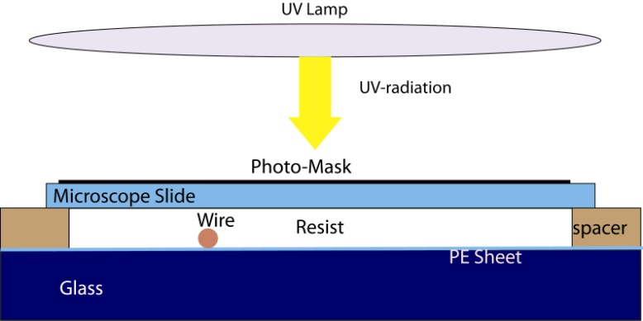

Figure 1. Scheme of the lithographic process
2.2 Materials

Microscope glass slides (Menzel Glaeser) were cleaned with water and soap, then rinsed with ultrapure water followed by etanol and acetone rinses. Immediately before use, the glass slides were cleaned in an UV-ozone cleaner (Jelight Inc. 42-220 model). In some cases, microscope cover glasses (170 micron thick) were used as top layers to seal chips and were cleaned by UV-ozone alone. As spacers, polymer sheets of known thickness, pieces of glass slides or silicon wafers were employed. Spacers in the range 25 microns - 1 mm were successfully tested, but thicker layers could be achieved if necessary, eventually by building a suitable container for liquid thiolene.

Photomasks were printed at a resolution of 4000 dpi on photographic polyester films by a local photoplotting/image-setting service company. In many cases to reduce further the production time, at the expense of resolution, masks were laser printed (600 dpi) onto transparencies and multiple transparencies were stacked to increase the optical density of the masks.

Thiolene based UV curable adhesives were obtained from Norland Products that commercialises them as optical adhesives under the acronym NOA. Different grades are available that differ in viscosity and sensivity and other properties. We extensively tested grade NOA61 that is reported to have viscosity 300 cps at 25ºC and good adhesion to glass. NO61 reaches its full hardness and best adhesion to glass by ageing 1 week after UV hard curing. This material is moderately hydrophobic with a characteristic water contact angle of 70°.

For rinsing uncured thiolene adhesive we used boiling water followed by ethanol, which has only a mechanical effect. Polyester sheets acting as temporary backing sheet for thiolene adhesive were cut from the transparent parts of photographic films used as photomasks. These films showed a good resistance to ethanol used during the rinsing step and a good adhesion towards thiolene glue. During the UV-curing of liquid thiolene adhesive the flexibility of the supporting polyester sheet posed a problem if it was not adequately fixed to a rigid support glass slide. Indeed the surface tension of thiolene liquid by capillarity tends to bring the polyester sheet in contact with the bottom substrate surface, causing problems in controlling the effective thiolene layer thickness. To avoid this we fixed the polyester sheet to a supporting microscope glass slide by using a ultrathin water layer as a “reversible glue” acting by capillarity. In this way the polymer sheet remained flat and adherent to the glass slide even during contact with liquid thiolene, but could easily be removed after UV curing with a razor-blade.

A 100 Watt mercury vapor UV flood lamp (Spectronics SB-100P), optimised for emission at 365 nm was used (luminous flux 6000 μW/cm² at 15 cm distance). The lamp was held at a distance of 70 cm from the sample. At this distance, a reasonable collimation and a good homogeneity over the illuminated chip area is achieved. To avoid back-reflection of the UV light that traverses the complete sample stack during photopolymerization, a UV absorbing pellicule (UV Sun-blocker, Unisol, Padova, Italy) was layed down beneath the sample. Exposure times depend on the thiolene layer thickness and the desired properties of the resulting thiolene structures but typically were between 7 min and 9 min for 200 micron thick spacers. To understand the curing behaviour of thiolene it is important to note that these materials polymerize by front-polymerization [9] with the liquid beginning to solidify starting from the lamp side. This fact can be exploited to continuosly adjust the polymerized layer thickness by acting on the exposure dose and in our case was used to fabricate very thick (>1 mm) structures for on-chip tube connectors. If spacers are used to confine thiolene liquid between two surfaces and a precise control of thickness is required the UV exposure dose should be at least as much as is required that the polymerization front arrives to the opposite surface (anti-stick surface). If the exposure is halted slightly before a thin liquid layer can remain between solidified thiolene and the anti-stick surface, thereby facilitating detachment.

A practical aspect is how to confine the glue between the surfaces. For spacer thicknesses lower than about 0,5 mm NOA 61 glue remains trapped by capillarity between the two microscope glass slides covering nearly the complete available area of the slide. For thicker spacers there is the risk that glue flows out. Thicker layers can be fabricated by using larger glass plates instead of microscope slides tehreby improving capillary confinement. For fabrication of very thick on-chip tube connectors by dose controlled liquid front polymerization we found it useful instead to invert the sample geometry with respect to Fig.1: a transparent glass container filled with liquid NOA glue was posed on top of a mask and illuminated from below through the mask.
3. SINGLE LAYER MICROFLUIDIC DEVICES
Single layer devices produced by liquid photopolymerization of thiolene monomers are useful e.g. for chemical microreactors because of the good solvent resistance of thiolene resins [10 ]. In the single layer fabrication method reported in the literature [6] thiolene liquid is sandwitched between two adhesive surfaces (glass slides) and rinsing of unpolimerized liquid is done on the fabricated chip with the channel already sealed. Rinsing in this case is done by either applying pressure or a vacuum to the formed channel network. The narrow width of microfluidic channels and the viscosity of adhesives can make this rinsing step cumbersome and often delamination of the chip can result. In our approach on the other hand rinsing of the chip is performed while the channels are still open, greatly facilitating the rinsing step. In this way, narrower/longer channels and more complex interconnected channel patterns can be more easily produced.

The chip is then “dry sealed” with a second glass slide by simply laminating this glass slide to the partially cured thiolene channel pattern. The elastomeric properties of partially cured thiolene resin and the tackiness of this rubber are exploited to obtain good conformal contact during lamination and can be performed even on non perfectly flat/smooth surfaces. To guarantee a better adhesion, an heavy weight (about 5 kg) with an opening the size of the glass slide is placed on top of the chip during the process of hard-curing.
Finally, connectors are glued to the chip above the drilled holes. According to the application, we have used thin capillary tubing, conic connectors or syring needles. For a quick fixing of the connector, we typically employed a small amount of a cyanidairlic glue, which was then covered by a thick layer of NOA61.

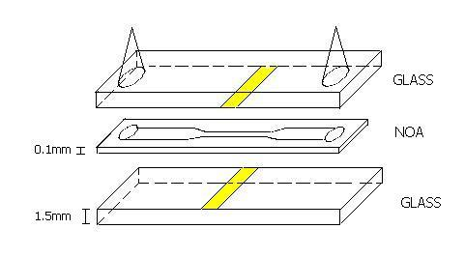
Figure 2: Schematic layout of the electroporation chip prototype.

Figure 2 shows the layout of a chip built for electroporation studies. It is formed by a single channel with a maximum width of 400 microns which decreases to 100 micron in the central region. The height of the channel is less than 100 microns. In the middle of the narrower channel, we have evaporated three gold stripes on the opposite sides of the glass walls of different widths. There are three electrodes to better evaluate which one works better. After the preliminary tests, the final chip will have only one pair of electrodes made out in ITO to allow direct optical access to the electroporation region. The length of the thin channel is much bigger than the entrance length to guarantee a well defined flow profile in proximity of the electrodes.

Figure 3 displays a photo of the fabricated chip with the channel filled with colored water to increase the contrast. It is evident a well defined channel profile and a tight system even in the region under the electrodes. This has required a slight modification in the fabrication procedure described above. The NOA layer was deposited above a glass slide with the evaporated electrodes. The top NOA surface was in contact with a silanized glass slide, above which one places the photomask. In this way, one avoids the shadow effects caused by the electrodes during the UV exposure.

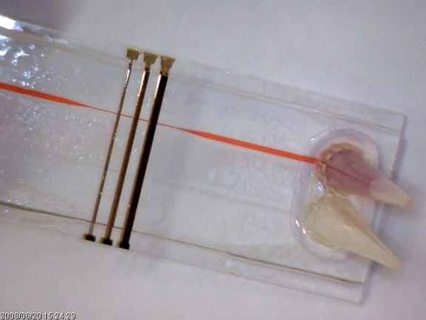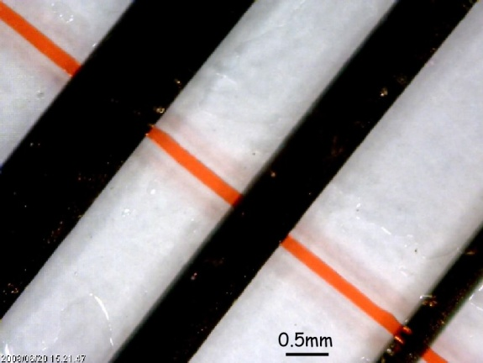
Figure 3. Left: Photo of the chip for electroporation studies; right: enlarged view of the channel
underneath the gold electrodes.

The phenomenon of thermophoresis regards the diffusion of particles induced by a temperature gradient. To better study this effect that may be exploited as a microfluidic particle filter, we have fabricated a simple chip in NOA whose layout is displayed in figure 4. A central rectangular channel 150 μm wide, 120 μm deep and 50 mm long, the main channel, is filled with the working fluid, a colloidal solution. For preliminary measurements, we have tested the thermophoretic behaviour of 1.0 μm diameter fluorescent polystyrene particles in deionized water. A Moleculoy® alloy wire, with a diameter of 60 μm, is inserted at a distance of 1 mm from one side of the main channel and connected to a power supply, while a second wider channel, the cooling channel, is placed at the same distance at the other side of the main channel and is filled with running cold water. By regulating the heating power and water flow is is possible to vary the temperature gradient across the main channel. .

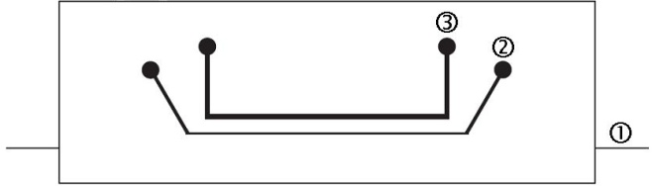

Figure 4: Photolithographic mask used to produce the thermophoretic microdevice: 1) resistance heating wire position, 2) main channel and 3) cooling line.

Figure 5 shows the fabricated chip with the main channel and the cooling line filled with colored water. It is possible to see the thin heating wire, which is strectched in position after the deposition of the NOA layer. In this way, the wire remain fixed and in good contact with the NOA matrix after the UV exposure.

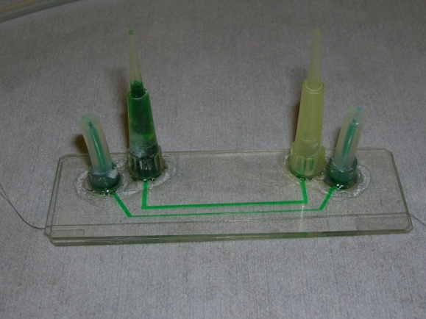
Figure 5: Photo of the chip for thermophoresis studies.

Finally, we have fabricated a microchannel sandwitched between two glass slides that present a rectangular obstruction, to be used to study how a water meniscus moves in a microchannel with a patterned profile. The channel, with a width of about 400 μm and an obstacle height of 250 μm, has been photolithographed on a layer of NOA having a thickness of 100 μm. The photos shown in Fig. 6 show the displacement of the water meniscus near the corner of the obstruction. Measurements are in progress to investigate the evolution of the meniscus in microchannel with regularly patterned obstacles.

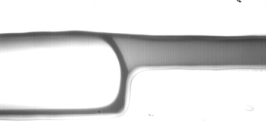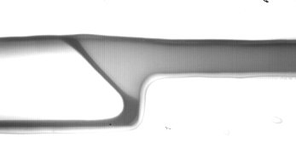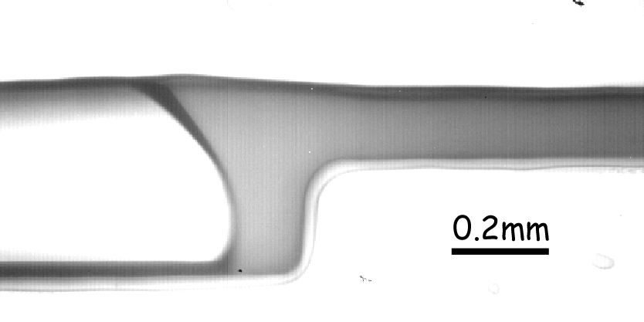
Figure 6: Displacement of a water meniscus pinned at the edge of an obstacle in a microchannel

4. CONCLUSIONS
We have presented a few examples of single-layer microfluidic chips fabricated by exploiting the adhesive and photoresist properties of NOA61, a thiolenic material commercialized by Norland Products. They show the good flexibility of this material, that allows a very rapid prototyping of chips that can easily include wires, electrodes, obstructions… during the fabrication process, as well as an easy sealing of the device. The required equipment, which includes a high-resolution laser printer and a UV lamp, is not expensive and can be easily found in most laboratories. Once the methodology has been optimized, it takes less than one day to fabricate the chip starting from the printing of the photomask. Based on our experience, a good transfer of the circuit layout into the NOA layer is achieved for vertical thicknesses larger than about 50 μm and for minimum lateral dimensions greater than about 200 μm. If one needs to realize channels having a typical width of 100 μm or less, this technique is not longer reliable and it is more convenient to use the standard replica molding of PDMS. However, this requires the fabrication of a master by mechanical micromachining or by photolithography of SU8.

ACKNOWLEDGEMENTS
Partial support from Progetto di Eccellenza Cariparo 2007 “Mischa” and from CNISM-CNR Progetto d’Innesco della Ricerca Esplorativa 2007 “Viscous flows in microfluidic devices” are warmly acknowledged.

REFERENCES
[1] M.A. Unger, H.Chou, T. Thorsen, A. Scherrer, S.R. Quake, Science 288, 113 (2000).

[2] C. Harrison, J. T. Cabral, C. M. Stafford, A. Karim, and E. J. Amis, J. Micromech. Microeng. 14, 153 (2004).

[3] C. Khoury, G.A. Mensing and D.J. Beebe, Lab Chip, 2, 50 (2002).

[4] J.B. Hutchison, K. T. Haraldsson, B.T. Good, R.P. Sebra, Ning Luo, K.S. Anseth, and C.N. Bowman, Lab Chip 4, 658 (2004).

[5] Z.T. Cygan, J.T. Cabral, K.L. Beers, and E.J. Amis, Langmuir 21, 3629 (2005).

[6] D. Bartolo, G. Degre, P. Nghe and V. Studer, Lab Chip 8, 274 (2008).

[7] M. Natali, S. Begolo, T. Carofiglio and G. Mistura, Lab Chip 8, 492 (2008).

[8] L. Brigo, T. Carofiglio, C. Fregonese, F. Meneguzzi, G. Mistura, Giampaolo, M. Natali and U. Tonellato, Sens. Actuators B 130, 477 (2008).

[9] J. T. Cabral, S.D. Hudson, C. Harrison, and J.F. Douglas, Langmuir 20, 10020 (2004).

[10] Z.T. Cygan, J.T. Cabral, K.L. Beers, and E.J. Amis, Langmuir 21, 3629 (2005).

Corresponding author. Email: mistura@padova.infm.it

