Complex dynamics in Quantum Dot Light Emitting Diodes

**K. A. Al Naimee**

Istituto Nazionale di Ottica- CNR, Largo E. Fermi 6, 50125, Florence, Italy

Dept. of Physics, College of Science, University of Baghdad, Al JAdiriyah, Baghdad, Iraq

**H. Al Husseini**

Dept. of Physics, College of Science, University of Baghdad, Al JAdiriyah, Baghdad, Iraq

**S.F. Abdalah**

Istituto Nazionale di Ottica- CNR, Largo E. Fermi 6, 50125, Florence, Italy

**A. Al Khursan**

Dept. of Physics, College of Science, Thi-Qar University, ThiQar, Iraq

**A. H. Khedir**

Dept. of Physics, College of Science, University of Baghdad, Al JAdiriyah, Baghdad, Iraq

**R. Meucci**

Istituto Nazionale di Ottica- CNR, Largo E. Fermi 6, 50125, Florence, Italy

**F.T. Arecchi**

Istituto Nazionale di Ottica- CNR, Largo E. Fermi 6, 50125, Florence, Italy

**Abstract**

We report an experimental and theoretical investigation on the appearance of Mixed Mode Oscillations (MMOs) and chaotic spiking in a Quantum Dot Light Emitting Diode (QDLED). The underlying dynamics is completely determined by the variation of the injecting bias current in the wetting layer of the QDLED. The theoretical model qualitatively reproduces the experimental results.

**Keywords**: Quantum Dot LED, Mixed Mode Oscillations, Chaos, Control

**1 Introduction**

Most light sources exhibit intensity and phase fluctuations due to the nature of the quantum transition process itself. These fluctuations are very important when the stability is a priority. In fact, every spontaneous emission event in the oscillating mode causes a phase variation of the electromagnetic field. This variation is defined as a quantum noise and it is responsible forcarrier density variations.

Semiconductor nitrides such as aluminum-nitride (AlN), gallium-nitride (GaN), and indium-nitride (InN) are commonly utilized as materials for their potential use in high-power and high-temperature optoelectronic devices. The commonly quoted value for the optical band gap of InN was 1.89 eV[Al-Husseini H, Al-Khursan AH, Al-Dabagh, 2009]. Nevertheless other values are obtained by changing the state [Chuang, 1996].The properties of III-N QDs are closely related to those of bulk materials [ Steiner, 2004]. Although bulk LEDs can be found as wurtzite, zinc blend, and rock salt structures, the wurtzite structure is more dominant in thermodynamically stable condition. III-nitride QDs are commonly strained systems. [Jindal, 2011]

In addition to chaotic spiking, recent studies involving surface chemical reactions[ Bertram and Mikhailov, 2001:Bertram, 2003:Kim,2001], electrochemical

systems[Kope, 1995: Plenge, Rodin, Scholl, andKrischer , 2001]neural and cardiac cells[ Alonso andLlin´as, 1989: Medvedev andCisternas, 2004], calcium dynamics[U. Kummer, 2000] and plasma physics[Mikikian, Cavarroc,Couedel, Tessier, and Boufendi, 2008] showed thatoscillatory dynamics often takes place in the form of complex temporal sequences known as Mixed Mode Oscillations (MMOs)[Marino, Ciszak, Abdalah, Al-Naimee, Meucci, and Arecchi, 2011]. However, periodic-chaotic sequences and Farley sequences of MMOs do not necessarily involve a torus or a homoclinicorbit. They can occur also through the canard phenomenon [Brøns, Krupa, andWechselberger, 2006]. Here a limit cycle born at a supercritical Hopf bifurcation experiences the abrupt transition from a small-amplitude quasi-harmonic cycle to large relaxation oscillations in a narrow parameter range. Most studies of this dynamics have been carried out in chemical systems. Nevertheless in semiconductor laser systems with optoelectronic feedback incomplete homoclinic scenarios have been recently predicted and observed [Al-Naimee, Marino, Ciszak, Meucci, and Arecchi, 2009: Al-Naimee et al.,2010].

The main goal of this work is to provide a physical model reproducing qualitatively the experimental results and showing that chaotic spiking and MMOs are a consequence bias current variations. Our experiments reveal that spiking competition in the active layer enhances the influence of self-feedback and modulating perturbation thus opening up new avenues for the study of chaos in quantum systems.

**2 Experiment**

Spikingphenomena in the output of the QDLEDs are related to a feedbackprocess that couples the output signal partially back to the input [Albert, 2011].We consider an open-loop optical system, consisting of a QDLED source emitting at 650nm wavelength. The QDLED operates with variable driven current. The light is sent to a photodetector whose output current is proportional to the optical intensity. The corresponding signal is sent to a variable gain amplifier characterized by a nonlinear transfer function of the form, where A is the amplifier gain and a saturation coefficient, then to a fast (500 MHz) digital oscilloscope. By decreasing the dc-pumping current which plays the role of control parameter, we observe the dynamical sequence shown in figures 1(a)-(f). In figure (1-a) we show the regular spiking at the injection current of 6.2 mA. Changing the control parameter, a transition from periodic dynamics toMMOs is observed as shown in figure 1-(b-d). When the injection current reaches a value of 5.01mA, the detected optical output is in a chaotic spiking regime where large intensity pulses are separated by irregular time intervals in which the system displays small-amplitude chaotic oscillations[see figure1-e]. Typical time traces are characterized by a mixture of large-amplitude relaxation spikes (L) followed by small-amplitude (S) quasi-harmonic oscillations, where oscillations intermediate between L and S do not occur). As the injection current is farther decreased (4.7mA), the spiking behavior vanishes and eventually a steady state is established as shown in figure 1-f. This scenario is qualitatively similar to Homoclinic Chaos (HC) as previously observed in semiconductor lasers and LEDs with optoelectronic feedback [Al Naimee, Marino, Ciszak, Meucci, andArecchi, 2009]. In HC signals, the pulse duration (associated with a precise orbit in the phase space) is uniform, while the interpulse times vary irregularly. This is shown by the corresponding interspike interval (ISI) probability distribution (fig.1 e). The ISI histogram displays sharp peaks,superimposed to a continuous background, corresponding to unstable periodic orbits embedded in the chaotic attractor [Alonso andLlin´as, 1989]. We will show in the next section that a fully deterministic theoretical model explains such a feature.

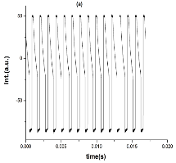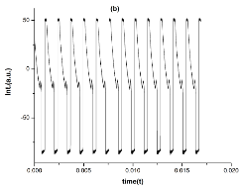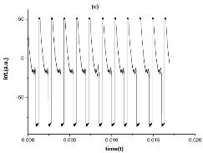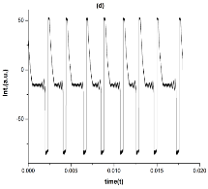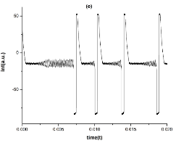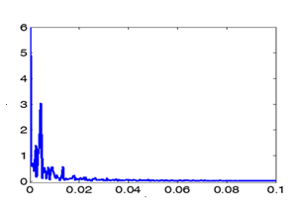

**ISI(s)**

P(ISI)

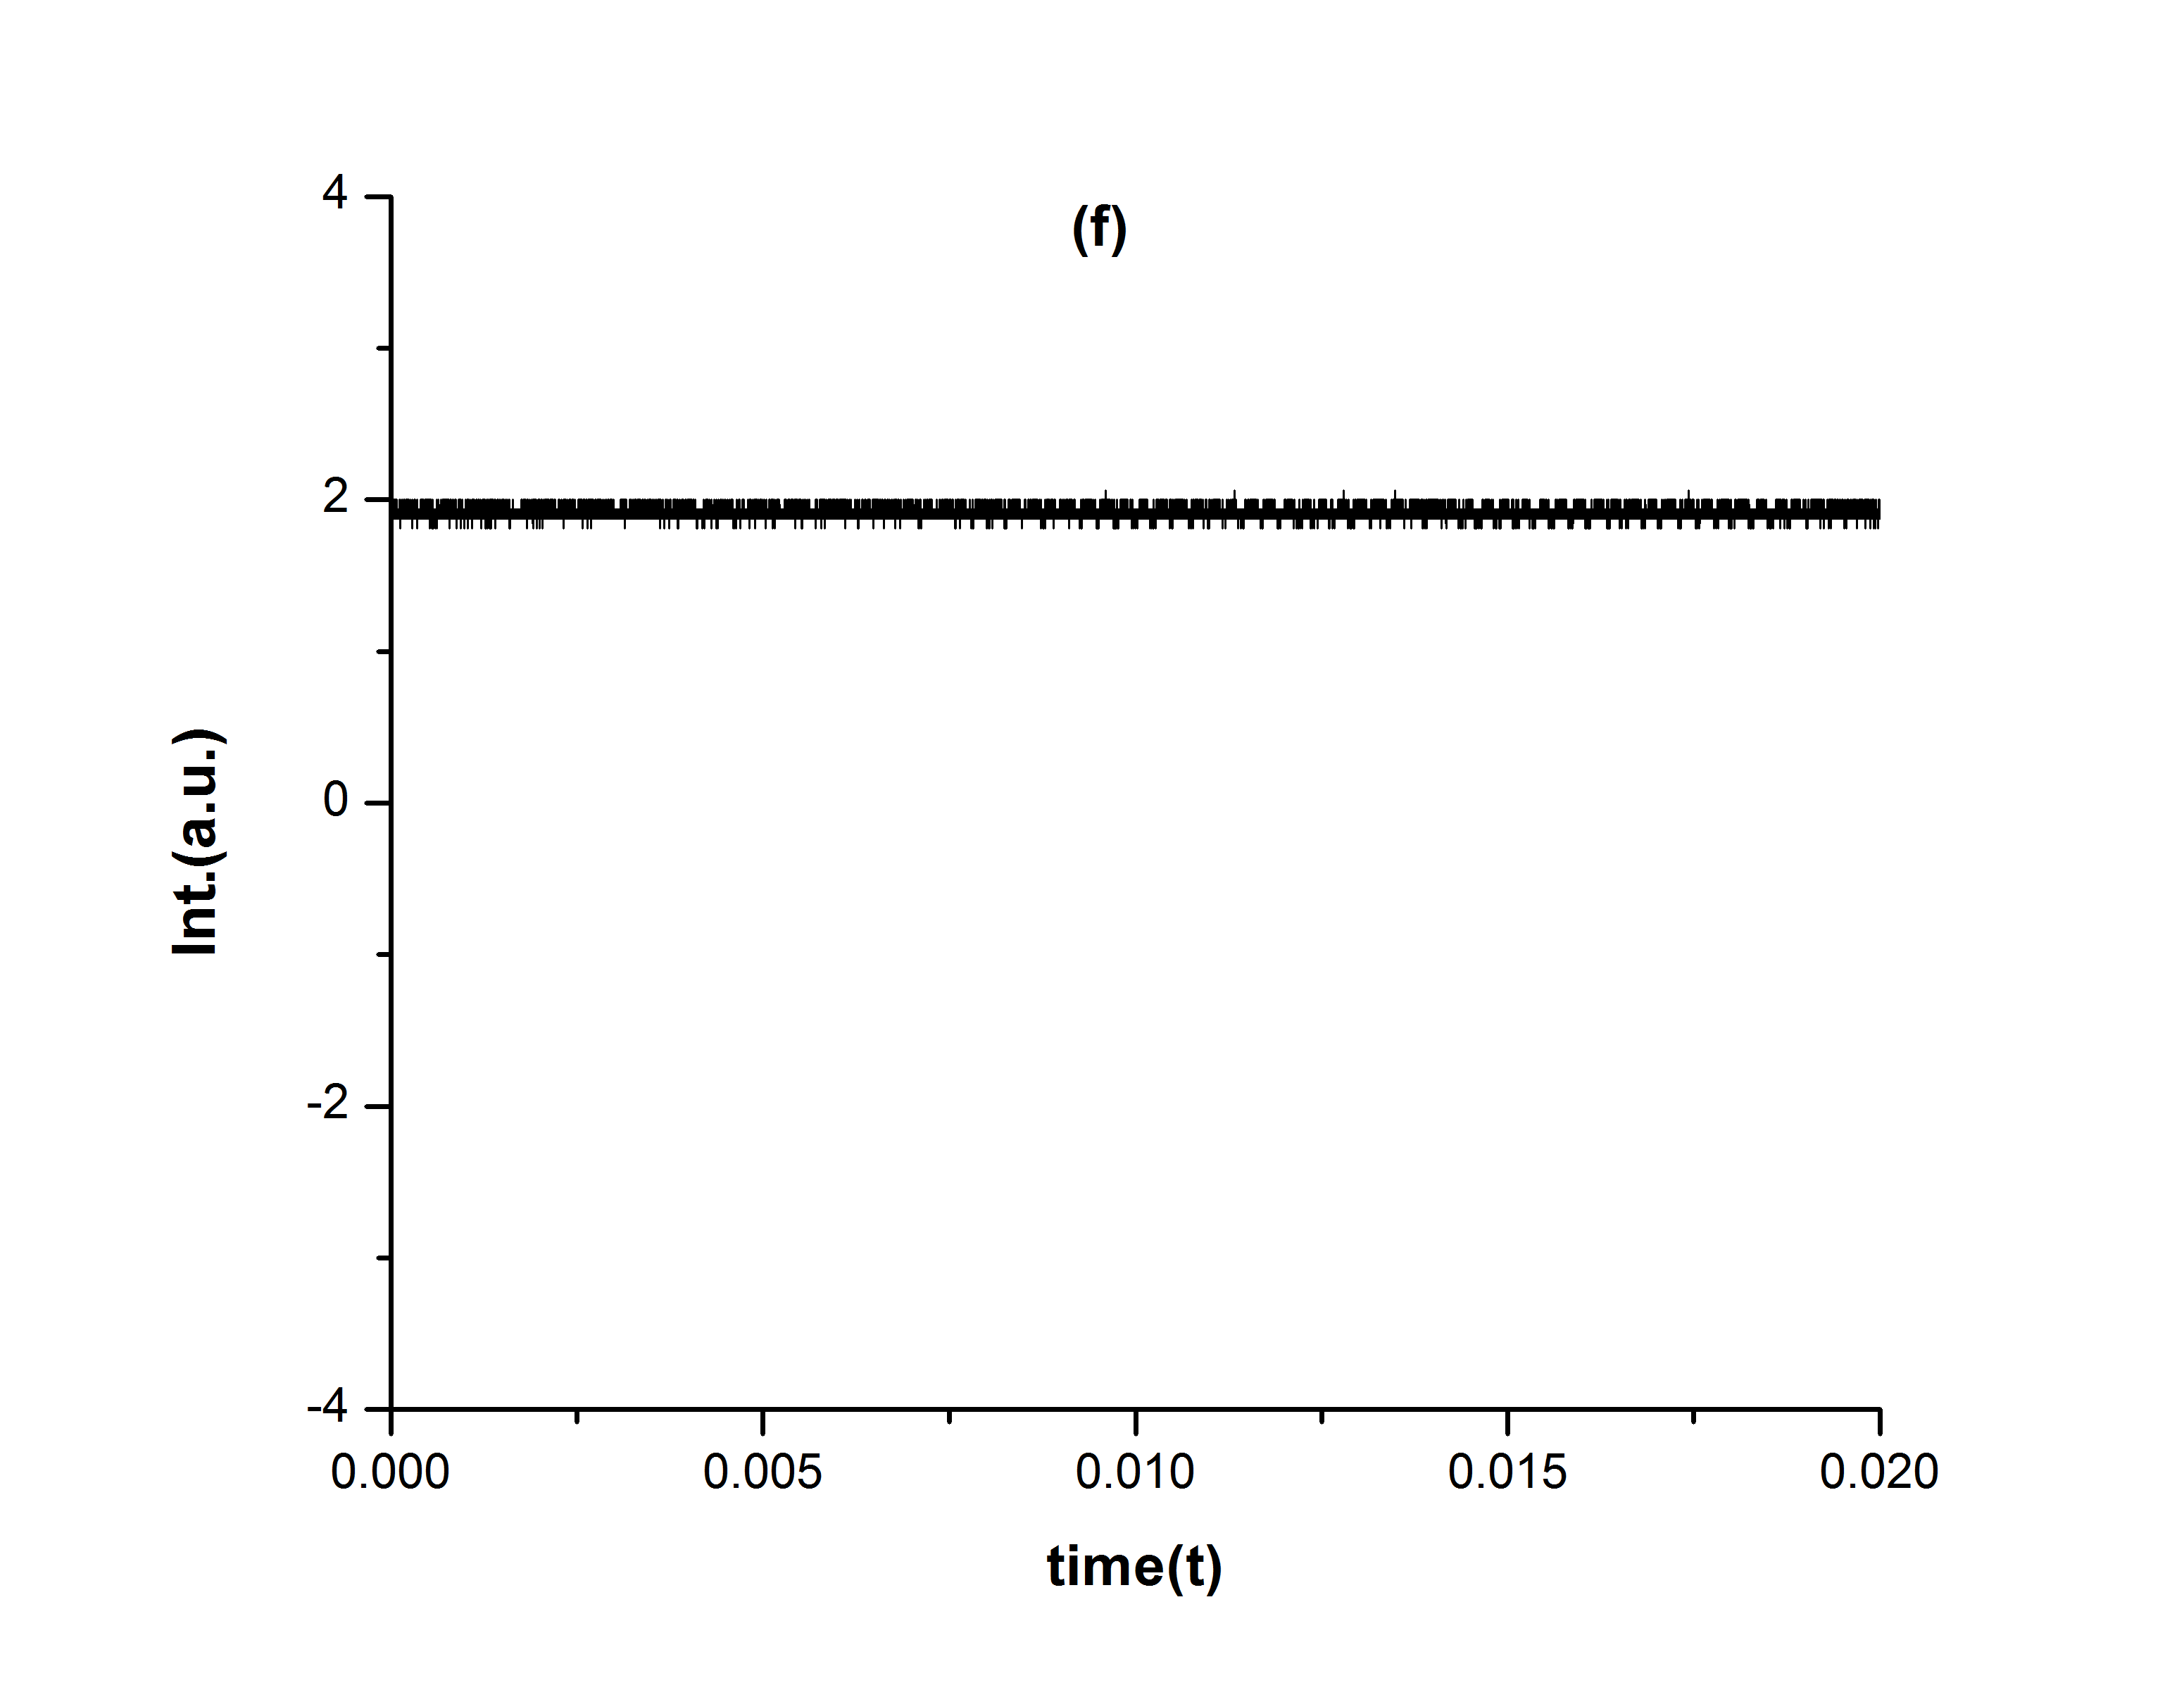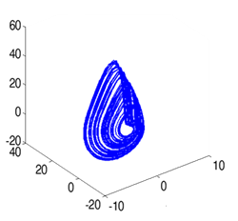

**I**

**Int.(t)**

Figure 1 Transition from periodic to chaotic spiking to and steady state as the dc-pumping current is varied (a) 6.2 mA, (b) 5.52 mA, (c) 5.35mA, (d) 5.21 mA, (e) 5.01mA, (f) 4.700 mA. (g). Experimental reconstruction of the phase portrait through the embedding technique. (h) The corresponding experimental ISI probability distribution for the chaotic spiking regime.

**3 The model**

In this study, we propose a rate equations model for a QDLED considered as a three-level system(see figure 2). In the QDLED, the electrons are first injected into the wetting layer (WL) before they are captured by the QDs. We consider a system made up of upper and lower electronic levels.

The equations describing the dynamics of the total population of carriers in the upper levels, the number of photons in the optical modes, and wetting layer population are as follows

(1)

*Z*



*WL*

*WL*

*QD*

*Energy*

Figure 2 Energy diagram illustrates the two recombination mechanisms considered in this work of the active layer QDLED; recombination radiative and non-radiative via deep level and reabsorption recombination processes

where is the spontaneous emission rate into the optical mode, and are the non-radiative decay rates of the population of carriers in the upper levels and WL respectively, is the two-dimensional density of dots; is the injection current, is electron charge, is the capture rate from WL into an empty dot, and and are the absorption and output coupling rate of photons in the optical mode, respectively.

For a two-level atomic system where the transition is homogeneously broadened, it can be shown [Loudon, 1983] that

(2)

whereis the occupation number of the lower level. In such a case, the spontaneous emission coefficient and absorption coefficient possess identical line shapes. For realistic material systems, such as semiconductor or organic emitters, both the lower and the upper levels can be considered as inhomogenously broadened. Population distributions in the lower and upper levels have to be taken into account explicitly in order to determine the correct relation between absorption and spontaneous emission spectra [Casey and Panish, 1978].

In this section we investigatethe unstable behavior from the QDLED equations without external feedback. To do so, we rescale the system (Eq.s1) to a set of dimensionless equations. Defining new variables and dimensionless parameters as, , , Eqs. 1 can be rewritten as

**(**3)

Here prime means differentiation with respect to and the bias current density is represented by.

In our simulations, the injection current in the pumping term , has been considered as the sum a dc component and an ac component in order to consider an additional periodic modulation

**4 Numerical results**

Equations 3 are solved numerically using the fourth -order Runge-Kutta method with 0.01 ns as step time. The parameter values used in the simulations are (the initial conditions are assigned as = 0.066, = 0.99, = 0.0049), =0.127, = 0.144, = 0.03, = 0.07, =0.087, a = 1.04 and b= 3.838. The injection parameters, i.e., the dc bias current,, or the dc bias strength , the modulation current , , or modulation depth, and modulation frequency, , have been chosen carefully.

As in the experiment, the chaotic spiking regime arises from the interplay of the large phase-space orbits and a period doubling route to chaos. In figure3 we show several time series and the corresponding attractorsfor different current injection current δo values. The related ISI distributions are reported in figure 4.

The WL has a large number of states it can be considered as a continuum state and its carrier number is always higher than zero as. There are limited number of states in QD structure, then the ground state is filled and emptied due to the capturing and relaxation processes (positive  and negative  parts in the second equation of the system, Eqs. 1). Thus, the behavior of the carrier numbernqd in QD goes between positive and negative values as shown in the left panel of figure 3. So, the negative part of photon number shown in figure 3 is due to both absorption and emission and it is also shown in experimental works in bulk LED.

In Figure 3 we observe that the transition from periodic dynamics to chaos is accompanied by MMOs. In these regimes, a mixture of L large amplitude relaxation spikes followed by S small-amplitude quasi-harmonic oscillations.



(a)

(b)

(c)

(d)

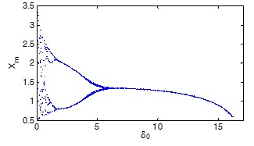

Figure 3 Numerical simulations of the model equations. Left panels: time series for the light intensity. Right panels: phase space reconstruction of the attractors.(a)=6, δ0 (b) =4, δ0 (c) =0.5, δ0 (d) = 0.1 correspond to δ0 = 6-0.1. The other parameters are: = 0.066, = 0.99, 0.0049, 0.127, 0.144, = 0.03, = 0.07, = 0.087, a = 1.04 and b = 3.838

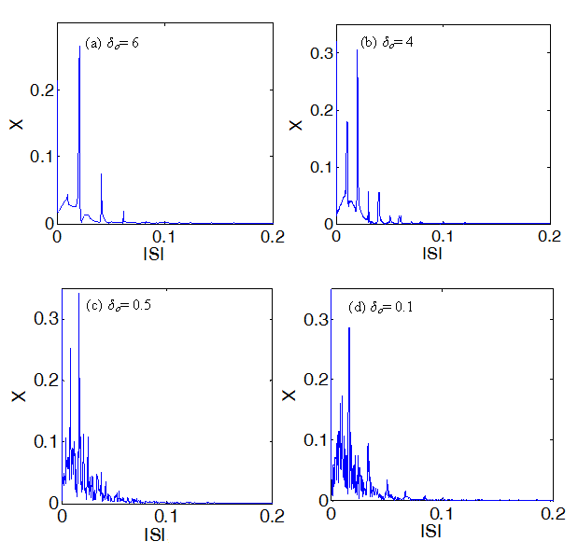Figure 4 The ISI distribution of the conditions as in fig. 3 ,when a) δo=6, b) δo=4, c) δo=0.5, d) δo=0.1.

In Figure 5 we show the bifurcation diagram of the maxima of x variable as a function of δo starting from the Hopf bifurcation. As δo approaches values less than 1, chaotic amplitude fluctuations are sufficiently large to trigger fast spiking dynamics. This results in an erratic-sensitive to initial condition-sequence of homoclinicspikeson top of a chaotic background.

Figure 5The Bifurcation diagram for the model equations. The parameter values are set as in figure 3.

As introduced, we have also considered the spiking dynamics in presence of a modulation amplidude*Iac*. As in the experiment, increasing the modulation depth by around 2 leads to faster chaotic spiking regimes until the duration of the slow–fast pulses becomes of the order of the chaotic background characteristic timescale (figure 6).



Figure 6 Bifurcation diagram of the photon density as a function of modulation depth (*Iac*) for the dc bias strength value δo= 0.6 and modulation frequency .

**5 Conclusions**

In conclusions, we have numerically and experimentally demonstrated the existence of chaotic behavior and MMOs in the dynamics of a quantum dot light emitting diode with optoelectronic feedback.

We provide a feasible minimal model reproducing qualitatively the experimental results showing chaotic and mixed mode oscillations dynamics. Remarkably, chaotic dynamics can be controlled by changing the bias current with a suitable modulation.

.

**References**

Al-Husseini H, Al-Khursan AH, Al-Dabagh S.Y.(2009) Open Nanosci J, 3: 1-11.

Chuang, S.L.(1996) IEEE J. Quantum Electron.,32, 1791.

Steiner, T.(2004) Artech House Inc: Norwood, USA.

Jindal Vibhu (2011) UMI dissertation publishing.

Bertram M. and A. S. Mikhailov (2001), Phys. Rev. E 63, 066102.

Bertram M. et al (2003) Phys. Rev. E 67,036208.

Kim K.et.al. (2001) Science 292, 1357.

Koper M.T.M.(1995)Physica D 80, 72.

Plenge F. , Rodin P., Scholl E, andKrischer K (2001) Phys. Rev. E 64, 056229.

Alonso A.A. and Llin´as R.(1989) Nature (London) 342, 175.

Medvedev G. S. and Cisternas J. E (2004)Physica D 194, 333.

Kummer U. et al (2000)Biophys. J. 79, 1188.

Mikikian M., Cavarroc M., Couedel L., TessierY.andBoufendi L.(2008) Phys. Rev. Lett. 100,225005.

Marino F., Ciszak M., Abdalah S.F., AlNaimee K., Meucci R. and F. T. Arecchi F.T.(2011) Phys. Rev. E 84, 047201.

Brøns,M. Krupa, andWechselberger M., Fields Inst. Comm. 49, 39, 2006; Krupa M.,Popovic N., and Kopell N.(2008) SIAM J. Appl. Dyn. Syst. 7, 361.

AlNaimee K., Marino F., Ciszak M.,Meucci R., and Arecchi F.T.(2009) New J. Phys. 11, 073022.

Al Naimee K. et al.(2010)Eur. Phys. J. D 58, 187.

Albert F., et al (2011), Nature Communications, 2:366. DOI: 10.1038/ncomms1370.

Loudon R.,(1983)The Quantum Theory of Light. Oxford, U.K.: Oxford Univ.Press.

Casey H.C. Jr. and Panish M. B.(1978)Heterostructure Lasers Part A: Fundamental Principles. New York: Academic.