**TRACKING WITH TARGET ATTRACTOR FEEDBACK**

**IN SUPERCONDUCTING JOSEPHSON JUNCTION**

Sergey Borisenok

Department of Electrical and Electronics Engineering

Faculty of Engineering

Abdullah Gül University

Kayseri - Turkey

sergey.borisenok@agu.edu.tr

**Abstract**

Target attractor (“synergetic”) feedback is applied to track the relative phase of the wave functions in super-conducting Josephson Junction. The efficiency of the tracking algorithm is demonstrated with numerical simulations.

**Key words**

Josephson Junction, feedback, tracking

**1 Introduction**

Last couple of decades information and computation technologies were supported by the significant prog-ress in control of quantum systems; that had a remarkable notification in 2012 when Haroche and Raimond had got the Nobel Prize in Physics for developing effective experimental technique to manipulate with quantum objects, see their review [Haroche, Raimond, 2006].

Classical bit of information is getting replaced by qubit. Two level quantum systems (atoms, nuclear magnetic resonance and spin systems, polarization states of photons) serve as their important examples. Among them one of the most prominent prototypes is represented by Josephson Junction (JJ). Originally it included two coupled superconductors, but now developments of more controllable and less deman-ding systems, such as coupled ultracold atoms or coupled plasmonic systems, are underway.

The effect of electrical current passing through a tunnel barrier between two superconductors predicted by Josephson [Josephson, 1962; Josephson, 1974] (1973 Nobel Prize in Physics [Josephson, 1973]) and proved in many experiments [Anderson, Rowell, 1963; Anderson, Dayem, 1964; Fulton 1989] plays an important role in the modern technology [Barone, Paterno, 1982; Bouchiat et al., 1998]. For instance, such Josephson Junctions are used to detect magnetic fluxes in superconducting quantum interference devi-ces (SQUIDs) [Dawe, 1998], combining the physical phenomena of flux quantization and Josephson tun-neling [Kleiner, 2004].

Josephson Junction has many physical realizations and possesses complicate dynamical properties [Likharev, 1986]; under special conditions it demonstrates a chaotic behavior that can be controlled by an external weak spatially distributed force [Olsena, Samuelsen, 2000].

Different non-classical realizations of JJ represent the most prominent candidates for the quantum computation engineering [Niskanen, 2004]. Among them we should mention soliton - metal surface plas-monic JJ, ultracold atoms trapped in a double-well potential and coupled cavity QED systems.

To use JJ-type quantum systems in modern information technologies, we need to examine Josephson Junctions from the point of control theory methods for the development of efficient algorithms to reach designated operation goals of the systems, such as the transfer of states.

An important particular case of control goal is tracking, when we force a set of given parameter(s) or functional(s) of the dynamical system to follow a preliminary defined time behavior. Classical control theory developed variety of feedback methods to target such goal [Fradkov, Pogromsky, 1998]. Some of them can be reformulated for many non-classical cases [Fradkov, 2007]: for instance, speed gradient algo-rithm for two-level quantum system [Borisenok, Fradkov, Proskurnikov, 2010].

Here we study an alternative approach for feedback, targeting attractor by so-called “synergetic” control [Kolesnikov, 2012]. It has been demonstrated that target attractor feedback works very successfully in classical physics and engineering problems. Our goal is to study how efficient it could be in the application for controlling the dynamical properties of a quantum system.

In this paper we apply target attractor feedback to track the relative phase in superconducting Josephson Junction. In Section 2 we formulate the mathematical model for JJ. Section 3 is devoted to details and inter-pretation of control algorithm that we study nume-rically in Section 4. Section 5 covers conclusions and further proposals.

**2 Superconducting Josephson Junction Model**

The wave function for two superconductors 1 and 2 separated by a thin insulator layer can be presented in the form:

 . (1)

Its time evolution calls for Schrodinger Eq. [Feyn-mann, 1971]:

 (2)

where *V* stands for the external voltage; *A* is the probability of tunneling between two sides of Jo-sephson Junction; and *q* = 2*e* represents the electrical charge of the Cooper pair.

**2.1 Dimensionless Form of the Model**

In the dimensionless form:

 (3)

we define:

 (4)

The dimensionless voltage *u* plays a role of control parameter.

By (3)-(4) the dynamical system (2) becomes:

 (5)

The electrical current through the insulator can be cal-culated as the time derivative:

 . (6)

The system (5) is over-defined, but it can be reduced to a couple of equations.

It can be easily done under an appropriate canonical transformation.

**2.2 Spinor Representation**

Let’s re-write (5) in the spinor representation:

 (7)

By (7) Eqs (5) can be simplified:

 (8)

with the current:

. (9)

There is an alternative form for (8) under the cano-nical transformation:

. (10)

Then in the place of (8) we get the system:

 (11)

The form (11) is especially useful for particular quantum realization of JJ, like ultracold atoms trap-ped in a double-well potential and coupled cavity QED systems.

The dynamical system (11) has the Hamiltonian:

 (12)

plotted on Fig.1.

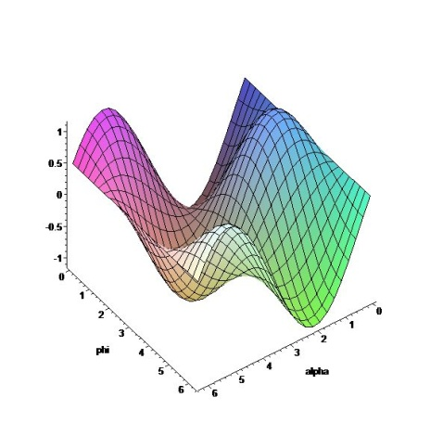

Figure 1. Hamiltonian (12) for *ω* = 1.0 and *u* = 0.5.

This quantum system (9), (11) is very sensitive with respect to the choice of the parameters *u* and *ω*.

**3 Target Attractor Feedback**

Target attractor control (“synergetic control” in author’s terminology) is based on the directed self-organization of the dynamical system [Kolesnikov, 2012]. The *m*-parametric attracting invariant manifold (the subset referring the control target)

 (13)

is defined with the functions of the state variables *x*1,…,*xn*. Eqs (13) must provide the asymptotic sta-bility of the system dynamics with respect to the control target.

To do it, let’s require minimum of the following opti-mizing functional to be satisfied:

 (14)

where *Ts* are positive constants (time scales). To achieve the minimum (14) in exponent asymptotic we define the “synergetic” feedback as a set of *s* equations for the observers [Kolesnikov, 2014]:

. (15)

Tending to zeros, the observers (13), (15) lead the dynamical evolution of the system to the target attractor.

This algorithm developed for classical applications can be easily re-formulated for superconducting Josephson Junction.

**3.1 Target Attractor Feedback for JJ**

Let’s construct the target attractor feedback algorithm for the spinor dynamical system (8) of Josephson Junction. For tracking the relative phase  from (4b), we consider the observer:

 (16)

with a given target function . In the exponential form the “synergetic” feedback (15) is given by:

 (17)

with the free control parameter *T*. That leads to:

 (18)

The solution to the phase tracking equation (18) is given by:

 (19)

Eq. (19b) provides the exponential achievement of the control goal of phase tracking as .

By (8b) and (18) we restore the control signal (dimensionless voltage) as:

 . (20)

Asymptotically, as  and , the control signal (18) does not tend to zero:

. (21)

This is quite typical for “synergetic” feedback [Kolesnikov, 2014], due to the fact that (16) makes permanent monitoring of the dynamics for Eqs (8) and forces the system to stay in the target attractor. In general this attractor is not stable without feedback control.

**3.2 Interpretation of the Algorithm as Master-Slave Synchronization**

The algorithm described in Section 3.1 allows us to present the phase attractor tracking as a Pecora-Carroll synchronization. Indeed, combining (8a) with (17) into the dynamical system:

 (22)

one can interpret Eqs (22) as a master-slave trans-mitter. The phase coordinate  is a synchronizing parameter, and the slave system (22) contains a partial observer for the master .

**4 Numerical Simulations**

Let’s chose the target function for the relative phase tracking as a superposition of harmonic functions:

 (23)

On Fig.2 the result of phase tracking is plotted for *ω* = 2, *T* = 10.

The positive parameter *T* represents a typical time scale. Indeed, on Fig.2 one can observe that the control goal is achieved in the exponential asymptotic at the time scale *t* = 10. In the neighborhoods of minima and maxima of the relative phase (23), where its time derivatives have greater magnitudes, the error for the algorithm (16)-(20) is also greater.

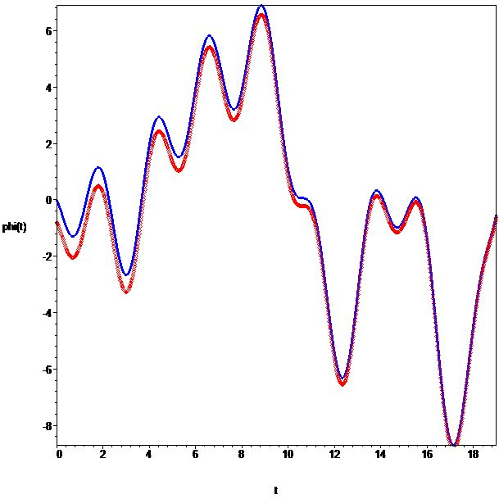

Figure 2. Tracking the relative phase (4b) (blue line)

with the target function (23) (red points); *ω* = 2, *T* = 10.

**5 Conclusion**

The target attractor feedback applied in the paper to Josephson Junction works efficiently (with exponent-tial asymptotic) for the dynamic goal control in the form of tracking. From this point it enriches the set of control algorithms for manipulation with two-level (and multi-level) quantum systems.

The basic handicap of this approach can be originated in the fact that the algorithm produces in the system an extra strong force to keep the system dynamical evolution in the neighborhood of the target attractor manifold, as it mentioned in Section 3. It may demand the pumping of sufficient energy (with high power) into the system for practical realization of the “syner-getic” method in certain physical applications.

The comparison of different feedback algorithms for efficient manipulation with quantum objects, parti-cularly with different realizations of Josephson Junc-tion, is a matter of our further research.

**Acknowledgements**

This work has been supported by Research Fund of the Abdullah Gül University; Project Number: BAP FBA-2015-2.

**References**

Anderson, P. W., Rowell, J. M. (1963)

Probable observation of the Josephson tunnel effect. Phys. Rev. Letters, 10, p. 230.

Anderson, P. W., Dayem, A. H. (1964)

Radio-frequency effects in superconducting thin film bridges. Phys. Rev. Lett., 13, p. 195.

Barone, A., Paterno, G. (1982). Physics and Applications of the Josephson Effect. New York. John Wiley & Sons.

Borisenok, S., Fradkov, A., Proskurnikov, A. (2010)

Speed gradient control of qubit state. Periodic Control Systems, 4(1), pp. 81-86.

Bouchiat, V., Vion, D., Joyez, P., Esteve, D., Devoret, M. H. (1998)

Quantum coherence with a single Cooper pair, Physica Scripta, 76, p. 165.

Dawe, R., (1998)

SQUIDs: A Technical Report - Part 3: SQUIDs (website). http://rich.phekda.org. Retrieved 2011-04-21.

Feynmann, R. A. (1971). Quantum mechanics. The Feynman Lectures on Physics. Addison-Wesley. Vol. 3, Chap. 21.

Fradkov, A. L., Pogromsky, A. Yu. (1998). Intro-duction to Control of oscillations and Chaos. World Scientific.

Fradkov A. L. (2007). Cybernetical Physics: From Control of Chaos to Quantum Control. Springer.

Fulton, T.A., et al. (1989)

Observation of combined Josephson and charging effects in small tunnel junction circuits. Phys. Rev. Lett., 63 (12), pp. 1307-1310.

Haroche, S., Raimond, J.-M., (2006). Exploring the Quantum. Atoms, Cavities, and Photons. Oxford.

Josephson, B. D. (1962)

Possible new effects in superconductive tunneling. Physics Letters 1, p. 251.

Josephson, B. D. (1973)

The Discovery of Tunneling Supercurrents (Nobel Lecture). The Nobel Prize in physics 1973, accessed 8-18-11.

Josephson, B. D. (1974)

The discovery of tunnelling supercurrents. Rev. Mod. Phys., 46 (2), pp. 251-254.

Kleiner, R., Koelle, D., Ludwig, F., Clarke, J., (2004)

Superconducting quantum interference devices: State of the art and applications. Proceedings of the IEEE, 92 (10), pp. 1534-1548.

Kolesnikov, A. (2012). Synergetic Control Methods for Complex Systems. URSS Publ. Moscow.

Kolesnikov, A. (2014)

Introduction of Synergetic Control. 2014 American Control Conference, Portland, pp. 3013-3016.

Likharev, K. K. (1986). Dynamics of Josephson Junctions and Circuits. Amsterdam. Gordon and Breach Science Publishers.

Niskanen, A. O. (2004)

Control of Quantum Evolution and Josephson Junction Circuits. Espoo: МЕЕ Publications, 552.

Olsena, O. H., Samuelsen, M. R. (2000)

Control of chaotic patterns in a Josephson junction model. Phys. Lett. A, 266 (2-3), pp. 123-133.