**VFA AND COD REGULATION IN A TWO-STAGE ANAEROBIC DIGESTER USED IN THE TREATMENT OF TEQUILA VINASSES**

|  |
| --- |
| Armando Campos-Rodríguez, Juan Paulo García-Sandoval, Hugo Oscar Méndez-Acosta and Victor González-Álvarez  Chemical Engineering Department  University of Guadalajara  México  [mando20009@hotmail.com](mailto:%20mando20009@hotmail.com),  [paulo.garcia@cucei.udg.mx](mailto:name1@university1.country1),  [hugo.mendez@cucei.udg.mx](mailto:%20hugo.mendez@cucei.udg.mx) |

**Abstract:** In this work, a hybrid cascade control scheme is proposed to regulate the VFA and COD concentrations in a two-stage (acidogenic-methanogenic) anaerobic digester used in the treatment of tequila vinasses. The inner loop contains a continuous nonlinear control scheme to regulate the VFA concentration of the acidogenic bioreactor using conductivity measurements to estimate on-line the VFA concentration in the acidogenic bioreactor, while the outer loop uses a discrete nonlinear controller that regulates the COD concentration of the methanogenic bioreactor by using sampled delayed off-line COD measurements. Results show that the proposed control scheme is able to achieve both, the VFA and COD regulations, in the face of load disturbances, set-point changes and control input saturations.

**Key words:** Cascade control, anaerobic digestion, continuous and discrete measurements.

**1 Introduction**

Tequila industry is one of the most important industries in Mexico, which has seen a continuing growth due mainly to the increasing worldwide demand of the traditional Mexican alcoholic beverage. Such an increasing production has brought about the expansion of production lines as well as economic benefits and revenues. Unfortunately, this phenomenon has also multiplied the generation of liquid effluents called vinasses (7–10 L of Tequila vinasses are generated per liter of Tequil produced), which due to its high organic content, complex composition and unbalanced nutrient ratio cannot be treated by using conventional technologies. As a result, Tequila vinasses are usually released untreated or partially treated into water streams causing severe environmental problems.

Recently, anaerobic digestion (AD) has shown to be a suitable treatment process for Tequila vinasses (Méndez-Acosta et al.,2010; López-López et al., 2010). Different bioreactor configurations such as completely mixed (CSTR), up-flow anaerobic sludge blanket (UASB) and fixed-bed (FBR) bioreactors have been studied with reasonable good results (Méndez-Acosta et al.,2010; Jáuregui-Jáuregui et al., 2010; López-López et al., 2010). However, given the large biodegradable organic content in Tequila vinasses, a major limitation of AD of these wastes in one-stage digesters is the rapid uncontrolled acidification and the subsequent pH decrease within the bioreactor, which inhibits the methanogenic bacteria activity (Schievano et al., 2010), which makes the optimization of the one-stage AD process very difficult because methanogenic and non-methanogenic bacteria are significantly different regarding to physiology, nutritional requirements, growth and metabolic characteristics, optimal environmental conditions and sensitivity to environmental stress (Jagadabhi et al., 2011). Recent studies suggest that by using a two-stage AD process (acidogenic-methanogenic) the chemical oxygen demand (COD) removal efficiency, methane yield and operational stability may be improved (Demirel and Yenigun, 2002; Demirer and Chen, 2005). A two-stage AD process consist of two bioreactors connected in series where, in the first one, complex pollutants are transformed by fermentative and acidogenic bacteria into VFA, which are then, converted to CH4 and CO2 by acetogenic and methanogenic bacteria in the second one.

The optimization and control of two-stage anaerobic digesters is an emerging research area. This is why, only few works can be found in the current literature. For instance, von Sachs et al. (2003) proposed a PI control strategy to improve the methane production at the methanogenic stage. Unfortunately, its application was restricted to the availability of on-line CH4 and VFA analyzers. Moreover, important aspects such as the achievement of environmental policies through the COD regulation, control input saturations, load disturbances and process operational stability through the VFA regulation were not taking into account in this control scheme. Thus, a hybrid cascade control is devised here to cope with the aforementioned problems. The proposed control scheme is designed and applied in the treatment of tequila vinasses to regulate the organic pollution level measured as COD as well as the VFA concentration in order to guarantee the so-called process operational stability. The paper is organized as follows. First, the considered AD model used in the controller design is briefly described. Later, the control scheme is proposed and tested experimentally in a two-stage up-flow fixed-bed bioreactor (FBR) used for the treatment of tequila vinasses. Finally, some concluding remarks are given.

**2 Materials and Methods**

*2.1 AD Model*

Robles-Rodríguez et al. [2013] proposed a model to describe the dynamic behavior of a two-stage AD process composed of two up-flow fixed-bed continuous bioreactors connected in series, whose first bioreactor contains mainly acidogenic biomass while the second bioreactor may contain both, acidogenic and methanogenic, biomasses. For our control purposes this model is given by

|  |  |  |
| --- | --- | --- |
| Acidogenic bioreactor: |  | (1) |
| Methanogenic bioreactor: |  | (2) |

where  and   are the state variables of the acidogenic and methanogenic bioreactor, respectively, while  is the control variable, namely the dilution rate of the acidogenic bioreactor, . , , , and  are vector fields given by







where  as a Monod-like specific growth rate for the acidogenic phase in bioreactor , while the Haldane kinetics 

represent the specific growth rate for the methanogenic phase in the second bioreactor. ,  and  are the Volatile Fatty Acid (VFA), the free VFA chemical oxygen demand (COD) and the biomass concentrations in bioreactor , with subindex  related to acidogen and methanogen microorganism cultures, respectively. The total COD concentration in each bioreactor can be calculated as , where  is a converting factor from VFA concentration to COD concentration. For each kinetic mechanism, constants  are the maximum growth rates, while the saturation constants are represented by . The substrate inhibition constant in Haldane law is represented by .  and  are the fraction of biomass that is not attached to the support, and thus, leaves the bioreactor because of the dilution effect, while  is the bioreactor's volume or dilution rate ratios. Finally,  denote the yield coefficients. Notice that if the final goal is to stabilize the total COD concentration in the methanogenic bioreactor at the reference , the steady state input must be , where  can be obtained by solving the equation

|  |  |
| --- | --- |
|  | (3) |

while the resulting state space vectors are





Equation (3) may have more than one solution including the washout and the desired operational stable equilibria. In the next subsection, a control algorithm to achieve the operational stable steady state is presented.

*2.2 On the Controller Design*

In order to regulate the effluent total COD concentration and at the same time to guarantee the process operational stability, namely to avoid the inhibition caused by VFA accumulation, a cascade hybrid control scheme depicted in Figure 1 is proposed. This control scheme is an adaptation of controller originally proposed in [García-Sandoval, 2009] to the particular case of model (1)-(2). The inner loop manipulates continuously the dilution rate, , in order to regulate the VFA concentration in the acidogenic bioreactor around the reference , by using a continuous measurement  with . Because of the physical restrictions the control variable has saturation limits . On the other hand, to regulate the outflow total COD

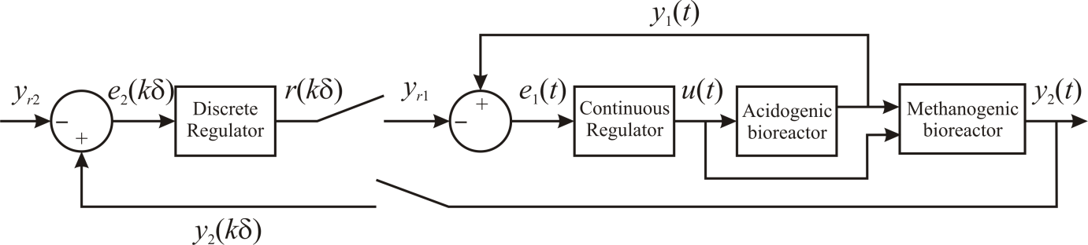

**Figure 1.** Hybrid cascade control algorithm.

concentration of the methanogenic bioreactor around the reference , the outer loop periodically calculates the reference  using a discrete measurement with sampling time , i.e. , with , and  To avoid the VFA accumulation, the reference calculated in the outer loop has an upper limit, .

The mathematical structure of controller is [see García-Sandoval, 2009]

**Inner loop:**

|  |  |
| --- | --- |
|  | (4) |

where matrices  and  are such that  and  are Hurwitz, with





and



Function , which saturates the input to guarantee that , confers the nonlinearity of the inner loop.

**Outer loop:**

|  |  |
| --- | --- |
|  | (5) |

The scalar  is such that  is Schur, where , , ,



and



The nonlinearity of the outer loop is due to function  which saturates the calculated VFA reference in order to guarantee that .

*2.3 Experimental set-up*

*2.3.1 Two-stage AD Process*

The flowchart of the lab-scale two-stage AD process used in the treatment of Tequila vinasses is depicted in Figure 2. As seen, the two-stage anaerobic system consists of two tanks, called the feeding (5L) and neutralization (4L) tanks, plus the acidogenic (4.5L) and methanogenic (8.7L) bioreactors; all of them made of polyvinyl chloride (PVC). The feeding tank is used to induce load disturbances to the process by mixing tap water with raw vinasses as well as for regulating the vinasses pH by means of an on-off controller that feed a 1N NaOH solution using a remotely controlled peristaltic pump. It is important to remark that both acidogenic and methanogenic bioreactors are up-flow FBR-type, where the support used consists of PVC tubes with an inner cross shaped plates that increase the surface area available for biofilm attachment. The two-stage digester was fully instrumented and automated, allowing the on-line monitoring of pH, temperature, conductivity, pressure and the biogas and wastewater flow rates. A National Instruments cRIO9014© device equipped with analogical and digital cards was used in the acquisition, treatment and storage of the data. A graphical interphase as well as the proposed controller were developed and implemented by using the LabVIEW© 8.2 software, respectively.

*2.3.2 Controller implementation*

In order to implement the proposed control scheme, conductivity measurements are used to estimate on-line and continuously the VFA concentration at the acidogenic bioreactor (Aceves-Lara et al., 2012), while the COD was determined by the closed reflux colorimetric method by using the HACH digester DBR200 and the spectrophotometer DR2800.

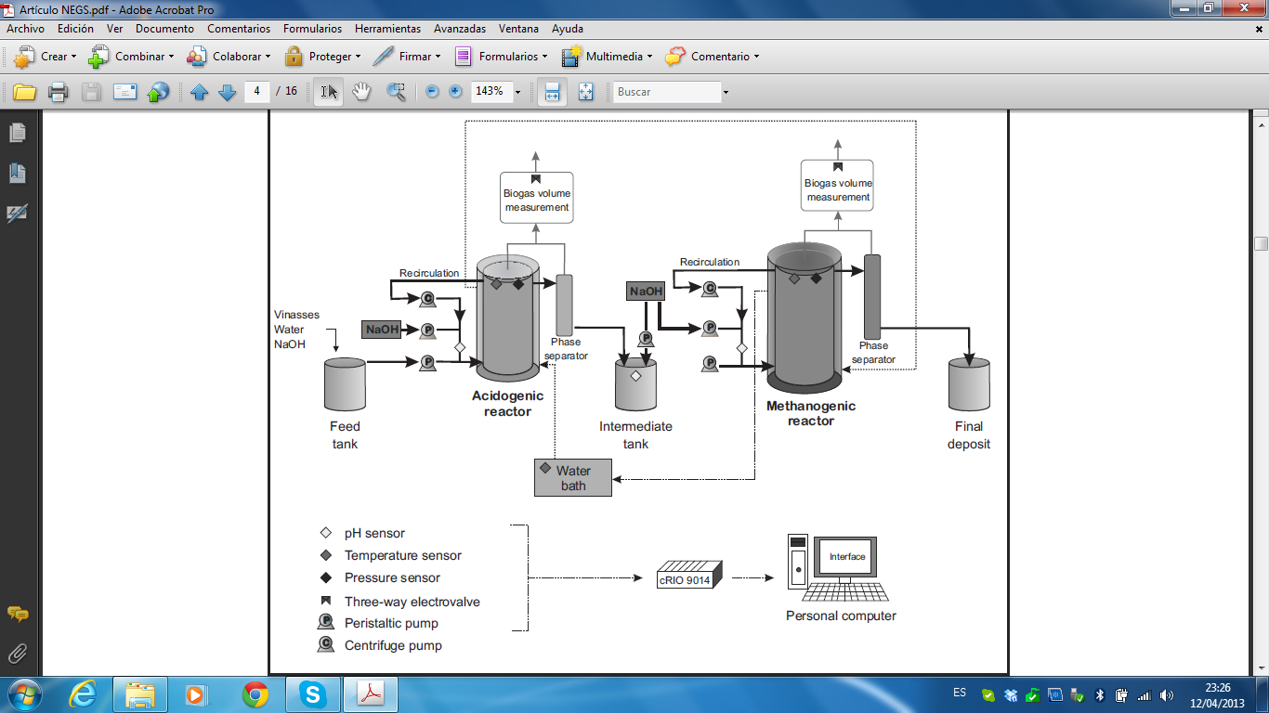

**Figure 2.** Flowchart of the lab-scale two-stage AD process used in the treatment of Tequila vinasses.

Thus, the outer control loop was implemented by using a sampling rate of 1 day and a sampling processing delay of 5 h, which is the time needed to determine the COD concentration of the sample by the HACH methodology. It is important to remark that the COD determined during the experiments corresponds to the soluble COD because: (a) most of the COD present in Tequila vinasses is soluble and (b) a possible contribution of washed out biomass in the COD measurement is eliminated.

The numerical values for the matrices of controller (4)-(5) used during the experimental run were computed with the parameter nominal values reported by [Robles-Rodríguez et. al, 2013] and shown in Table 1. While a nominal value for the total COD concentration of  and influent concentrations of COD and VFA  and , were also considered.

The proposed control scheme was tested during 35 days in the previously described two-stage AD process used for the treatment of Tequila vinasses. The inlet flow rate was used as manipulated variable *Q*in = *DjVj*, where *Vj* and *Dj* for *j* = 1, 2 are the volume and the dilution rate of the acidogenic and methanogenic bioreactors, respectively. Remotely controllable peristaltic pumps were connected to the dilution and neutralization tanks to ensure the desired influent flow rate to each bioreactor, which was constrained in order to avoid undesired effects such as the washout phenomena and the bioreactor emptying**,** i.e., 0.05 < *D*1(d-1) < 1 and 0.025 < *D*2(d-1) < 0.5.

**Table 1.** Nominal values of parameters for the two-stage AD model described in equations (1) and (2).

|  |  |  |  |  |  |
| --- | --- | --- | --- | --- | --- |
| Acidogenic bioreactor | | | Methanogenic bioreactor | | |
| Parameter | Value | Units | Parameter | Value | Units |
|  | 0.27 |  |  | 0.5 |  |
|  | 24 |  |  | 3.5 |  |
|  | 0.13 |  |  | 0.29 |  |
|  | 3.5 |  |  | 16 |  |
|  |  |  |  | 27 |  |
|  |  |  |  | 0.38 |  |
|  |  |  |  | 0.9 |  |

**3 *Results***

The dynamic response of the effluent total COD concentration, the effluent VFA concentration in the acidogenic bioreactor and the dilution rate for the acidogenic bioreactor under the influence of the hybrid cascade control are depicted in Figures 3, 4 and 5, respectively. Initially, the influent total COD concentration was  and the first 5 days of the experimental run the process was operated at open loop with a constant dilution rate of  which induced a steady state around  and . Then, at  the loop was closed with a reference of  for the total COD in the methanogenic reactor. As seen in Figure 4, the outer loop immediately decreased the VFA reference for the acidogenic bioreactor in order to increase the total COD at the methanogenic bioreactor, and therefore the inner loop increased the dilution rate (see Figure 5). After two days the control variable was saturated from the top during approximately one day producing an overshoot in the COD concentration while the outer loop updated the VFA reference every day. After approximately 7 days, the controller was able to regulate the COD concentration around the predetermined reference; however, the dilution rate and the VFA concentration kept varying due to the inner dynamics related to the sluggish biomasses' growth. Finally, approximately at day 19, the dilution rate and the VFA concentration reached constant values around  and .

On the other hand, since the composition of the tequila vinasses can change drastically from company to company (and even from batch to batch in the same company), an uncertain load disturbance was induced at day 21 by choosing a nominal influent COD concentration 25% higher than the concentration fed to the digester during the first 21 days resulting in an influent COD concentration around. Under this load disturbance, at the first day the outer loop kept the VFA reference constant due to the delayed off-line COD measurement. This load caused an increase in the VFA concentration which the inner loop attenuated by increasing the dilution rate. As a result, during this first day, the effluent COD concentration had an increase up to . Nevertheless, as soon as the outer loop received the measurement, it increased the VFA reference for the inner loop up to the saturation, and as a consequence the dilution rate decreased up to saturation during approximately one day. Finally, after approximately 8 days the cascade controller was able to regulate the effluent total COD concentration around the set-point with a dilution rate of  and a VFA concentration of  in the acidogenic bioreactor. 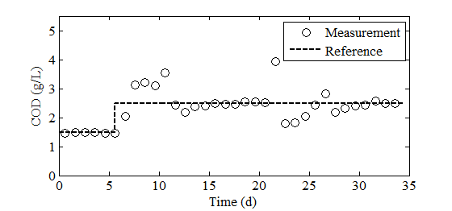

**Figure 3.** Total COD concentration in the methanogenic bioreactor.

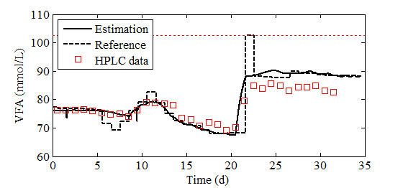

**Figure 4.** VFA concentration in the acidogenic bioreactor.

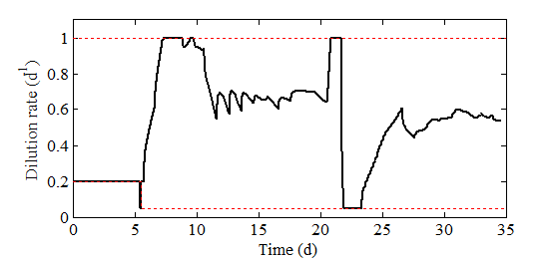

**Figure 5.** Dilution rate for the acidogenic bioreactor.

It is worth noticing that in both cases, changes of set-point and load disturbance, the hybrid cascade controller needed approximately just one and a half times the residence time of the total two-stage system to drive the process close to the desired reference.

As seen in Figure 5, although the inner loop continuously computed the influent flow rate, its variation is quite smooth. This behavior is a desired feature from a practical point of view, in order to guarantee the safe operating conditions and increase the lifetime of the feeding pump. In addition, although the VFA concentration was estimated from conductivity measurements, a daily HPLC analysis was conducted corroborating the reliability of the estimation (see Figure 4). Furthermore, by taking into account the technological and cost restrictions that may be involved for having on-line COD and VFA measurements, the use of the conductivity measurements in order to estimate on-line and continuously the VFA concentration and the use of off-line discrete COD measurements represent a useful, practical and economical approach, while the remarkable performance of the hybrid cascade controller encourage the use of this technology at industrial level.

**4 *Conclusions***

A hybrid cascade control was proposed to regulate the VFA and COD concentrations in a two-stage (acidogenic-methanogenic) anaerobic digestion process and experimentally evaluated in a digester used in the treatment of tequila vinasses. The controller showed a good performance and yielded robustness in the face of parametric uncertainties, load disturbances, and variable set-points by using conductivity measurements in order to estimate on-line and continuously the VFA concentration and off-line discrete COD measurements. The proposed scheme is particularly encouraging to scale it up to industrial applications because: (a) its simple structure is easy to implement, (b) expensive on-line sensors are not required and (c) neither the exact knowledge of the influent composition nor the process kinetics.

***References***

Aceves-Lara C.A., E. Latrille, T. Conte and J.P. Steyer, 2012. Online estimation of VFA, alkalinity and bicarbonate concentrations by electrical conductivity measurement during anaerobic fermentation. Water Science & Technology 65(7): 1281–1289.

Demirel, B., Yenigun, O., 2002. Two-phase anaerobic digestion processes: a review. Journal of Chemical Technology and Biotechnology 77, 743–755.

Demirer, G.N., Chen, S., 2005. Two-phase anaerobic digestion of unscreened dairy manure. Process Biochemistry 40, 3542–3549.

García-Sandoval J.P., 2009. Cascade hybrid control for anaerobic digestion systems, in proceeding of ADCHEM 2009, Turkey.

Jagadabhi, P.S., Kaparaju, P., Rintala, J., 2011. Two-stage anaerobic digestion of tomato, cucumber, common reed and grass silage in leach-bed reactors and upflow anaerobic sludge blanket reactors. Bioresource Technology 102, 4726–4733.

Lopez-Lopez A, Davila-Vazquez G, Leon-Becerril E, Villegas-Garca E, Gallardo-Valdez J. 2010. Tequila vinasses: Generation and full scale treatment processes. Rev Environ Sci Biotechnol 9:109–116.

Méndez-Acosta H.O., R. Snell-Castro, V. Alcaraz-González, V. González-Álvarez, C. Pelayo-Ortiz, 2010. Anaerobic treatment of tequila vinasses in a CSTR-type digester. Biodegras in an up-flow fixed-bed reactor: start-up, operation and restartup. 12th World Congress on Anaerobic Digestion, Guadalajara-Jal, Mex

Robles-Rodríguez C.E., V. Alcaraz-González, J.P. García-Sandoval, V. González-Álvarez and H.O. Méndez-Acosta, 2013. Modelling and parameter estimation of a two-stage anaerobic digestion system for the treatment of tequila vinasses, Proceedings of Anaerobic Digestion congress AD13, Spain (accepted).

Schievano A., G. D’Imporzano, L. Malagutti, E. Fragali, G. Ruboni, F. Adani, 2010. Evaluating inhibition conditions in high-solids anaerobic digestion of organic fraction of municipal solid waste. Bioresource Technology 101, 5728–5732.

von Sachs J., U. Meyer, P. Rys, H. Feitkenhauer, 2003. New approach to control the methanogenic reactor of a two-phase anaerobic digestion system. Water Research 37, 973-982.