SPEED GRADIENT DRIVING OF NEURON SPIKING

Sergey Borisenok
Department of Electrical and Electronics Engineering
Faculty of Engineering
Abdullah Gül University
Kayseri - Turkey
sergey.borisenok@agu.edu.tr

Abstract
Speed gradient method is applied to the model of resonate-and-fire neuron to drive it to the target function of the membrane action potential. The tracking control algorithm is supported by numerical simulations demonstrating its efficiency.
Keywords
Speed gradient, resonate-and-fire neuron

1 Introduction
Biological neurons demonstrate variety of complex dynamical behavior that includes intermittency between resting and bursting at the different time scales [DiLorenzo, Victor, 2013]. In the bursting regime the neuron, stimulating by external electrical currents (signals) coming to its dendrites from the companion neurons and by internal processes of information treating in its own soma, produces in its axon an intensive spike train (ST), or several spikes, or just one. Bursting is a quasi-periodical process, and in reality it represents a chaotic dynamics [Cymbalyuka et al., 2005].
Transitions to spiking and bursting regimes has been experimentally studied for different types of cells: pyloric dilator [Abbott et al., 1991] and lateral pyloric [Elson et al., 1999], midbrain dopaminergic [Drion et al., 2010], striatal and pallidal [Jaeger, 2003], pyra-midal neurons [Lewis et al., 2007; Meisel et al., 2015]. The methods for practical driving of a neuron cover wide range: they include, for instance, not only electrical microstimulators [Tehovnik et al., 2006], but optogenetic manipulation [Cardin et al, 2009] and the interface between a single neuron and carbon nanotube [Sucapane et al., 2008; Yu et al., 2012].
Networks with spiking neurons play an important role in many applications of pattern recognition [Awadalla, Sadek, 2012] and computational neuroscience [Bower, 2013]. Variety of the applications causes the development of efficient control algorithms to drive different dynamical regimes of spiking neurons.
Majority of control algorithms applied to neuronal models designs spike trains with the fixed shapes of the spikes, but with the variation over the inter-spike intervals and the number of pulses in the train. Optimal control scheme was performed in [Ahmadian, et al., 2011], where the control current I, consisted of the sequence of rectangular pulses, was limited in its amplitude. Alternative analysis (for a simplified 1d-reduced model) was given in [Nabi, Moehlis, 2012]. Adapted inverse control with delay was developed in [Li et al., 2013]. Also we should mention the Spike Response Model [Jolivet et al., 2003] that predicts STs in-vivo. Spike synchronization across neurons was discussed in [Brody, Hopfield, 2003].
Linear response with fluctuations [Fourcaud-Trocme et al., 2003] used feedforward noisy input with a small harmonic component. The similar combination of open-loop designed pulses with the small noise applied to HH52 model has been studied in [Danzl, Moehlis, 2008].
The set of open-loop control signals has been reviewed in [Izhikevich, 2000]; the corresponding detailed stability analysis one can find in [Haddad et al., 2014] for a single neuron, and for dynamical networks of several neuron see [Schultheiss et al., 2011].
Feedback methods used experimentally for stimuli-tion of non-monotonic firing response [Lewis et al., 2007].
In our paper we use the external electrical currentas a control parameter to drive the dynamics of the single neuron with the smooth tracking function. To calculate the shape of driving current we use feedback algorithm based on the speed gradient observer. The sufficient novelty of our approach is the ability to design an arbitrary chosen regime, covering single spike, ST, irregular bursting, where the spikes in the trains and bursts may have time-varying amplitudes.
In Section 2 of the paper we present a short description of differential models, with a special impact on the resonate-and-fire neuron driven by the stimulating electrical current. In Section 3we use this current as the control signal to track the action potential with speed gradient algorithm. Section 4 is devoted to numerical simulations, while Section 5 contains the conclusion and discussion part.
2 Mathematical Models for Spiking Neurons

2.1 Differential Models
The most adequate ODE model for a single neuron was derived phenomenologically by Hodgkin and Huxley in [Hodgkin, Huxley, 1952], the 1963 Nobel Prize in Physiology and Medicine (HH52 model). Later the class of planar (2-dimensional) hybrid spiking (HS) models has been developed. The most famous among this family is Fitz-Hugh-Nagumo (FN) model [FitzHugh, 1955; Nagumo et al., 1962] modified later by Izhikevich [Izhikevich, 2001; Izhikevich, 2003] and others [Touboul,Brette, 2009; Visser, Van Gils, 2014; Marzantowicz, Signerska, 2015].Non-smooth variant of HS is discussed in [Coombes et al.,2012].
HH52 contains four independent variables: one stands for the action potential producing spikes, and three for the probabilities of the membrane ion gates to be open or closed. Being 4-dimentional, this model covers the resting-and-bursting intermittency, but it is too sophis-ticated for regular studies and simulations and demands for the further development of the theory of super-chaotic systems in 4d.
The planar HS family (one variable for the action potential and one for all membrane ion channels) is much more simple and convenient for practical modeling, but it has a sufficient handicap: from the theory of nonlinear dynamics we know that an intermittent regime does not exist in a 2d model with the continuous time.
Nevertheless, in HH52 and HS models both we get an extra parameter, the electrical current stimulating the membrane that is taken usually to be a constant or a simple step-type function. The review of bursting properties in HS models one can find in [Raesi, 2012].
Interesting and perspective development of the planar model can be represented as its extension into the complex domain. The natural object of such modeling is so-called ‘quantum neuron’, that is able to demonstrate non-classical properties due to the tunneling in ion channels (this idea has been pronounced as early as in 1990! [Donald, 1990]) or synaptic quantum tunneling of transmitters [Beck, 2008]. There are some phenomenological qubit-based models for quantum spiking of neurons as well [Borisenok, 2013].

2.2 Resonate-and-Fire Neuron
We use here the dimensionless form of the planar model for the resonate-and-fire neuron described in details in [Izhikevich, 2001] and based on the separation of fast and slow variables.

(1)

Here the pair of v and w is a dimensionless super-position of two other variables, one for the action potential, another for the tunneling ions through ion channels (we remind that in the more realistic model this dynamical parameter w is 3-dimensional), while ε is a small dimensionless positive constant. The fast parameter v calls for on/off of the spiking regime, while w represents the slow dynamics of the system. The electrical current I, stimulating neuron spiking, plays a role of control signal.
The function f(v) usually is taken in a polynomial form. In this caseit must be at least a cubic to satisfy the conditions for the existence of a unique limit cycle (Poincaré-Bendixson theorem [Teschl, 2012]), which isresponsible for the transition between spiking and resting.
In the model (1) there is a threshold for the constant current [Tonnelier, 2005]: below the curtain level control signal I does not produce spiking. This model has or has no reset property, depending on the choice of the function f. But because our dynamical system is forced to track the target action potential, the reset condition does not influence our algorithm.
The model (1) allows also a spatial extension:

(2)

where A, B are constants. Eq.(2) has a traveling wave solution for the spike propagating along the axon in the x-coordinate direction.
An important particular case of HS family is FN mo-del [FitzHugh, 1955; Nagumo et al., 1962], where:

(3)

with a positive constant a.

3 Speed Gradient Algorithm
Speed gradient algorithm is based on the definition of the scalar target function (observer) [Fradkov, Pogromsky, 1998; Fradkov, 2007]:

(4)

The goal of feedback control is achieved when the target function G tends to zero. The specific target (4) observing the goal membrane potential v* as a time-dependent function is called tracking.
Let’s take the time derivative of (4):

. (5)
The algorithm defines the feedback control in the gradient form in the space of control signal. In our case it is reduced to the single partial derivative due to 1-dimensional character of the driving current I:

. (6)

Hereγ is a positive constant. By (4) and (6) we get:

(7)

The substitution (7) into (1) finalizes our model as:

(8)

Remarkably the small parameter ε in (8a) forms a natural scale for the ODE terms. The second term (control) in RHS(8a) is the leading one, and this effect is even more supported by increasing the control constant γ.

4 Numerical Simulation
For numerical simulation we take FN model as the set (1) and (4).
The target action potential for tracking is chosen in the form:

; (9)

(a type of bursting behavior). The result of speed gradient control (7)-(8) is plotted on Fig.1.

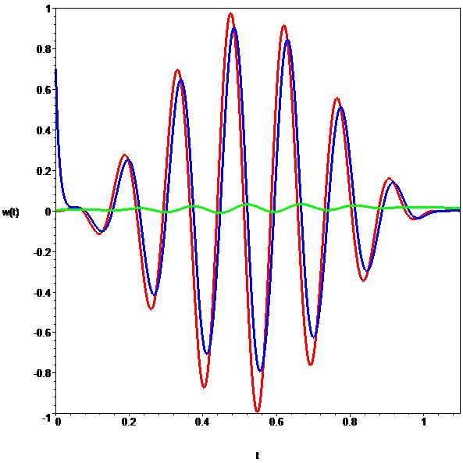

Figure 1.Time dynamics of the target signal v*(t) (red), the driven action potential v(t) (blue) and the slow variablew(t) (green).

The numerical values of the system parameters and the initial conditions on Fig.1 correspond to: ε = 0.1; a = 0.3; γ = 1, and v(0) = 0.7; w(0) = 0.
Sure, the tracking in the model is not perfect, and its error is maximal around the points of extrema of the target function (9). The dynamics of speed gradient driven neuron becomes quasi-periodic, as one can see with the projection of the phase trajectory on the plane [v,w] (Fig.2).

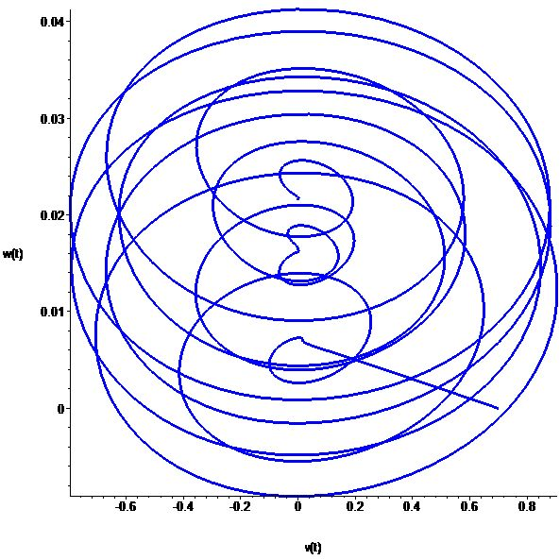

Figure 2. Projection of the phase trajectory
on the plane [v,w],the time interval is [0, 2.1].

5 Conclusions
Speed gradient can be a simple but in the same time effective algorithm to drive the membrane action potential in a planar neuron model with stimulating electrical current. Taking the control signal as a dyna-mical dissipative force (8) around the target manifold, it does not demand a high-power pumping of energy into the system.
The approach developed above can be extended for other classes of models: multidimensional differential model for a single neuron (like HH52) or quantum neuron. It maybe also re-formulated for dynamics of neural populations.

References
Abbott, L. F., Marder, E., Hooper, S. I. (1991)
Oscillating Networks: Control of Burst Duration by Electrically Coupled Neurons. Neural Computation, 3, pp. 487-497.
Ahmadian, Y., Packer, A. M., Yuste, R., Paninski, L. (2011)
Designing Optimal Stimuli to Control Neuronal Spike Timing. J. Neurophysiol., 106 (2), pp. 1038-1053.
Awadalla M. H. A., M. Sadek, M. A. (2012)
Spiking Neural Network-based Control Chart Pattern Recognition.Alexandria Engineering Journal, 51, pp. 27-35.
Beck, F. (2008)
Synaptic Quantum Tunnelling in Brain Activity. NeuroQuantology, 2, pp. 140-151.
Borisenok, S. (2013)
Quantum Statistical Approach to Brain Dynamics. 6-th World Conference on 21st Century Mathematics, Lahore,Abdus Salam School of Mathematical Sciences, pp. 10-11.
Bower, James M (Ed.) (2013)
20 Years of Computational Neuroscience. Springer Series in Computational Neuroscience.
Brody, C. D., Hopfield, J. J. (2003)
Simple Networks for Spike-Timing-Based Compu-tation, with Application to Olfactory Processing. Neuron, 37, pp. 843-852.
Cardin, J. A., Carlen, M., Meletis, K., Knoblich, U., Zhang, F., Deisseroth, K.,Tsai, L.-H., Moore, C. I. (2009)
Driving Fast-Spiking Cells Induces Gamma Rhythm and Controls Sensory Responses. Nature, 459, pp. 663-668.
Coombes, S., Thul, R., Wedgwood, K. (2012)
Nonsmooth Dynamics in Spiking Neuron Models. Physica D: Nonlinear Phenomena, 241, pp. 2042-2057.
Cymbalyuka, G. S., Calabrese, R. L., Shilnikov, A. L. (2005)
How a Neuron Model Can Demonstrate Co-existence of Tonic Spiking and Bursting. Neurocomputing, 6566, p. 869875.
Danzl, P., Moehlis, J. (2008)
Spike Timing Control of Oscillatory Neuron Models Using Impulsive and Quasi-Impulsive Charge-Balanced Inputs. 2008 American Control Conference, Seattle, Washington, USA, pp. 171-176.
DiLorenzo, P. M., Victor, J. D. (Eds.) (2013)
Spike Timing: Mechanisms and Function. CRC Press.
Donald, M. J. (1990)
Quantum Theory and the Brain. Proc. Roy. Soc. Lond. A, 427, pp. 43-93.
Drion, G., Bonjean, M.,Waroux, O., Scuvee-Moreau, J., Liegeois, J.-F., Sejnowski, T. J., Sepulchre, R., Seutin, V. (2010)
M-type Channels Selectively Control Bursting in Rat Dopaminergic Neurons. European Journal of Neuroscience, 31, pp. 827-835.
Elson, R. C., Huerta, R., Abarbanel, H. D. I., Rabinovich, M. I., Selverston, A. (1999)
Dynamic Control of Irregular Bursting in an Identified Neuron of an Oscillatory Circuit. J. Neu-rophysiol., 82(1), pp.115-122.
Fourcaud-Trocme, N., Hansel, D., van Vreeswijk, C., Brunel, N. (2003)
How Spike Generation Mechanisms Determine the Neuronal Response to Fluctuating Inputs. The Journal of Neuroscience, 23 (37), pp. 11628-11640.
Fradkov, A. L., Pogromsky, A. Yu. (1998).
Introduction to Control of Oscillations and Chaos. World Scientific.
Fradkov A. L. (2007). Cybernetical Physics: From Control of Chaos to Quantum Control. Springer.
FitzHugh, R. (1955)
Mathematical Models of Threshold Phenomena in the Nerve Membrane. Bull. Math. Biophysics, 17, pp. 257-278.
Haddad, W. M., Hui, Q., Bailey, J. M. (2014)
Human Brain Networks: Spiking Neuron Models, Multistability, Synchronization, Thermodynamics, Maximum Entropy Production, and Anesthetic Cascade Mechanisms. Entropy, 16, pp. 3939-4003.
Hodgkin A. L., Huxley A. А. (1952)
A Quantitative Description of Membrane Current and Its Application to Conduction and Excitation in Nerve. J. Physiol., 117, pp. 500-544.
Izhikevich, E. M. (2000)
Neural Excitability, Spiking and Bursting. Interna-tional Journal of Bifurcation and Chaos, 10 (6), pp. 1171-1266.
Izhikevich, E. M. (2001)
Resonate-and-Fire Neurons. Neural Networks, 14, pp. 883-894.
Izhikevich, E. M. (2003)
Simple Model of Spiking Neurons. IEEE Transac-tions on Neural Networks, 14 (6), pp. 1569-1572.
Jaeger, D. (2003)
The Control of Spiking by Synaptic Input in Striatal and Pallidal Neurons. Advances in Behavioral Bio-logy, 54, pp. 209-216.
Jolivet, R., Lewis, T. J., Gerstner, W. (2003)
The Spike Response Model: A Framework to Predict Neuronal Spike Trains. ICANN/ICONIP 2003, LNCS 2714, pp. 846-853.
Lewis, J. E., Lindner, B., Laliberte, B., Groothuis, S. (2007)
Control of Neuronal Firing by Dynamic Parallel Fiber Feedback: Implications for Electrosensory Reafference Suppression. The Journal of Experi-mental Biology, 210, pp. 4437-4447.
Li, L., Brockmeier, A., Chen, B., Seth, S., Joseph T. Francis, J. T., Sanchez, J. C., Príncipe, J. C. (2013)
Adaptive Inverse Control of Neural Spatiotemporal Spike Patterns with a Reproducing Kernel Hilbert Space (RKHS) Framework. IEEE Transactions on Neural Systems and Rehabilitation Engineering, 21 (4), pp. 532-543.
Marzantowicz,W., Signerska J. (2015)
On the Interspike-Intervals of Periodically-Driven Integrate-and-Fire Models. Journal of Mathematical Analysis and Applications, 423, pp. 456-479.
Meisel, C., Klaus, A., Kuehn, C., Plenz, D. (2015)
Critical Slowing Down Governs the Transitionto Neuron Spiking. PLoS Computational Biology,11 (2), p. 1004097.
Nabi, A., Moehlis, J. (2012)
Time Optimal Control of Spiking Neurons. Journal of Mathematical Biology, 64 (6), pp. 981-1004.
Nagumo J., Arimoto S., Yoshizawa S. (1962)
An Active Pulse Transmission Line Simulating Nerve Axon.Proc. IRE, 50, pp.2061-2070.
Raesi, B. (2012)
Classification of Global Phase Portraits of Morris-Lecar Model for Spiking Neuron. Advanced Studies in Biology, 4 (4), pp. 175-194.
Schultheiss, N. W., Prinz, A. A., Butera, R. J. (2011)

Phase Response Curves in Neuroscience: Theory, Experiment, and Analysis. Springer Science & Busi-ness Media.

Sucapane A., Cellot G., Prato, M., Giugliano, M., Parpura, V., Ballerini, L. (2008)
Interactions between Cultured Neurons and Carbon Nanotubes: a Nanoneuroscience Vignette. Journal of Nanoneuroscience, 1, pp. 1-7.
Tehovnik, E. J., Tolias, A. S., Sultan, F., Slocum, W. M., Logothetis, N. K. (2006)

Direct and Indirect Activation of Cortical Neurons by Electrical Microstimulation. Journal of Neuro-physiology, 96 (2), pp. 512-521.
Teschl, G. (2012). Ordinary Differential Equations and Dynamical Systems. Providence, American Mathematical Society.
Tonnelier, A. (2005)
Categorization of Neural Excitability using Threshold Models. Neural Computation, 17 (7), pp. 1447-1455.
Touboul, J,Brette, R. (2009)

Spiking Dynamics of Bidimensional Integrate-and-Fire Neurons. SIAM J. Appl. Dyn. Syst., 8(4), pp. 1462-1506.
Visser, S., Van Gils, S. A. (2014)
Lumping Izhikevich Neurons. EPJ Nonlinear Bio-medical Physics, 2, p. 6.
Yu, Z., McKnight, T.E., Ericson, M.N., Melechko, A.V., Simpson, M.L., Morrison, B. 3rd. (2012)

Vertically Aligned Carbon Nanofiber as Nano-Neuron Interface for Monitoring Neural Function. Nanomedicine, 8(4), pp. 419-423.

