Design and Manufacturing Relative Humidity Sensor By Photonic Crystal Fibers
Nadia F. Muhammad^{1,2} , Sudad S. Ahmed¹ , Aseel I. Mahmood^{2,*} , Shehab A. Kahdum² , Kais A. M. Al Naimee^{2,3}
¹Physics Department, Collage of Science , University of Baghdad, Baghdad, Iraq
²Laser and Electro-optic Research Center, Ministry of Science and Technology, Baghdad, Iraq
³CNR-Istituto Nazionale di Ottica, INO, Largo E. Fermi 6, 50125, Florence, Italy
*Corresponding author:aseelibrahim208@gmail.com

Abstract
Photonic crystal fiber interferometers have attained great importance in recent times due to the simple fabrication process involved and excellent sensing performance. A photonic crystal fiber interferometer that operates in reflection mode for humidity sensing is presented in this work. The fabrication of the sensor head is therefore simple since it only involves cleaving and splicing. The all-silica nature of the device has the potential for many applications. The photonic crystal fiber interferometer response is observed for a range of humidity values from (35% RH to 90% RH), the position of the interference peaks is found to be shifted to longer wavelength with humidity increasing. In this work, a different length of PCFs are used, and the maximum humidity sensitivity of (5.180 pm / %RH) is achieved with (4.5cm) PCF length. The photonic crystal fiber interferometer has the advantage that it does not require the use of any hygroscopic material.
Key words: Humidity sensors, Optical fiber sensor, Photonic crystal fiber, Interferometer.
Introduction
The first appearance of Photonic Crystal Fibers (PCFs) in 1996[1] is made a remarkable invention over traditional optical fiber. (PCFs) geometry is characterized by a periodic arrangement of air holes running along the entire length of the fiber, centered on a solid or hollow core. (PCFs) could be made of a single material and have several geometric parameters which can be manipulated offering large flexibility of design. Even more, these fibers offer the possibility of light guiding in (PCFs), which is opening new perspectives in fields such as nonlinear fiber optics, fiber lasers, supercontinuum generation, particle guidance, and fiber sensors [2, 3]. Therefore, there is a high interest of the scientific community in employing (PCFs) in all kind of fields. Humidity measurement is required for several applications, like meteorological services, chemical and food processing industry, civil engineering, air-conditioning, horticulture and electronic processing. PCF Humidity sensors offer unique advantages, due to its small size and weight, immunity to electromagnetic interference, corrosion resistance and remote operation. The PCF humidity sensors work with two methods either with hygroscopic material or without hygroscopic material [4]. The importance of PCF Interferometers (PCFI) came from its simple of fabrication process and the excellent sensing performance [5]. There are two main type of PCFI: the reflection-type PCFI which consists of a thump of PCF fusion spliced at the end of a SMF [6] and the transmission – type PCFI which consists of a short length of PCF is fusion spliced between two SMFs and its air holes in the splicing regions were fully collapsed during the fusion splicing process[7]. The important element of PCFI is the whole collapsed region close to the splice point because in the splice regions the holes of the PCF are fully collapsed to allowing the coupling and recombination of PCF core and cladding modes [8]. Relative Humidity (RH) sensor based on a PCFI has been submitted in this paper, have an outstanding property such as it doesn't require any hygroscopic material to measure humidity and the sensor head is made of single material (silica). Therefore, this sensor is suitable for working in harsh and high-temperature environments[9]. For an interferometric type fiber optic RH sensor, the sensing mechanism relies on the perturbation of the light signal phase properties that travelling in the optical fiber introduced by the humidity change. The phase change detection is realized by mixing the signal of interest with a reference signal, then converting the phase difference into wavelength shift or an optical intensity change [10].
Experimental Part
PCFs has a special structure so it’s easy to break and smashed. The procedure of stripping and cleaving single mode fiber and PCF as it follows:
First of all removing the coating of the of PCF by overflow the piece of ESM-PCF in acetone for about 5-8 minute and then removing the polymer coating from it, and left for about an hour to giving time to acetone to evaporate, then removing the sleeve of the SMF and its polymer coating by using the mechanical stripper (JIC-375 Tri-Hole).
Cleaving the PCF and SMF by fiber cleaver (CT-30) from Fujikura company, and cleaning the SMF and PCF by alcohol to remove any solvent or tiny pieces that would be in the ends of PCF or SMF to prevent infiltration inside the holes of PCF, prevent the failure of connect between PCF and SMF, and failure of sensing, then taking a side view picture for SMF and -PCF by microscope to insure that the ends of the fibers had a good cleaving ends. Figure (1) is shown a microscopic picture of cleaved ESM-PCF. The head of humidity sensor made by fusion splicing of the PCF to the SMF by using the electric arc discharge of a conventional arc fusion splicer (FSM-60S from Fujikura company). During the splicing process need to prevent the PCF collapse through surface tension within a microscopic region close to the splice point as shown in figure (2).
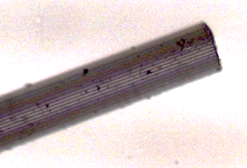

Figure 1 Microscopic image of cleaved PCF.
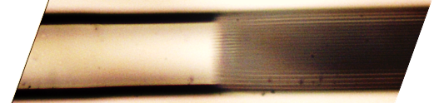

Figure 2 Microscopic picture of splicing region.
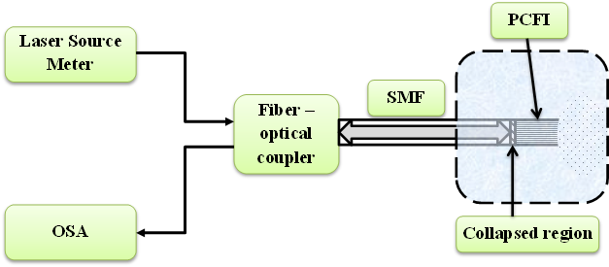
The operating principle of the PCFI is based on the excitation and recombination of modes occurring in the region of the collapsing between SMF and PCF. Because of diffraction of the fundamental SMF mode in the collapsed section mode broadens, allowing excitation of two core modes in the PCF. The modes propagate through the PCF until they reach the cleaved end from where they are reflected. When the reflected modes re-enter the collapsed region they are recombined as in SMF core mode. The range relative humidity is different between (35% - 100%). The setup of the experimental work is shown in figure (3) which allowed for tracking of the shift of the interference peaks with high resolution. The reflection spectrum of the interferometer exhibits a regular interference pattern where the period of the interference pattern is inversely proportional to the length of the PCF section. In this experimental setup, it has been used a alser source with wavelength of 1550 nm connected to optical fiber coupler with three connection, the first terminal connect to the laser source, the second terminal connect to (SMF-PCF) terminal and the third terminal connect to Optical Spectrum Analyzer OSA. The (SMF-PCF) terminal should be put in the humid box and sealed the box then operate the humidity generation and lookout the humidity thermometer and recording the spectra for every change of the relative humidity. When the relative humidity reach to the 100% the door of the box and the two holes should opened to make the humidity decreasing and also the spectra recorded for every decreasing relative humidity. Figure (4) shows the experimental setup of the work.

Figure 3 The principle work of PCFI humidity sensor.
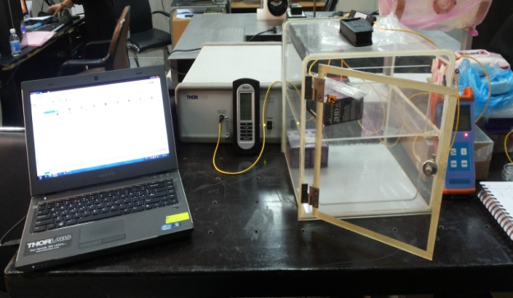

Figure 4 The photographic picture of experimental setup of PCFI humidity sensor.

Result and Discussion
The adsorption of water vapor by PCF’s surface changes the effective refractive index (neff) of the interfering mode of the cladding of the PCF. The adsorption is a reversible process, so according to the ambient humidity values, the modulation of the (neff) occurs which lead to change the position of the interference pattern. The increasing of the humidity is lead to increasing the cladding modes leading to increasing the (neff).The response of the PCFI is observed for a range of humidity values (35%, 40%, 50%, 60%, 70%, 80%, 90%) RH. The position of the interference peak is found shifted within
- The Hysteresis Loop of The Fabricated RH Sensor
A linear up and down input to a sensor, results in an output that lags the input. The transmission of laser should be capable of following the changes of the input parameter regardless of which direction the change is made; hysteresis is the measure of this property. As shown in figure (5).
The shift in wavelength happened because the water molecules has a hydrogen – bonded network (ice – like), which grows up at the relative humidity increases from 0% to 40%. The structure of liquid water is appearing in RH range from 40% to 60%, while the structure of ice-like continues growing to saturation. Above 60% relative humidity, the liquid water configuration grows on top of the ice -like layer. The lower curves present the shift in wavelength with decreasing of RH which caused decreasing the structure of liquid water.
(a)

(b)

(c)

Figure 5 The Hysteresis behavior of the fabricated RH sensor with (a) length of (2 cm), (b) length of (4.5 cm) and (c) length of (12 cm) for humidity rang (35-95)%.
- The Effect of length of The Fabricated RH Sensor
The results of the behavior of the sensor depending on its length in figure (4) is shown a compression between the humidity case and dehumidify case for all lengths of the sensor (2, 4.5, and 12 ) cm. From the above figures it’s clear that the propagation loss of the interfering cladding mode is high the fringe visibility will decreasing on increasing the length of PCF. For a longer device, the fringe spacing will be shorter which limits the measurement range of the device. Decreasing the length of the PCFI to a much shorter length is also not suitable because if the length is less than 0.5 mm the fringe spacing will be greater than 100 nm, therefore not suitable for observing the shift in the interference spectrum. Selecting a shorter length will also result in a reduced sensitivity, but that can be improved by infiltrating the microholes with suitable hygroscopic materials.
- The Sensitivity of The Fabricated RH Sensor
The sensitivity of the sensor is defined as the slope of the output characteristic curve or, more generally, the minimum input of physical parameter that will create a detectable output change. In some sensors, the sensitivity is defined as the input parameter change required producing a standardized output change. Figure (6) is shown the sensitivity of the fabricated sensors in cases of humidity day1. Figures (7) is shown the sensitivity of the fabricated sensors in cases of humidity after chemically and thermally treatment to the fabricated sensors, it is observed that PCFI with length (4.5 cm) shows the higher sensitivity (5.180 RH%/Pm) compared with the other PCFI lengths. For device with less length (2 cm) the sensitivity is less because for smaller length the interaction between the adsorbed water vapor and the cladding mode is smaller and that lead to smaller phase difference between the interfering modes. But for longer device (12 cm) the sensitivity will decreasing too due to the infiltration of water molecules may need long time and the fringe visibility will diminish which lead to increasing the propagation loss of the interfering cladding mode.

Figure 6 The sensitivity of the fabricated RH sensor for humidity rang (35-95)% in day 1.

Figure 7 The sensitivity of the fabricated RH sensor for humidity rang (35-95)% in day 7.
Conclusion
In this work, a reflection type Photonic Crystal Fiber Interferometer (PCFI) is presented without using of any hygroscopic material. The sensor is made by splicing SMF with solid core-PCF. The operating principle of the PCFI - RH sensor is adsorption and desorption of water vapour at the silica-air interface within the PCF capillaries and it shows a good RH sensitivity; maximum sensitivity is (6.180 RH%/Pm) for the samples of PCFI with length (4.5 cm), in the other hand the minimum sensitivity is (2.080 RH%Pm) recorded for the sample with length (12 cm). The PCFI-RH sensor showed a good a reversibility and repeatability. The sensitivity of the PCFI- RH sensor depends on the length of the PCF and for a device with longer length PCF section is more sensitive to relative humidity changes for a specific length and also depends on the splicing region. The designed RH sensor is almost temperature independent.
Reference
- Russell, P. (2008) Photonic Crystal Fibers. Appl. Physics, 299: 358-362
- Bigot, L.; and Roy, P. (2007) Photonic crystal fibers: 10 years of existence and a wide range of applications. Images of physics, 71–80.
- Cerqueira, A. (2010) Recent progress and novel applications of photonic crystal fibers. Reports on Progress in Physics, 73(2), Article ID 024401.
- Pinto, A. and Lopez-Amo, M.( 2012) Photonic Crystal Fibers for Sensing Applications. Journal of Sensors, Article ID 598178.
- Wang, J. and Tang, J. (2012) Photonic Crystal Fiber Mach-Zehnder Interferometer for Refractive Index Sensing. Sensors, 12:2983-2995.
- Wu, Q.; Semenova, Y.; Wang, P. and Farrell, G. (2011) High sensitivity SMS fiber structure based refractometer - analysis and experiment. OPT. LETTERS, 19(9):7937–7944.
- Li, T.; Dong, X.; Chan, C. Ch.; Ni, K.; Zhang, Sh. and Shum, P. P. (2013) Humidity Sensor With a PVA-Coated Photonic Crystal Fiber Interferometer. IEEE Sensors Journal, 13(6).
- Mathew, J.; Semenova, Y.; Rajan, G. and Farrell, G. (2010) Humidity sensor based on photonic crystal fibre interferometer. Electronics Letters, 46(19):1341-1343.
- Kolpakov, S. A.; Gordon, N. T.; Mou, Ch. and Zhou, K. (2014). Toward a New Generation of Photonic Humidity Sensors”, sensors, 14:3986-4013.
- Mathew, J. (2013) Development of Novel Fiber Optic Humidity, Sensor and Their Derived Application. Ph. D Thesis, Dublin Institute of Technology.

