CONTROLLER-ESTIMATOR DESIGN FOR A QUARTER-CAR SUSPENSION SYSTEM UNDER ROAD DISTURBANCES

Ervin Jesus Alvarez-Sanchez, Rosario Aldana-Franco, Andres Lopez-Velazquez
Facultad de Ingeniería Mecánica y Eléctrica, Región Xalapa.
Universidad Veracruzana
México
eralvarez@uv.mx, raldana@uv.mx, andlopez@uv.mx

Abstract
In this article the controller design for a quarter-car suspension system under road perturbations is presented. However, due the lack of exactitude for system parameters values and the necessity of identify the variables measurement an estimator is required. The estimator proposed here is designed using a novel nonlinear technique.

Key words
Modeling, Linear System, Identification, Control System

1 Introduction
Nowadays the safety and passenger’s comfort are the main goal for the automotive industry due the constant change on road conditions and the different kinds of drivers. This new designs for suspension systems are mainly based on maintain the car body in horizontal position without allowing rotations about the mass center even under the effects of the road.
The full suspension system is composed by the front mechanism and rear mechanism, each one with a left subsystem and a right subsystem, usually called quarter-car suspension system. A suspension subsystem should be able to compensate the perturbations induced by road conditions and due the forces produced by the interaction with the other suspension subsystems, in other words, compensate the dynamics induced by the full-car suspension system.
The proposed linear mathematical model in the literature for the quarter-car suspension system represents passive, semi-active or active behavior for typical car suspensions. This model represents the dynamics of tire and car body using springs, dampers, masses and an actuator located between the car body and the wheel. This actuator, allows modify the damping rates (semi-active) or the force applied to car body (active) according to the control objective and the kind of controller used.
Some of the control design approach includes adaptive control [Nugroho et al., 2012], fuzzy control [Ranjbar-Sahraie et al. 2011], optimal control [Paschedag, et al. 2010], sliding mode control [Alvarez, 2013][Ahmed and Taparia, 2013] and skyhook control [Chen, 2009]. However, the requirement of knowledge the parameters values make almost impossible the implementation of the controller designed without a parameter identification [Zarringhalam et al., 2012 ], even a robust one.
The control scheme presented here is a traditional space state control design using a novel technique that avoid the necessity of know all the parameters system values and the full state vector, resulting in a robust and a feasible control law. The numerical values used for simulations, correspond to a real car system parameter values.

2 System dynamics
The figure 1 shows the quarter-car suspension system used to obtain a mathematical model that allows design a controller capable to fulfill the control objective: passengers comfort. The subscript “s” is for the sprung elements, the subscript “u” represents the unsprung subsystem while the subscript “t” refers to tire.

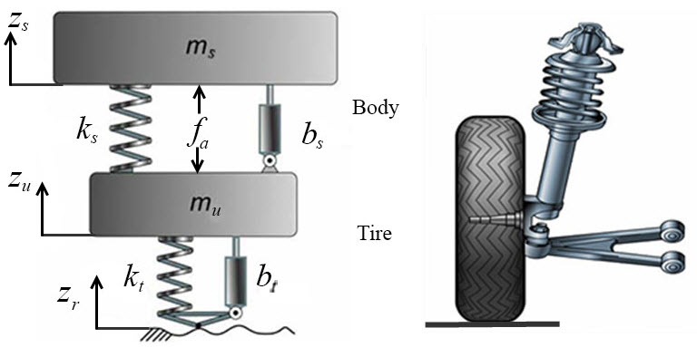
Figure 1. Quarter-Car Suspension System

2.1 Mathematical Model
According to Newton methodology, the equations that describe the system dynamics are

$m_{s}{\ddot{z}}_{s}=-b_{s}\left({\dot{z}}_{s}-{\dot{z}}_{u}\right)-k_{s}\left(z_{s}-z_{u}\right)+f_{a}$ (1)
${m_{u}\ddot{z}}_{u}=b_{s}\left({\dot{z}}_{s}-{\dot{z}}_{u}\right)+k_{s}\left(z_{s}-z_{u}\right)-f_{a}+b_{t}\left({\dot{z}}_{r}-{\dot{z}}_{u}\right)+k_{t}\left(z_{r}-z_{u}\right)$ (2)

where $m_{s} and m_{u}$ denotes the mass of the sprung and unsprung elements, respectively. While $b_{s}, b_{t}, k_{s} {and k}_{t}$are the damping rate and stiffness of the car body (sprung mass) and tire, respectively. The linear actuator is represented by means of $f_{a}$ and the term $z_{r}$ denote the road perturbations.
2.2 Space State System
Using $z_{1}=z_{s}, z_{2}={\dot{z}}_{s}, z_{3}=z_{u}, z_{4}={\dot{z}}_{u}$ (1) and (2) can be rewritten in the next state space form

$${\dot{z}}_{1}=z_{2} \\ {\dot{z}}_{2}=\frac{1}{m_{s}}\left[-b_{s}\left(z_{2}-z_{4}\right)-k_{s}\left(z_{1}-z_{3}\right)\right]+\frac{1}{m_{s}}f_{a}$$${\dot{z}}_{3}=z_{4}$ (3)
$${\dot{z}}_{4}=\frac{1}{m_{u}}\left[b_{s}\left(z_{2}-z_{4}\right)+k_{s}\left(z_{1}-z_{3}\right)-f_{a}\right. \\ \left.+b_{t}\left({\dot{z}}_{r}-z_{4}\right)+k_{t}\left(z_{r}-z_{3}\right)\right]$$

The first two expressions of (3) describe the car body dynamics, which is the variable of interest to control. Using the second equation of (3), a new equation in the form of a perturbed one can be expressed as

${\dot{z}}_{2}+\frac{b_{s}}{m_{s}}z_{2}+\frac{k_{s}}{m_{s}}z_{1}=\frac{1}{m_{s}}\left(b_{s}z_{4}+k_{s}z_{3}\right)+\frac{1}{m_{s}}f_{a}$ (4)

This last equation can be used to design the controller that fulfills the comfort objective.

3 Controller – Estimator Design
In order to fulfill the control objective, $z_{1}→z_{d}$. The desired value for the sprung mass, $z_{d}$, is given by

$$z_{d}=Asin\left(ωt\right)$$

where $ω$ is the frequency required for comfort purposes. This frequency needs to be selected according to [Guglielmino et. Al, 2008] in the range of 0.75 Hz and 4 Hz in order to avoid nausea, vertigo, fatigue and even column damage.
Using (4) is easy to design the next controller that cancels the undesired dynamics and impose a new one

$f_{a}=m_{s}\left[-\frac{1}{m_{s}}\left(b_{s}z_{4}+k_{s}z_{3}\right)+\frac{b_{s}}{m_{s}}z_{2}+\frac{k_{s}}{m_{s}}z_{1}\right]$
$+m_{s}\left[{-k}_{d}\left(z_{2}-z_{2d}\right)-k_{p}\left(z_{1}-z_{1d}\right)-{\dot{z}}_{2d}\right]$ (5)

where $k_{d}$ and $k_{p}$ are positive constants.

Substituting (4) in (5) the closed loop system is obtained, in function of $z_{1}$, as

$\left({\ddot{z}}_{1}-{\ddot{z}}_{1d}\right)+k_{d}\left({\dot{z}}_{1}-{\dot{z}}_{1d}\right)+k_{p}\left(z_{1}-z_{1d}\right)=0$ (6)

However, the controller (5) needs to know the dynamics of the unsprung mass and all the parameters of the entire system, which is the disadvantage of this kind of control design.

3.1 Estimator design
The subsystem composed by the first two equations of (3) can be rewritten as

$${\dot{z}}_{1}=z_{2}$$${\dot{z}}_{2}=∅\left(∙\right)+\frac{1}{m_{s}}f_{a}$ (7)

where

$$∅\left(∙\right)=\frac{1}{m_{s}}\left[-b_{s}\left(z_{2}-z_{4}\right)-k_{s}\left(z_{1}-z_{3}\right)\right]$$

represents the dynamics to be estimated.
According to[Rosas and Alvarez, 2011] an observer-estimator for (7) is given by

$$\dot{{ \hat{z}}_{1}}=c_{1}\left({z_{1}-\hat{z}}_{1}\right)+w_{1} \\ {\dot{w}}_{1}=c_{2}\left({z_{1}-\hat{z}}_{1}\right)+c_{3}sign\left({z_{1}-\hat{z}}_{1}\right)$$${\dot{\hat{z}}}_{2}=c_{4}\left({w_{1}-\hat{z}}_{2}\right)+w_{2}+\frac{1}{m_{s}}f_{a}$ (8)
$${\dot{w}}_{2}=c_{5}\left({w_{1}-\hat{z}}_{2}\right)+c_{6}sign\left({w_{1}-\hat{z}}_{2}\right)$$

where $c_{1}, c_{2}, c_{3},c_{4}, c_{5}$ and $c_{6}$ are positive constants such that assures an origin exponentially stable [Rosas, Alvarez and Fridman, 2007], obtaining

$${\dot{\hat{z}}}_{1}→z_{1} \\ w_{1}→z_{2}$$${\dot{\hat{z}}}_{2}→z_{2}$ (9)
$$w_{2}→∅\left(∙\right)$$

Using (9) the controller (5) can be rewritten as

$f_{a}=m_{s}\left(-w_{2}-k_{d}e_{2}-k_{p}e_{1}-{\ddot{z}}_{1d}\right)$ (10)

where
$$e_{1}=z_{1}-z_{1d} \\ e_{2}={\hat{z}}_{2}-{\dot{z}}_{1d}$$

Substituting the controller (10) in (7) the closed loop system obtained is

${\ddot{e}}_{1}+k_{d}{\dot{e}}_{1}+k_{p}e_{1}=0$ (11)

which is a stable equation that converges to zero according the values of $k_{d}$ and $k_{p}$.

4 Simulation Results
The system parameters used for simulations correspond approximately to the real values for a quarter-car Honda Civic 2005 property to one of paper's authors. These values are listened in table 1.

Table 1. Quarter-car Honda Civic 2005 parameters
Parameter | Value | Units
Sprung mass (m_{s}) | 315 | Kg
Unsprung mass (m_{u}) | 51 | Kg
Spring stiffness (k_{s}) | 43.3 | KN/m
Damping constant (b_{s}) | 3.9 | KN•s/m
Tire stiffness (k_{t}) | 210 | KN/m
Tire damping (b_{t}) | 1.1 | KN•s/m
Distance floor to tire center | 0.311 | m
Distance floor to car body center of mass | 0.5176 | m

The Observer-Estimator and the control parameters are shown in table 2

Table 2. Observer-Estimator and Control Parameters
Parameter | Value
c₁, c₂, c₃ | 5.5, 1.2, 0.1
c₄, c₅, c₆ | 150, 150, 1055
k_{d}, k_{p} | 110, 22

The simulations results were obtained by means of SIMNON® with a fixed integration step of 1 ms.
The road perturbation profile is shown in figure 2. One can notice three different amplitudes and frequencies acting directly over the tire. The first two signals represents a bumpy road, with 5 cm and 10 cm of deep, and the last signal is a speed reducer of 10 cm of high.
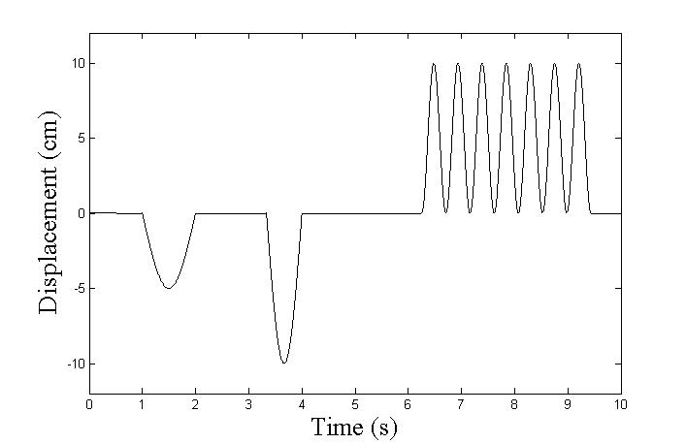
Figure 2. Road perturbations

From real comfort purposes, the desired behavior for body car (sprung mass) is

$$z_{d}=0.1sin\left(0.5t\right)$$

The $ω=0.5$ represents a frequency of $π Hz$, which is between the recommended values. The free displacement (segmented line) versus the controlled displacement (continues line) is shown in figure 3, where the values are displaced the distance from the floor to the car body center of mass.
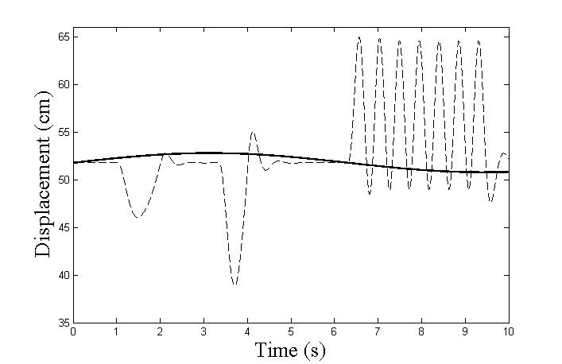
Figure 3. Sprung mass: controlled vs free

The force required to control the sprung mass and avoid the road perturbations is shown in figure 4. Where the effect of the observer-estimator is clear due the high frequency oscillations in the control signal.

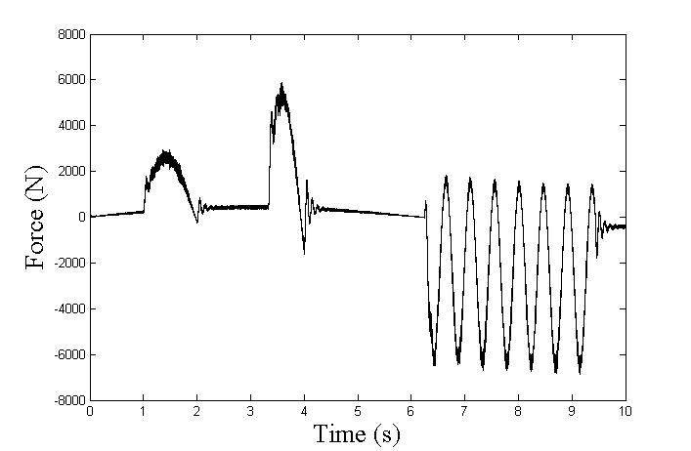
Figure 4. Force control

Figure 5 shows the comparison between the dynamics $∅\left(∙\right)$ and its estimation $ω_{2}$. The continues line represents the real dynamics meanwhile the segmented line the estimated one. Due that the estimated signal is around the real signal, a zoom it is necessary.

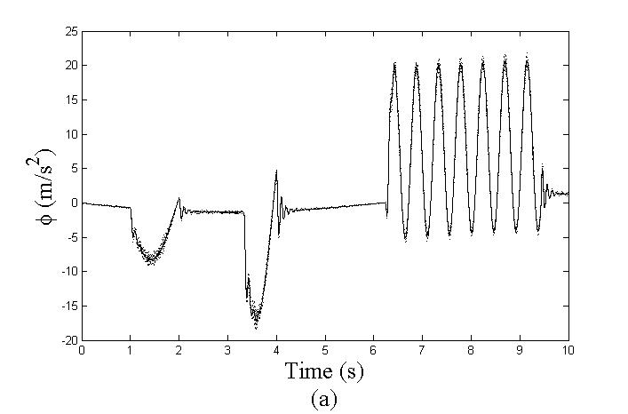
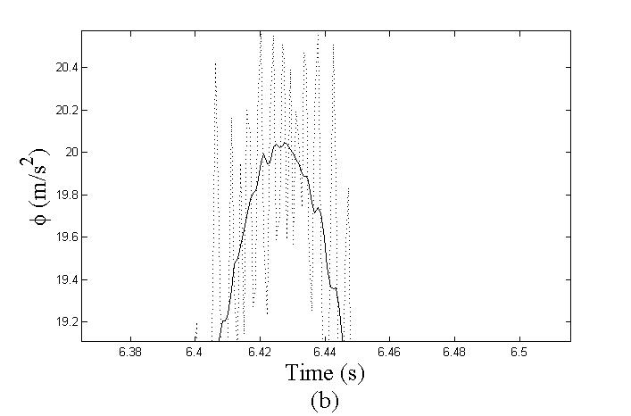
Figure 5. (a) Dynamics $∅\left(∙\right)$ real vs estimated ($ω_{2}$) (b) Zoom of signals $∅\left(∙\right)$ and $ω_{2}$

The tracking error for the sprung mass is shown in figure 6, where one can notice that is in order of millimeters.

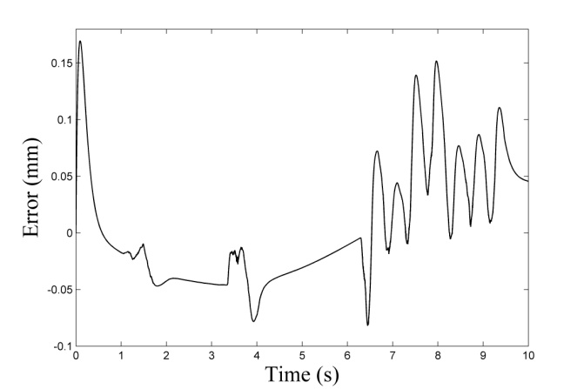
Figure 6. Sprung mass: tracking error

The behavior of the sprung mass (car body) and unsprung mass (tire) induced by the road profile are shown in figure 7, where the distance among the signals represents a real separation for the tire center to the road and the body car mass center to the road.

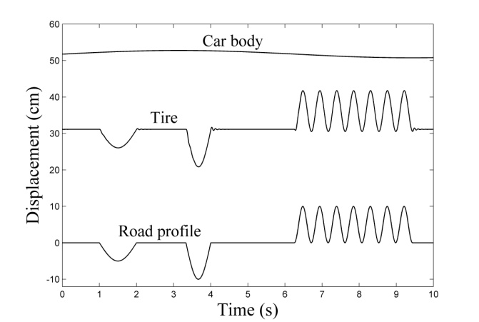
Figure 7. Displacement comparison: road profile, tire and car body

5 Conclusion
The methodology presented in this paper allows have an useful estimator that could be implemented in a testing car in order to demonstrate the effectiveness of the controller designed, this because it is not necessary to know the parameters of the quarter-car, the road profile neither the tire dynamics. Even when the observer-estimator is nonlinear due the use of sign function, the high frequencies are not induced to the car body and the control aim, passengers comfort, is fulfilled. The results obtained motivate to continue to the next step, the control of a half-car.

References
Ahmed A., F. and Taparia R. (2013). Modeling, Analysis and Control of Active Suspension System using Sliding Mode Control and Disturbance Observer. International Journal of Scientific and Research Publications, Vol. 3, No. 1, pp. 1-6, January 2013.
Alvarez-Sanchez, E. (2013). A quarter-car suspension system: car body mass estimator and sliding mode control. The 2013 Iberoamerican Conference on Electronics Engineering and Computer Science. pp. 1-7. April, 2013.
Chen, Y. (2009). Skyhook Surface Sliding Mode Control on Semi-Active Vehicle Suspension System for Ride Comfort Enhancement. Engineering, Vol. 1, No. 1, pp. 23-32.
Guglielmino, E., Sireteanu, T., Stammers, C. W., Ghita, G. and Giuclea, M. (2008). Semi-active Suspension Control. Improve Vehicle Ride and Road Friendliness. Springer.
Nugroho, P. W., Du, H., Li, W. H. & Alici, G. (2012). A new adaptive fuzzy-hybrid control strategy of semi-active suspension with magneto-rheological damper. In Y. Gu & S. Saha (Eds.), 4th International Conference on Computational Methods, pp. 1-9.
Paschedag, T., Giua, A., Seatzu, C. (2010). Constrained optimal control: an application to semiactive suspension systems, Int. Journal of Systems Science, Vol. 41, No. 7, pp. 797-811, July 2010.
Ranjbar-Sahraie, B., Soltani, M. and Roopaie, M. (2011). Control of Active Suspension System: An Interval Type -2 Fuzzy Approach. World Applied Sciences Journal, Vol. 12, No. 12, pp. 2218-2228.
Rosas, D., Alvarez, J. and Fridman, L. (2007). Robust Observation and Identification of nDOF Lagrangian systems. International Journal of Robust and Nonlinear Control, 17, pp. 842-861.
Rosas, D. and Alvarez, J. (2011). Robust Control of Mechanical Systems, Challenges and Paradigms in Applied Robust Control, Prof. Andrzej Bartoszewicz (Ed.)
Zarringhalam, R., Rezaeian, A., Melek, W., Khajepour, A., Chen, S. and Moshchuk, N. (2012). A Comparative Study on Identification of Vehicle Inertial Parameters. 2012 American Control Conference, pp. 3599 – 3604.

