ENOC 2008, Saint Petersburg, Russia, June, 30-July, 4 2008

Using Hybrid Isolation Systems with Friction Dampers for Seismic Protection of Structures

Yuri Ribakov
Department of Civil Engineering
Ariel University Center of Samaria, Israel
rbakov@ariel.ac.il
Gregory Agranovich
Department of Electrical Engineering
Ariel University Center of Samaria, Israel
agr@ariel.ac.il

Abstract
Seismic isolation of structures is one of the most popular ways for design of earthquake resistant buildings. It results in improved structural behavior during earthquakes. However the base isolators’ displacements are rather big. Addition of dampers to base isolators is a common way for reduction of these displacements. Using active or semi-active dampers aimed to achieve optimal structural behavior is also well known. This study id focused on a method for selection of friction dampers properties based on optimal active control algorithms. The aim of the design is to find the passive friction dampers properties so that the seismic response of a base isolated structure with these dampers would be as close as possible to that of a structure with optimally controlled active dampers. Such behavior is achieved if the energy dissipated in passive friction dampers will be equal to that in active dampers. The efficiency of the proposed method is demonstrated in a numerical example. Behavior of a base isolated building with supplemental passive friction dampers designed according to three various strategies is compared. It is shown that the proposed method yields a structural seismic response that is more similar to that if an active control system is used.

Key words
Base isolation, hybrid systems, friction dampers, seismic design

1. Introduction
Base isolation is a well known and widely used technique in seismic design. Addition of isolators results in increased building flexibility and energy absorption. The isolating system absorbs part of the earthquake energy before it is transferred to the structure. The lateral flexibility of the isolators shifts the natural period of the isolated structure and the inertia forces are reduced, the energy dissipated by the structural elements decreases. A wide review on base isolation systems (BIS) was done by Kelly (1986, 1988), Buckle et al. (1990), Al-Hussaini et al. (1994), Naeim and Kelly (1999), Skinner et al, 1993 and others. Two most popular types of BIS are elastomeric bearings and sliding friction pendulums (FP). The shear forces and inter-story drifts in structures with FP base isolators are reduced 4 -6 times, allowing elastic behavior of the upper structure during earthquakes [Al-Hussaini et al., 1994]. Base isolators have proved themselves as effective devices yielding enhanced structural seismic response, but large displacement appear at the base isolation level. In order to decrease these displacements and to yield additional improvement in structural seismic response, dampers are added to base isolators.
Addition of viscous dampers to BIS reduces the base displacement at the expanse of increasing floor accelerations and inter-story drifts [Kelly, 1999]. To overcome it, active and semi-active dampers were used [Reinhorn et al., 1987, Yang et al., 1996, Gluck et al., 2000, Ribakov and Gluck, 2002, He et al., 2003]. Chang et al. (2002) studied the effectiveness of lead-rubber BIS with supplemental friction and viscous dampers. They have found that passive dampers are effective in reducing both displacement and base shear forces.
This paper deals with a method for selection of friction dampers (FD) properties based on an optimal active control algorithm. The aim of the design is to achieve a seismic response of a base isolated building (BIB) with supplemental passive FD that will be as close as possible to that of a building with an active controlled base isolation system.

2. Modeling of artificial earthquake
Generally active control design of structures is based on LQG, H₂, and H∞ algorithms [Antsaklis and Mitchel, 1997, Soong, 1990, Dyke, S.J. et al., 1995]. These algorithms assume that the external excitation is a Gaussian white noise zero mean signal with an assigned intensity. It is a reasonable assumption, because the power spectral density of the possible earthquake is unpredictable. Hence, selection of some special power spectral density may result in design of a control system, which is turned to the assumed excitation, but not effective for other earthquakes. In a case of nonlinear control design, it is not enough to assign white noise intensity. In this case a probability distribution function of a stochastic process or process realization should be assigned. The distribution is required for design and analysis. Simulation-based design methods (like Monte Carlo simulations) require generation of the excitation time histories.
At the first stage of this work an artificial earthquake is generated using an originally developed algorithm. The initial data for this algorithm is: the desired peak ground acceleration (PGA); the desired spectrum bandwidth (BW); and the duration of the earthquake (t_{f}). In order to design the active control system the following parameters were selected: PGA = 0.3g, BW = 10 Hz and t_{f} = 50 s. The selection was based on available data on natural earthquakes. The proposed method and its program realization allow changing the parameters according to the required design conditions. A time history of the generated artificial earthquake for the selected parameters is presented in Figure 1. Figures 2 and 3 show the power spectrum density and the cumulative power spectrum density of the artificial earthquake respectively. These graphs demonstrate how the earthquake realization (Figure 1) is close to the ideal pass bounded white noise. The coefficient of the slope part curve in Figure 3 is the mean value of the white noise intensity.

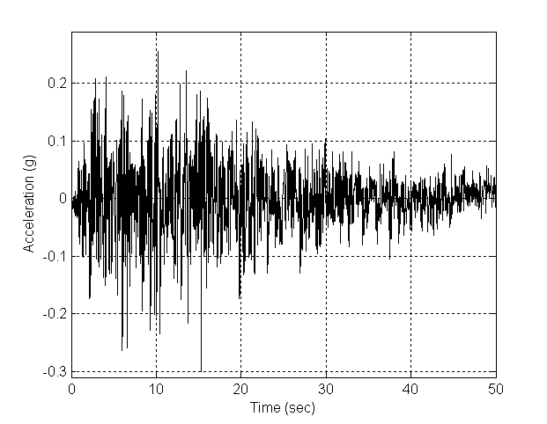
Figure 1. A white noise artificial ground acceleration for PGA = 0.3g, BW= 10 Hz.
3. Calibration of active controlled base isolation system
At the second stage of this work it is assumed that a building has a hybrid base isolation system with active controlled dampers. The building is subjected to the generated white noise ground motion and the control forces in the dampers are calculated according to the LQG algorithm. The dynamic equilibrium equation of a structure is presented in a state-space form (Soong, 1990):
$\overset{˙}{x}(t)=Ax(t)+Bu(kτ)+E{\overset{¨}{x}}_{g}(t)$ (1)

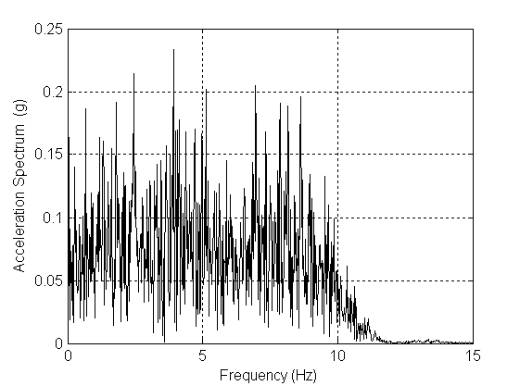
Figure 2. Power spectrum density of the white noise artificial ground acceleration.

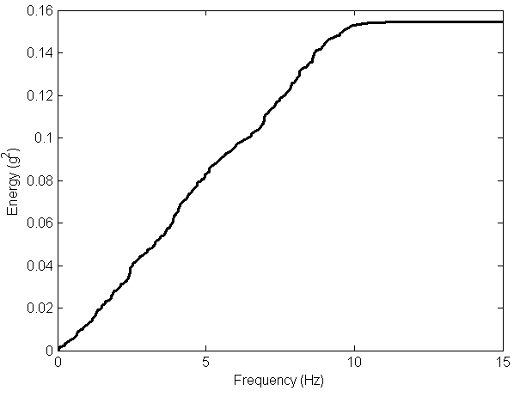
Figure 3. Cumulative power spectrum density of the artificial white noise ground acceleration.

where $x(t)$ is the state space vector of the system’s continuous part; $u(kτ)$ is the control signal vector; τ is the controller’s sampling period; ${\overset{¨}{x}}_{g}(t)$ is the ground acceleration; A is the system matrix; B defines the location of the control forces, $u(kτ)$, and E is the excitation forces location matrix in the state space (Soong, 1990). It is assumed in this study that ${\overset{¨}{x}}_{g}(t)$ is the artificial white noise with prescribed properties. The control forces are applied only at the base isolation level. The control system is realized in a digital form, hence equations (1) are transformed to an equivalent system of finite-differences equations, based on an equivalent transformation [Antsaklis and Mitchel, 1997]:
$x(kτ)=A_{d}x(kτ)+B_{d}u(kτ)+E_{d}{\overset{¨}{x}}_{g}(kτ)$ (2)
$A_{d}=e^{Aτ}, B_{d}=\int_{0}^{τ}{e^{\text{At}}}B \text{dt}, E_{d}=\int_{0}^{τ}{e^{\text{At}}}E \text{dt}$ (3)
According to the LQG approach, applied to a discrete-time system described by Eq. (2) the optimal control forces, $u(kτ)$, should minimize the following infinite horizon performance index:
$J=\underset{T→∞}{\text{lim}} \frac{1}{T}E\left[\sum_{kτ≤T}{y^{T}(kτ)} \text{Qy}(kτ)+u^{T}(kτ)\text{Ru}(kτ)\right]$(4)
where $y(kτ)=Hx(kτ)+Du(kτ)$ (5)
Matrices H and D define the minimized output as a function of the state and the control forces vectors under a seismic excitation. The outputs are: displacement in the BIS, and floors displacements of the building relative to the first floor columns bottom end. An additional assumption is that the optimal feedback is a function of the measurement vector, containing the noised measurements of the floors accelerations
$y_{m}(kτ)=H_{m}x(kτ)+D_{m}u(kτ)+F_{m}{\overset{¨}{x}}_{g}(kτ)+v(kτ)$ (6)
Matrices H_{m}, D_{m} and F_{m} describe the parameters of the measurement subsystem. According to the LQG approach, the ground acceleration ${\overset{¨}{x}}_{g}(kτ)$ and the measurement noise $v(kτ)$ are assumed to be stationary white noises with known intensities. The separation principle [Antsaklis and Mitchel, 1997] allows the control and the estimation problems to be considered separately, yielding a discrete-time dynamic controller. Hence the optimal control law is
$u(kτ)=−G\hat{x}(kτ)$,
$G=(R+D^{T}\text{QD}+B_{d}^{T}\bar{P}B_{d})^{−1}B_{d}^{T}(\bar{P}A_{d}+\text{QH})$ (7)
where $\bar{P}$ is the solution of the Riccati equation
$$A_{d}^{T}\bar{P}A_{d}−\bar{P}− (A_{d}^{T}\bar{P}+H^{T}Q)B_{d}(R+$$
$D^{T}\text{QD}+B_{d}^{T}\bar{P}B_{d})^{−1}B_{d}^{T}(\bar{P}A_{d}+\text{QH})+H^{T}\text{QH}=0$ (8)
A Kalman steady-state estimation of the system state vector is obtained from the filter equation
$$\hat{x}(kτ+τ)=A_{d}\hat{x}(kτ)+B_{d}u(kτ)+$$
$L[y_{m}(kτ)−D_{m}u(kτ)−H_{m}\hat{x}(kτ)]$ (9)
where $\hat{x}(kτ)$ is the optimal estimate of the system’s state vector x(kτ). The filter gain matrix
$L=({\text{SH}}_{m}^{T}+{\text{EQ}}_{m}F_{m}^{T})(R_{m}+{\text{SH}}_{m}^{T})^{−1}$ (10)
$$A_{d}{\text{SA}}_{d}^{T}−S+{\text{EQ}}_{m}E^{T}+({\text{SH}}_{m}^{T}+$$
${\text{EQ}}_{m}F_{m}^{T})(R_{m}+{\text{SH}}_{m}^{T})^{−1}(H_{m}S+F_{m}Q_{m}E^{T})$ (11)
where Q_{m} and R_{m} are the intensity matrices of the ground acceleration, and the measurement noise white-noise approximations. The optimal choice of weighting parameters Q and R in the performance index is performed [Agranovich et al., 2004]. The global performance index W(Q,R) is assigned as
$W_{1}=\text{max}\left\{\underset{t,i}{\text{max}}\frac{\left|d_{i}(t)\right|}{h_{i}}\right\}$,$d_{\text{base}}(t)≤d_{\text{max}}$ (12)
where d_{i}(t) are interstory displacements and d_{base}(t) is the base displacement.

4. Methods for design of equivalent passive friction dampers
4.1. Design aims and criteria
The third stage of this work is aimed to design a hybrid BIS with passive friction dampers (PFD) that would yield structural seismic response close to that of an active controlled BIB. To demonstrate various design methods and to compare their efficiency, a six-story BIB described in a numerical example below was studied. It was assumed that the response of a BIB with LQG controlled active dampers and that with PFD will be close if
- the maximum displacements in the BIS with PFD are close to those with LQG controlled devices;
- the energy dissipated in the PFD is equal to that in active LQG controlled dampers.

4.2. Equivalent energy at maximum dampers displacement
A first method used to obtain the properties of equivalent PFD was based on that proposed by Ribakov and Gluck (1999) for selection of optimal properties of ADAS devices. The idea is that to get equivalent behavior of a structure with two different types of dampers, the hysteretic area at maximum displacement, obtained for one damper, should be equal to that for the other. Figure 4 shows the damping force vs. displacement in an active LQG controlled device under the artificial earthquake. The hysteretic loop at the maximum displacement can be approximated by an ellipse. The horizontal semi-axis, a, is equal to the maximum base displacement, and the vertical semi-axis, b, equals to the equivalent control force, which can be obtained by one of the following ways:
$b={\left\|f_{\text{contr}}(t)\right\|}_{∞}$ (i), $b={\left\|f_{\text{contr}}(t)\right\|}_{1}$ (ii),
$b={\left\|f_{\text{contr}}(t)\right\|}_{2}$ (iii) (13)

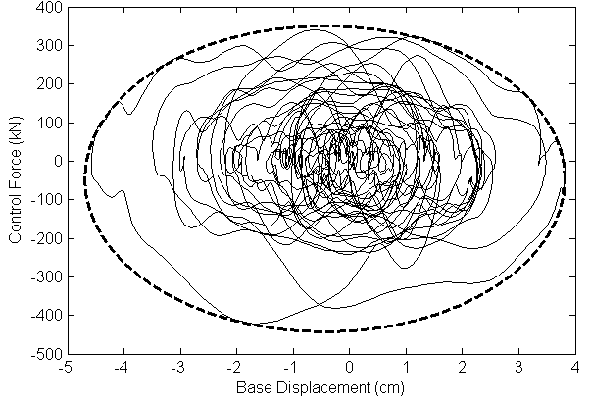
Figure 4. Relation between damping force and displacement in an active LQG controlled damper connected to the BIS(solid line) and approximated dissipated energy (dashed line).

The form of an PFD’s hysteretic loop can be approximated by a rectangle with an area $S_{\text{passive}}=4F_{\text{passive}}a$. The energy dissipated in the active damper, approximated by an ellipse, is $S_{\text{active}}=π a b$. Because the dissipated energy in both dampers has been assumed to be equal,
$F_{\text{passive}}=π b / 4$ (14)
where b is defined by one of the expressions (13). Eq. (14) does not yield a desired outcome for the selected building because non-stationary nature of the base displacement transferred to the damper.
4.3. Simulation-based optimization procedure
A second method for design of PFD that was studied is based on the following optimization procedure. Simulating the response of a BIB with LQG controlled dampers under the artificial earthquake, the dissipated energy is obtained:
$P_{\text{LQG}}=\int_{0}^{t_{f}}{\left|f_{\text{contr}}(t){\overset{˙}{d}}_{\text{base}}(t)\right|\text{dt}}$ (15)
The energy dissipated by the PFD is
$P_{\text{PFD}}=F_{\text{passive}}\int_{0}^{t_{f}}{\left|{\overset{˙}{d}}_{\text{base}}(t)\right|\text{dt}}$ (16)
The next step is to find $F_{\text{passive}}$ that should meet the equivalence conditions. This problem has no solution hence an approximated solution was found using nonlinear programming algorithm. The algorithm was aimed to select the value of$F_{\text{passive}}$, minimizing the performance index $J(F_{\text{passive}})=\left|P_{\text{LQG}}−P_{\text{PFD}}\right|$ under a constraint inequality $\text{max}\left|d_{\text{base}}(t)\right|≤d_{\text{max}}$. The optimal value of $F_{\text{passive}}$was chosen using a numerical procedure, implemented in original MATLAB routines.

5. Numerical Example
5.1. Description of the analyzed building
To realize the proposed method and to demonstrate its effectiveness MATLAB - based optimum search procedures and simulations of structural seismic response were carried out. A typical 6-story steel building [D’Amore, 1995], shown in Figure 5, has been chosen for the analysis. The natural frequencies of the building without BIS are 1.083, 2.92, 4.799, 9.596, 7.93, and 6.478 Hz. An initial damping ratio of 2% was assumed for all vibration modes of the structure without the BIS.
The response of the structure was checked for the following four cases:
- case 1: building without BIS;
- case 2: building with BIS (without dampers);
- case 3: BIB with active LQG controlled dampers added to the BIS;
- case 4: BIB with PFD added to the BIS.

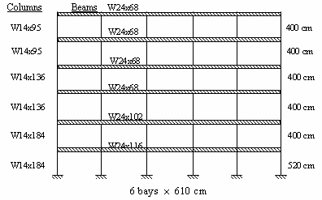
Figure 5. A six-story steel frame (D’Amore, 1995)

The natural frequencies and corresponding damping ratios of the BIB (case 2) are shown in Table 1. The natural frequencies and corresponding damping ratios of the BIB with LQG optimal active control are shown in Table 2. The frequency of the active controlled building’s isolated mode (case 3) was slightly increased and the damping ratio was about 6 times higher, compared to case 2. For the second mode the difference in damping ratio was about 40 %, and for higher modes it was negligible.

Table1. Natural frequencies of the BIB (case 2)
Number | Natural frequency (Hz) | Damping ratio
1  2  3  4  5  6  7 | 0.53  2.4  4.5  6.4  7.9  9.5  41.0 | 0.027  0.016  0.025  0.034  0.041  0.048  0.230

Table 2. Natural frequencies of the BIB (case 3)
Number | Natural frequency (Hz) | Damping ratio
1  2  3  4  5  6  7 | 0.55  2.4  4.5  6.4  7.9  9.5  41 | 0.21  0.023  0.025  0.034  0.041  0.048  0.23

5.2. Structural response to the artificial earthquake and selection of PFD’s properties
Different design strategies described in Eq. (13) and (14), and the simulation-based optimization procedure, presented in chapter 4.3 were used to obtain the desired friction force in the PFD that would yield a structural seismic response similar to that with active controlled one. The resulted values of the design friction forces are shown in Table 3.

Table 3. Design friction forces at the PFD for various strategies (kN)
F ∞ | F ₁ | F ₂ | F _{Optimal}
331 | 68 | 88 | 165

The building’s response with BIS including PFD, designed according to various strategies, was obtained. Figure 6 presents maximum floor displacements in the structure with active controlled BIS and in BIB with supplemental PFD, designed according to three various strategies. Maximum displacements values at the BIS corresponding to these cases are given in Table 4.
Using PFD selected according to the F_{optimal} strategy yield the closest values of floor displacements in the frame, compared to those obtained with active controlled dampers. F_{optimal} design results in most effective reduction of maximum displacements in the BIS. Hence response of the frame with PDF designed according to the F_{optimal} strategy was further investigated.
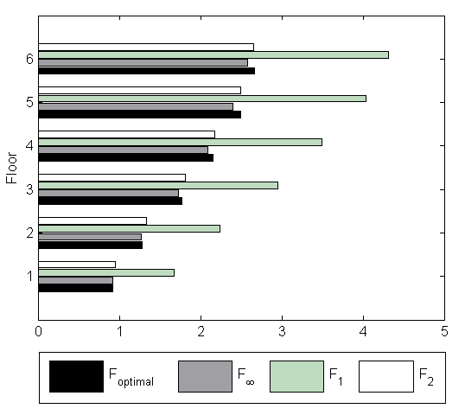

Figure 6. Maximum floors displacements of the building with PFD (cm) relative to the first floor columns bottom end.

Table 4. Maximum displacements at the BIS (cm)
Design strategy | F∞ | F₁ | F₂ | Optimal | LQG
Maximum displacement | 6.0 | 6.3 | 6.1 | 5.3 | 4.6

Figure 7 shows that the maximum floor displacements of the BIB with PFD under the artificial ground motion are close to those of the BIB with active controlled devices. The maximum displacements at the base isolation level for Case 4 are about 1.4 times higher compared to Case 3, but significantly lower relative to Case 2.
Using PFD, designed according to the proposed method, yields a reduction of about 40% in base displacements, compared to Case 2, whereas applying active controlled devices results in a decrease of about 60%. Using the PFD, selected according to the proposed method, (Case 4) yields also a significant reduction in roof displacements, compared to Case 2.

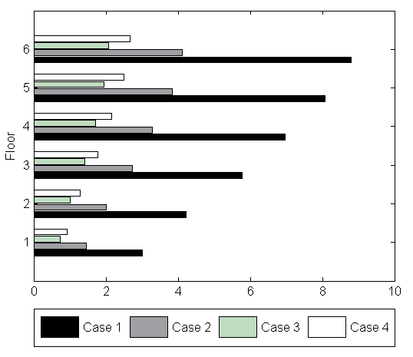

Figure 7. Maximum floors displacements (cm) of the building under the artificial earthquake relative to the first floor columns bottom end.

Table 5. Maximum displacements at the BIS (cm)
Case 2 | Case 3 | Case 4
10.4 | 4.6 | 5.6
5.2. Structural response to natural earthquake records
Seismic response of the structure, designed using the artificial earthquake, was further investigated under the following natural earthquakes: El Centro (1940), Loma Prieta (1989) and Kobe (1995). Maximum floors displacements of the building, relative to the first floor columns bottom end, are shown in Figures 8– 10.

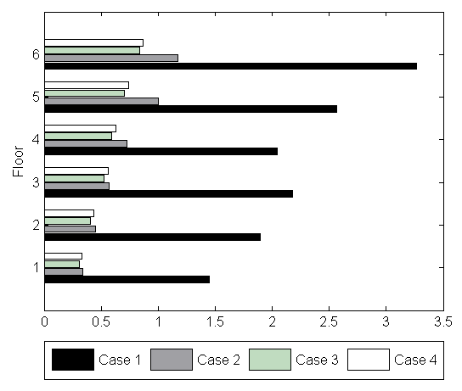

Figure 8. Maximum floors displacements under the Loma Prieta earthquake (cm).

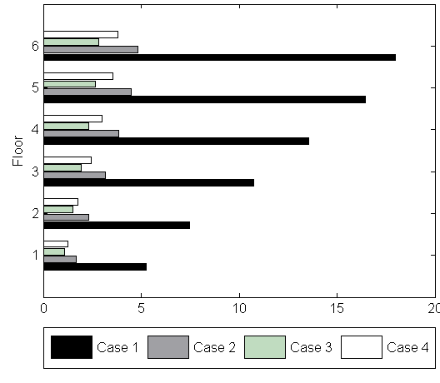
Figure 9. Maximum floors displacements under the El Centro earthquake (cm).

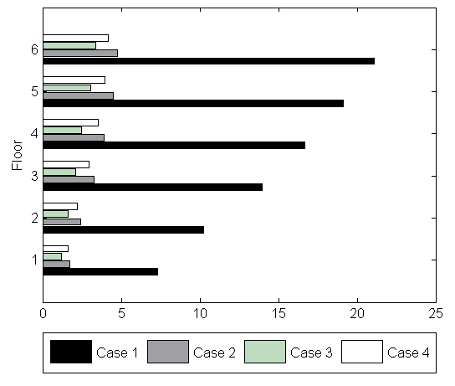

Figure 10. Maximum floors displacements under the Kobe earthquake (cm).

Using BIS yields a reduction in floors maximum displacements of about 60%-70%, compared to the fixed base structure. Addition of dampers allows additional reduction in floors peak displacements without significant change in floors’ accelerations. Peak displacements at the BIS are given in Table 6. Addition of PFD, designed according to the proposed method, yields reduction in BIS displacements (up to 25%). Although the structural response with the PFD (case 4) is worse than that of an active controlled structure (case 3), it is improved, compared to that obtained for a BIS without supplemental dampers (case 2).

Table 6. Maximum displacements at the BIS (cm)
 | Case 2 | Case 3 | Case 4
Loma Prieta | 2.4 | 1.5 | 1.9
El Centro | 12.0 | 6.4 | 8.0
Kobe | 12.4 | 6.8 | 10.2
6. Conclusions
Seismic response of buildings with hybrid BIS, including supplemental PFDs, was studied. A method for selection of PFDs properties based on optimal active control algorithm was proposed. The aim of the design was to find the PFDs properties so that the seismic response of a BIB with these dampers would be close to that of a structure with optimally controlled active damping devices.
The properties of the PFDs were selected using an artificial earthquake with desired PGA, spectrum bandwidth and duration. These parameters were selected based on the data on natural earthquakes. A 6-story building was studied. Three different strategies for selection of PFDs parameters were compared. Response of the frame to the artificial earthquake was studied and a most appropriate strategy was chosen for further investigation of structural behavior under real earthquakes.
Behavior of a BIB with supplemental PFDs, designed according to the selected strategy, under three real earthquakes was obtained. Although the structural response with the PFDs is worse than with active devices, it is improved, compared to a BIB without dampers. Addition of PFDs yields reduction in base displacements up to 25%, compared to the structure with a BIS without supplemental dampers. Maximum values of floors’ displacements in a BIB with PFDs are up to 30% lower, compared to those in a BIB without dampers. No increase in floors’ accelerations was observed.
The proposed method is recommended for design of seismic resistant structures with hybrid BISs, including PFDs. Application of such systems is effective and results in enhanced structural response to earthquakes.

References
Agranovich, G. Ribakov, Y. and Blostotsky, B. (2004). A Numerical Method for Choice of Weighting Matrices in Active Controlled Structures, The Str. Design of Tall and Special Buildings, 13, pp. 55-72.
Al-Hussaini, T., Zayas, V. and Constantinou M. (1994). Seismic Isolation of Multi-Story Frame Structures Using Spherical Sliding Isolation Systems, NCEER 94-0007, Buffalo, NY.
Antsaklis P., Mitchel A. (1997).Linear Systems, McGraw-Hill.
Buckle, L. and R. (1990). Seismic Isolation History, Application and Performance - A World View, Earthquake Spectra, 6, pp. 161-201,
Chang, S., Makris, N., Whittaker, A. and Thompson, A. (2002). Experimental and analytical studies on the performance of hybrid isolation systems, Earthquake Eng. and. Str. Dyn., 1, pp. 421-443,
D’Amore, A. (1995). Seismic Behavior of Six-story Instrumented Building under 1987 and 1994 Northridge Earthquakes, Rep. UCB/CE – Steel 95/03, Univ. of California, Berkeley.
Dyke, S. et al. (1995). Acceleration Feedback Control of MDOF Structures, ASCE, J. of Eng. Mech., 122 (9), pp. 897–971.
Gluck, J., Ribakov, Y. and Dancygier A. (2000). Selective Control of Base Isolated Structures with CS Dampers, Earthquake Spectra, 16, pp. 593-606.
He, W., Agrawal, A. and Yang, J. (2003). Novel Semiactive Friction Controller for Linear Structures against Earthquakes, ASCE J. of Str. Eng., 129 (7), pp. 941-950.
Kelly J. (1986). Aseismic Base Isolation: Review of Bibliography, Soil Dynamics and Earthquake Engineering, 5, pp. 202-216.
Kelly, J. (1988). Base Isolation in Japan, Berkeley, EERC.
Kelly, J. (1999).The Role of Damping in Seismic Isolation, E Eng. and Str. Dyn., 28, pp. 3-20.
MATLAB, (1993). High Performance Numeric Computation and Visualization Software. User’s Guide, The Math Works Inc.
Naeim, F. and Kelly, J. )1999). Design of Seismic Isolated Structures: from Theory to Practice. Wiley, NY.
Reinhorn, A., Soong, T. and Wen C. (1987)..Base-Isolated Structures with Active Control, ASME PVP Conf., San Diego, California, pp. 413-420.
Ribakov Y. and Gluck J.. (1999). Optimal Design of ADAS Damped MDOF Structures, Earthquake Spectra,. 15 (2), pp. 317-330.
Ribakov, Y., and Gluck, J. (1999). Active Controlled Friction Damped MDOF Structures with Variable Stiffness: 8th Canadian Conference on Earthquake Eng., Vancouver, pp. 409-414.
Ribakov, Y. and Gluck, J. (2002). Selective Controlled Base Isolation System with MR Dampers. Earthquake Eng. and Structural Dynamics, 31 (6), pp. 1301-1324.
Skinner, R., Robinson, W. and McVerry, G. (1993). Seismic Isolation, Chichester, J. Wiley & Sons.
Yang J., Wu J., Reinhorn A. and Riley M. (1996). Control of Sliding-Isolated Buildings Using Sliding-Mode Control, ASCE J. of Str. Eng., 122, pp. 179-186.
Soong, T. (1990). Active Structural Control: Theory and Practice, J. Wiley & Sons.

