APPROXIMATE ASSESSMENT OF THE WORK OF ADIABATIC PROCESSES FOR IDEALIZED CYCLES

Delfino Ladino-Luna¹, Ricardo T. Páez-Hernández²
Ciencias Básicas, Universidad Autónoma Metropolitana-A
México
¹dll@correo.azc.uam.mx, ²phrt@correo.azc.uam.mx

Abstract
In order to obtain alternative expressions for power output and thermal efficiency in the case of cycles with adiabatic processes, a procedure including the time of such processes in the cycle is proposed. In spite of being very small, these times can be taken into account to get theoretical results more aligned with reality. With a parameter that includes the compression ratio, these times for adiabatic processes are obtained by comparing adiabatic work with isothermal work, and are included in the expression for power output in case of Otto and Diesel cycles. These expressions of power output are compared with those known in the classical equilibrium thermodynamics literature.
Keywords: Otto Cycle, Diesel cycle, finite time thermodynamics, adiabatic processes.
Introduction
It is known that no engine operating between two heat reservoirs can be more efficient than the named Carnot engine operating between the same reservoirs; thus, the most likely possible efficient cycle is the Carnot cycle (Carnot, 1824). Nevertheless, real engines are way less efficient than the Carnot cycle is. One has to understand this cycle as a limit idealization of the supplier of work real engines. Carnot’s efficiency, $η_{C}$, is the maximum efficiency of any real engine when its performance is taken without diverse internal dissipative phenomena. The reversible Carnot engine is objectionable since a reversible process is only made if it is infinitely slow, given a null power because that power output for the cycle, P, is definite as the ratio between the total made work, W, and the time of duration of the cycle, t, namely, $P=\frac{W}{t}$. For adiabatic processes, it is possible to assume a good approximation to a reversible process, but it is not possible for the processes involving heat transfer.
Since 1975, the named finite time thermodynamics has been developed as a theory in which the duration of processes of heat transfer is taken into account (Curzon and Ahlborn, 1975; Rubin, M., 1979a, 1979b, 1980; Gutkowics-Krusin et 1978, among others). At first in this theory, a modified Carnot cycle was proposed (Curzon and Ahlborn, 1975) taking into account a finite heat transfer during the isothermal processes in the cycle as shown in Figure 1, in which T_{H} and T_{C} are the temperatures of reservoirs, and T_{HW} and T_{CW} are the temperatures of the working substance. Subsequently, some authors have analyzed diverse aspects of the effect to take into account a finite time in the heat transfer processes, on the efficiency while on the power output of the thermal engines. Thus, it is possible to recognize two ways in finite time thermodynamics: in the first one, taking the heat reservoirs as fixed, it is try to find general principles of performance of cycles (Curzon and Ahlborn, 1975; Rubin, M., 1979a, 1979b, 1980; Gutkowics-Krusin et al 1978); in the second one, considering the temperature of reservoirs as parameters to control, a quantity as function of these parameters is searched to optimize, namely, power output, efficiency or any other (Rubin, M., 1979a, 1979b, 1980; Andresen et al, 1977; Angulo-Brown, 1991, among others). So the models made in the context of finite time thermodynamics search more realistic limits for the variables of processes.
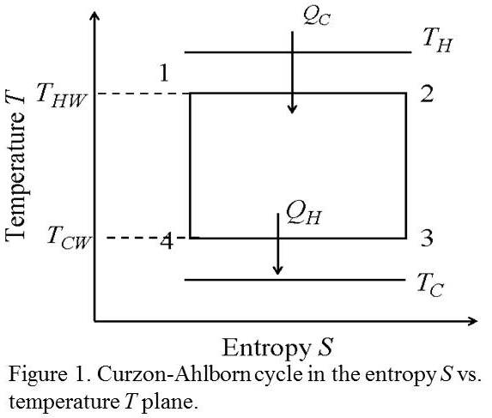
On the other hand, in the finite time context, several authors have analyzed other idealized cycles different to the modified Carnot cycle, named Curzon and Ahlborn cycle. Particularly the Otto and Diesel cycles have been analyzed (Mozurkewich and Berry, 1982; Angulo-Brown and Chavoya, 1984; Left, 1987; Angulo-Brown et al, 1994; Páez-Hernández and Angulo Brown, 1996; among others).
In this paper, a simplified procedure is proposed in order to obtain alternative expressions of power output and thermal efficiency for the idealized Otto and Diesel cycles, taking into account the time of the adiabatic processes in the cycle obtained through the comparison between the adiabatic work and an isothermal work built for the same values of volume in the process. The different expressions obtained for both power output and efficiency are also discussed. The proposed procedure is not the only possible one. In the case of the Curzon and Ahlborn cycle, a simple procedure has been proposed to include the duration time of the adiabatic processes depending on the calculated time of the isothermal processes prior to the adiabatic ones.
Otto and Diesel cycles
As it is known, the Otto and Diesel cycles are idealized models to describe internal combustion of real cycles, in which the limit value of temperature could exceed the temperature of stroke of machinery when the agent of transformation that receives heat changes due to continuity, not through the walls of machinery but by the generation of heat into the volume of themselves. Besides, the real cycles are open systems and the agent of transformation is a renewer for each cycle (air + fuel). The corresponding processes of compression and expansion are assumed to be adiabatic processes, at constant volume or constant pressure, and its time of duration is assumed to be much less than the total cycle time; so they are assumed to be not sufficient to make a noticeable change of heat (Kirillin et al, 1976). These idealized cycles are shown in Figure 2.
On the other hand, it is known that in an idealized reversible classical equilibrium thermodynamics context, the Otto cycle has the efficiency,
$η_{θ}=1−\frac{1}{r_{C^{γ−1}}}$, (1)
where $r_{C}$ is the compression ratio, $γ$ is the ratio of heat capability at constant pressure and capability at constant volume, $γ=\frac{C_{P}}{C_{V}}$.
Similarly, the idealized reversible Diesel cycle, with $r_{C}$ the compression ratio, and $r_{E}$ the expansion ratio (Zemansky, 1973), has the efficiency,
$η_{D}=1−\left[{\left(\frac{1}{r_{E}}\right)}^{γ}−{\left(\frac{1}{r_{C}}\right)}^{γ}\right]{\left[γ\left(\frac{1}{r_{E}}−\frac{1}{r_{C}}\right)\right]}^{−1}$, (2)
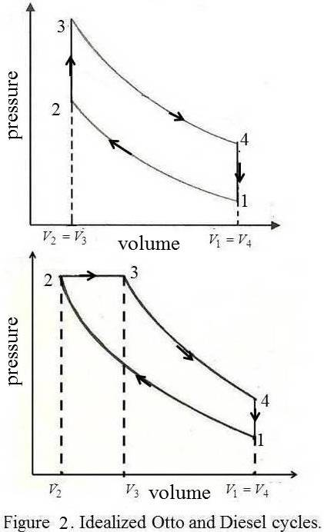
To include the time of the adiabatic processes, since the definition of power output one find for the Otto cycle (Angulo-Brown, Fernández-Betanzos and Díaz-Pico, 1994),
$P_{θI}=\frac{(C_{V1}−C_{V2}r_{C^{1−γ}})}{(K_{1}+K_{2}r_{C^{1−γ}})}$. (3)
The corresponding power output for the Diesel cycle in the same context is as (Páez-Hernández and Angulo-Brown, 1996),
$P_{R}=\frac{C_{P}(r_{C}−r_{E})(r_{C}r_{E})^{γ−1}−C_{V}(r_{C}^{γ}−r_{E}^{γ})}{K_{1}(r_{C}−r_{E})(r_{C}r_{E})^{γ−1}+K_{2}(r_{C}^{γ}−r_{E}^{γ})}$, (4)
$K_{1}$ and $K_{2}$ are constant parameters related to the heating and cooling average, respectively; $C_{V1}$ and $C_{V2}$ are the heating capability during the exchange processes of heat. With appropriate values of parameters, one can verify that the power output can be written as a function of $r_{C}$.
Real Otto and Diesel cycles are not as in Figure 2. These cycles are idealizations to be analyzed for the sake of pedagogical interest. Approximate real Otto and Diesel cycles are shown in Figure 3, which shows that the expansion and compression processes, namely 3 to 4 and 1 to 2 respectively, in Figure 2 are not exactly adiabatic processes.
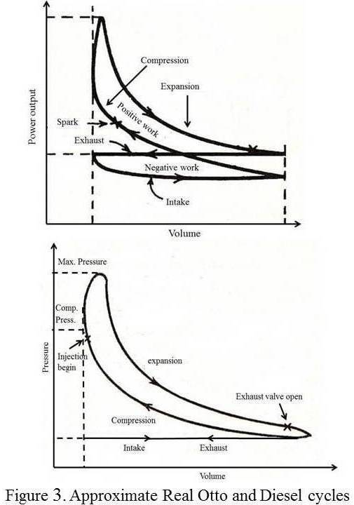
Approximate work during an adiabatic process
As it is known the work performed by a system, during any process, is defined as
$W_{\text{if}}=\int_{i}^{f}{\text{pdV}}$, (5)
Where $W_{\text{if}}$ is the work between states i and f, p is the pressure and dV is a volume differential that is interpreted as the area under the curve, where pressure appears as the function $p=p(V,T)$.
The time duration of the adiabatic processes in the Curzon and Ahlborn cycle (1975), with the procedure shown there, basically consists of assuming it a function of the isotherms time prior to each adiabatic process. It would be convenient to look for ways of not depending on the previous isothermal processes. The situation could be resolved if we use a procedure similar to the Riemann area calculation: we need to establish a partition of the range of values of the maximum and minimum volumes during the process. To get to this procedure, the area calculation is briefly reviewed by using the Riemann method.
As it is known, given the shape of a function in the Cartesian plane by the expression $y=f(x)$, where y represents the value of f for the value of x variable, the area enclosed by the curve represented by f is approximated for a partition as$\left\{x_{0},x_{1}, \text{.}\text{.}\text{.} ,x_{N}\right\}$, that is,
$\text{area}≈\sum_{i=1}^{N}{(x_{i}−x_{i−1})f(σ_{i})}, x_{i−1}≤σ_{i}≤x_{i}$. (6)
Partitioning the interval will allow the set of intervals,
$\left\{[x_{0},x_{1}],[x_{1},x_{2}],\text{.}\text{.}\text{.},[x_{N−1},x_{N}]\right\}$, (7)
as shown in Figure 4. In general, the size of the sub-intervals is arbitrary, as well as the point that it represents $σ_{i}$in each sub-interval.
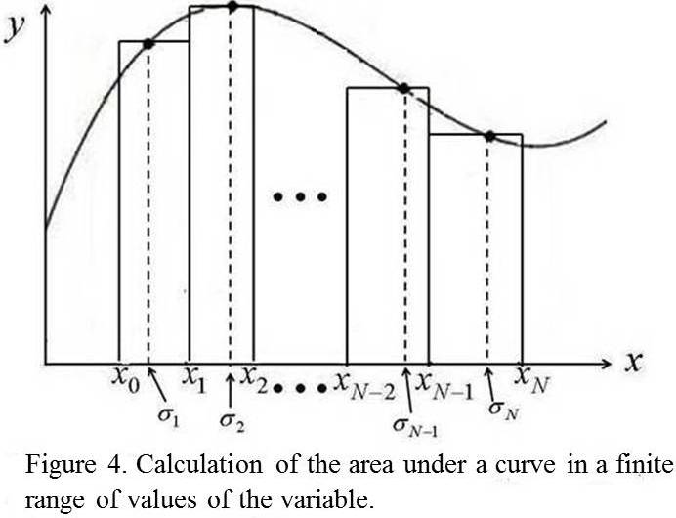
But if the $σ_{i}$ value has only the constraint of being within the corresponding sub-interval, and the width of each sub-interval is arbitrary, the calculation can be simplified, by taking $σ_{i}=\frac{x_{i}+x_{i−1}}{2}$, and assuming sub-intervals of the same size, that is, $\left|x_{1}−x_{0}\right|=\left|x_{2}−x_{1}\right|=\text{.}\text{.}\text{.}=\left|x_{N}−x_{N−1}\right|$. This means,
$\text{área}≈\sum_{i=1}^{N}{\left|x_{i}−x_{i−1}\right|f(\frac{1}{2}(x_{i}+x_{i−1}))}, x_{i−1}≤σ_{i}≤x_{i}$. (8)
The limit to infinity of this sum (or the previous one) leads to the calculation of the definite integral.
To model the adiabatic work of an expansion (or compression), a partition of the interval of values of volumes can be established, $[V_{\text{mín}},V_{\text{máx}}]$, where $V_{\text{mín}}=V_{0}$ and $V_{\text{máx}}=V_{N}$, and it can be chosen so that the sub-intervals are the same size, namely, $\left|V_{1}−V_{0}\right|=\left|V_{2}−V_{1}\right|=\text{.}\text{.}\text{.}=\left|V_{N}−V_{N−1}\right|$. Taking the isotherms for each $V_{i}$ as a function for the calculation of the work (as an area under the curve), it must be decided between choosing the midpoint of each sub-interval, and choosing the one necessary to have the average of the corresponding temperatures. The second option is more appropriate because it allows us to know the value of the function for each$σ_{i}$, so that $V_{i−1}<σ_{i}<V_{i},$ with $i=0,1,2,\text{.}\text{.}\text{.}\text{.},N$. Figure 5 clearly shows this situation.
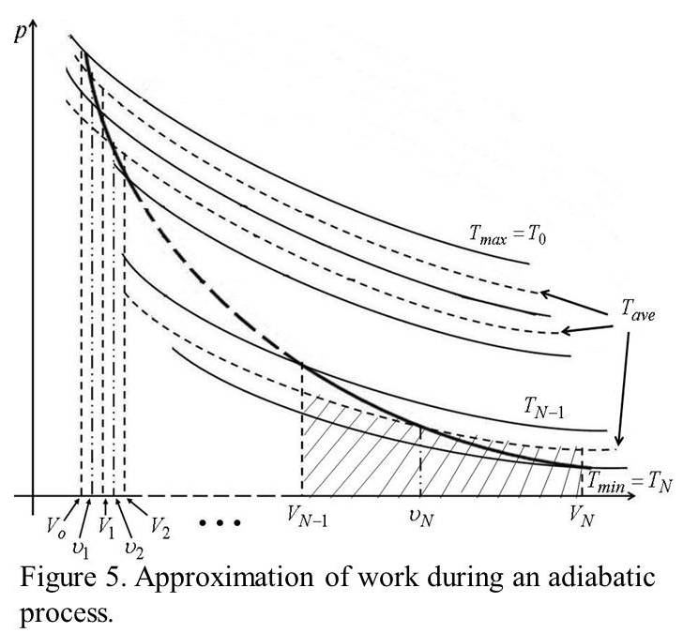
As it is shown in Figure 5, the work was modeled during an adiabatic process by means of successive isothermal expansions, followed by isochoric cooling, so that in each sub-interval an area above the adiabatic and an area under the adiabatic appear, in order that when adding and taking the limit to infinity, the work done by the adiabatic is obtained, simulated by sums of sub-areas of the average isotherms in each sub-interval. The grated part corresponds to the approximate area, that is, the work developed during the process approximated as discussed above. For each sub-range of volumes, an average temperature of the temperatures corresponding to each point of the partition of the volume interval is associated. We can write it as follows:
$ΔV=V_{1}−V_{0}=V_{2}−V_{1}=\text{.}\text{.}\text{.}\text{.}=V_{N}−V_{N−1}$. (9)
In the case of i-th volume,
$V_{i}=V_{0}+iΔV$; (10)
And for the temperature one has,
$T_{\text{iave}}=\frac{1}{2}(T_{i}+T_{i−1})$, (11)
so that,
$W_{\text{ad}}≈\sum_{i=1}^{N}{{\text{RT}}_{\text{iave}}\text{ln}\frac{V_{i}}{V_{i−1}}}=\sum_{i=1}^{N}{R\frac{1}{2}(T_{i}+T_{i−1})\text{ln}\frac{V_{i}}{V_{i−1}}}$. (12)
As it can be seen, finding the limit of this series is very complicated, but it can be approximated if we remember that for values of x around 1 we have,
$\begin{aligned}\text{ln}x≃(x−1)−\frac{1}{2}(x−1)^{2}+\frac{1}{3}(x−1)^{3} \\ −\frac{1}{4}(x−1)^{4}+ ⋯ +(−1)^{N−1}(x−1)^{N},\end{aligned}$ (13)
and, since $\frac{V_{i}}{V_{i−1}}=\frac{V_{i−1}+ΔV}{V_{i−1}}$, approaching first order,
$W_{\text{ad}}≈\sum_{i=1}^{N}{R\frac{1}{2}(T_{i}+T_{i−1})(\frac{V_{i}}{V_{i−1}}−1)\text{.}}$ (14)
As it can be seen in Figure 5, $T_{i}<T_{i−1}$, and the difference between them is decreasing, that is $\left|T_{i}+T_{i−1}\right|→0$, when $N→∞$ in expression (12). By evaluating the expression (12), for $i=1,2,⋯,$ the next gross approximation can be obtained,
$W_{\text{ad}}≈{\text{RT}}_{\text{iave}}\text{ln}\frac{V_{\text{max}}}{V_{\text{mín}}}=R\frac{1}{2}(T_{\text{max}}+T_{\text{min}})\text{ln}\frac{V_{\text{max}}}{V_{\text{mín}}}$, (15)
similar to the approximation,
$W_{\text{ad}}(j→f)≈W_{\text{isot}}(j'→f')⇒ t_{\text{ad}}(j→f)≈t_{\text{isot}}(j'→f'),$ (16)
which represents the situation shown in Figure 6.
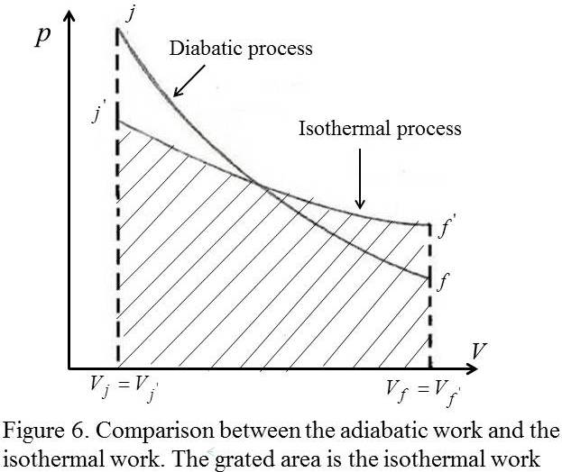
Otto and Diesel cycles with non-instantaneous adiabats
In finite time thermodynamics, it is usual that only the non-adiabatic processes are taken into account to write the time of the cycle, e.g. only the time of the processes of heat exchange, and the cyle is supposed to be endoreversible. Nevertheless, in real engines, there are internal effects not generally taken into account. However, adiabatic processes are only an idealization of real processes. So there has to be an effect related to the time of such processes. Thus, the power output can be obtained as the difference between the power output of cycle with instantaneous adiabats, and a loss of power during the adiabatic processes.
It has been pointed out that there is not a direct procedure to calculate the time of adiabatic processes in a cycle (Gutkowics-Krusin et al 1978; Agrawal et al, 1994). For the Curzon and Ahlborn cycle, this time is supposed to be a function of the time of the previous isothermal processes in the cycle (Gutkowics-Krusin et al 1978; Ladino-Luna and de la Selva, 2000).
In the case of the Otto and Diesel cycles, there are no isothermal processes related to the adiabatic processes. Nevertheless, the mechanical interpretation of work leads to consider a comparison between adiabatic work and isothermal work for a process with the same known volumes, as it is shown in the previous section.
Taking the isothermal process as the middle temperature, $T_{m}=\frac{1}{2}(T_{j}+T_{f})$, so an internally generated heat $Q^{}≈\frac{R}{2}(T_{j}+T_{f})\text{ln}({V_{f'}}/{V_{j'}})$ and and time can be taken as fact during the isotherm $T_{m}$. When applying the previous idea in the Otto and Diesel cycles, we have the situation shown in Figure 7 for the adiabatic expansion in each one.
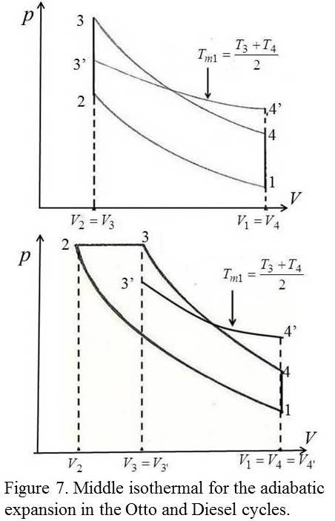
The time of the adiabatic expansion in the Otto cycle is supposed proportional to the time of the middle isotherm of the extreme temperatures in the interval of volumes [$V_{3},V_{4}$]. If the generated internal heat by internal effects in the engine during the expansion is taken as,
$Q_{1}^{}≈R\frac{1}{2}(T_{3}+T_{4})\text{ln}\frac{V_{4}}{V_{3}}$, (17)
and the time of the corresponding adiabatic expansion appears in the form,
$t_{\text{ad}1}=\frac{R\frac{1}{2}(T_{3}+T_{4})}{α(T_{3}−T_{4})}\text{ln}\frac{V_{4}}{V_{3}}$, (18)
where $α$ is a coefficient depending on the conductance. In this case, the conductance is of working substance. The adiabatic process $1→2$ of cycle in Figure 7 has a time,
$t_{\text{ad}2}=\frac{R\frac{1}{2}(T_{1}+T_{2})}{α(T_{1}−T_{2})}\text{ln}\frac{V_{2}}{V_{1}}$. (19)
The total power output in the cycle can be written as the difference between the power of the reversible cycle $P_{R}$ and lost power $P_{l}$ during the adiabatic processes, namely. So for the Otto cycle
$P_{θI}=\frac{(C_{V1}−C_{V2}r_{C^{1−γ}})}{(K_{1}+K_{2}r_{C^{1−γ}})}−\frac{α}{2}(T_{3}−T_{1}r_{C^{γ−1}})(1−r_{C^{1−γ}})$. (20)
For the Diesel cycle, a similar analysis can be made. The time of adiabatic processes is as in (18) and (19), but now the ratio of volumes in each adiabatic process is the compression ratio and the expansion ratio, as in (4). The power can be written as
$\begin{aligned}P_{\text{tot}}=\frac{C_{P}(r_{C}−r_{E})(r_{C}r_{E})^{γ−1}−C_{V}(r_{C}^{γ}−r_{E}^{γ})}{K_{1}(r_{C}−r_{E})(r_{C}r_{E})^{γ−1}+K_{2}(r_{C}^{γ}−r_{E}^{γ})} \\ −\frac{{αT}_{4}(1+r_{E}^{γ−1})(1−r_{E}^{γ−1})(1+r_{C}^{γ−1})\text{ln}r_{E}}{(1+r_{E}^{γ−1})(1−r_{C}^{γ−1})\text{ln}r_{E}+(1−r_{E}^{γ−1})(1+r_{C}^{γ−1})\text{ln}r_{C}}\text{.}\end{aligned}$(21)
The efficiency of these cycles can be written in terms of power output and the total time also as,
$η=\frac{P_{\text{tot}}}{{Q_{\text{tot}}}/{t_{\text{tot}}}}$, (22)
which allows us to obtain the efficiency for both Otto and Diesel cycles. Particularly for the Otto cycle we obtain
$\begin{aligned}η_{θI}=\left[\frac{(C_{V1}−C_{V2}r_{C^{1−γ}})}{(K_{1}+K_{2}r_{C^{1−γ}})}−\frac{α}{2}(T_{3}−T_{1}r_{C^{γ−1}})(1−r_{C^{1−γ}})\right]× \frac{(T_{3}−T_{1}r_{C^{γ−1}})(K_{1}+K_{2}r_{C^{1−γ}})−\frac{R(1+r_{C^{1−γ}})}{α(1−r_{C^{1−γ}})}\text{ln}r_{C}}{C_{V1}(T_{3}−T_{1}r_{C^{γ−1}})}\text{.}\end{aligned}$(23)
The first part of (20) and (21) corresponds to the power output of the reversible cycle with instantaneous adiabats, and the second part is the effect of taking into account the loss of heat in the adiabatic processes.

Conclusions
As it can be seen, to introduce the fictitious isothermal processes in the idealized Otto and Diesel cycles, the time of duration of adiabatic processes can be assumed, and it leads to having a procedure to take into account some non-reversible processes near adiabatic processes into the engine which are necessarily present in real engines. Adequate expressions for power output with the proposed model methodology have been shown here. Non-instantaneous adiabats can be taken into account to improve models of cycles. We expect numerical values calculated by this means to be closer to experimental values than others in the finite time thermodynamics literature. Many authors have analyzed Otto and Diesel cycles while other cycles, but they still considered instantaneous adiabats in the analysis (Rocha et al, 2002; Zheng, 2002; Khaliq, 2005 among others). For adequate values of the parameters involved, a comparison of the power output of cycle for instantaneous adiabats and non-instantaneous adiabats is shown in Figure 8.
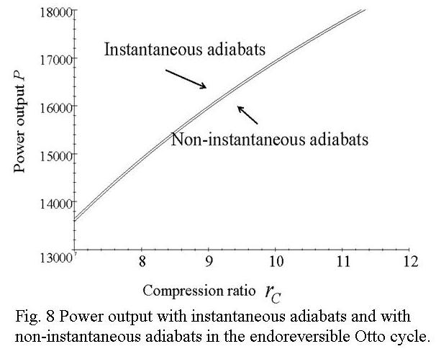
Acknowledgments
The authors thank the total support of Universidad Autónoma Metropolitana-A (México).
References
Andresen, B., P. Salamon, and R.S. Berry; Thermodynamics in finite time: extremal for imperfect heat engines, J. Chem. Phys.: 66, 1571-1577 (1977).
Angulo-Brown, F.; An ecological optimization criterion for finite-fime heat engines, J. Appl. Phys.: 69, 7465-7469 (1991).
Angulo-Brown, F. and O. Chavoya; Un tratamiento del ciclo de Otto en el marco de la termodinámica de tiempos finitos, Acta Mex. C. Tec.: II [5], 73-79 (1984).
Angulo-Brown, F., J. Fernández-Betanzos, and C. Díaz-Pico; Compression ratio of an optimized air standard Otto-cycle model, Eur. J. Phys.: 15, 38-42 (1994).
Agrawal, D.C., M.J. Gordon and M. Huleihil; Endoreversible engines with finite-time adiabats, Indian J. Eng. Mat.Sc.: 1, 195-198 (1994).
Carnot, S. ; Réflexions sur la puissance motrice du feu et sur les machines propres à développer cette puissance, París (1824,). Spanish translation, IPN Press (México) (1998).
Curzon, F. L. and B. Ahlborn; Efficiency of a Carnot engine at maximum power output, Am. J. Phys.: 43, 22-24 (1975).
Gutkowics-Krusin, D., I. Procaccia, and J. Ross; On the efficiency of rate processes. power and efficiency of heat engines, J. Chem. Phys.: 69, 3898-3906 (1978).
Khaliq, A. And R. Kumar; Finite-time heat transfer analysis and ecological optimization of an endoreversible and regenerative gas turbine power-cycle, Appl. Energy: 81, 73-84 (2005).
Kirillin, V., V. Sichev and A.E. Sheindlin, Termodinámica técnica., Chap. 10, Ed. MIR, In Spanish, Moscú (URSS) (1976).
Ladino-Luna, D. and S.M.T. de la Selva; The ecological efficiency of a thermal finite time engine, Rev. Mex. Fís.: 46, 52-56 (2000).
Leff, H.S.; Thermal efficiency at maximum work output: New results for old heat engines; Am. J. Phys.: 55, 602-610 (1987).
Mozurkewich, M. And R.S. Berry, Optimal paths for thermodynamic systems: The ideal Otto cycle, J. Appl. Phys.: 53, 34-42 (1982).
Páez-Hernandez, R.T. and F. Angulo-Brown, Eficiencia y relación de compresión de un ciclo Diesel a tiempo finito, Rev. Mex. Fís.: 42, 684-691 (1996).
Rubin, M.; Optimal configuration of a class of irreversible heat engines. I, Phys. Rev. A: 19, 1272-1276 (1979a).
Rubin, M., Optimal configuration of a class of irreversible heat engines. II, Phys. Rev. A:: 19, 1277-1289 (1979b).
Rubin, M., Optimal configuration of a class of irreversible heat engines with Fixed Compression ratio, Phys. Rev. A: 19, 1741-1752 (1980).
Rocha-Martínez, J.A., T.D. Navarrete-González, C.G. Pavía-Miller, R.T. Páez-Hernández and F. Angulo-Brown, Otto and Diesel engine model with cyclic variability, Rev. Mex. Fís.: 48, 228-234 (2002).
Zemansky, M.W. Calor y termodinámica, Chap. 7, Ed. Aguilar, (México) (1973).
Zheng, J., L. Chen, F. Sun and Ch. Wu, Powers and efficiency performance of an endoreversible Braysson cycle, Int. J. Therm. Sci.: 41, 201-205 (2002).

