Microstructure and Magnetic Properties of Сo-С and Сo-Pd Films with the Internal Bend of a Lattice
L.I. Kveglis, V.S. Zhigalov, V.A. Musikhin, V.G. Arkhipkin
L.V. Kirensky Institute of Physics SB RAS, 660036 Krasnoyarsk, Russia.
PACS: 68.35.Gy, 68.03.Hj, 68.37.Lp
Nanocrystalline magnetic films, saturation magnetization, structure, crystallization, viscous tension.

Abstract
The explosive crystallization processes in nanocrystalline Со-С and Со-Pd films have been studied by transmission electron microscopy and electron diffraction methods. The analysis of bend extinction contour microphotographies has shown the considerable internal bend (~100º/micron) of crystalline lattice. On the basis of the experimental data we founded the correlation of magnetic properties and lattice curvature. In present paper the shear transformation zone theory was used for attempt to explain the mechanism and kinetics of the explosive crystallization in Co-C and Co-Pd films.

Introduction
The question about microstructure of nanocrystalline materials, obtained in the nonequilibrium conditions, remains under discussion at present day problem of condensed matter physics. Thus, experimental investigations of structure formation in these materials have great importance for explaining of nanocrystalline substances behavior and for the prediction of new possibilities of their technical application. For instance, in case of magnetically ordered films, its magnetization saturation decreases, as a rule, during the explosive crystallization processes [1, 2].
Developed by Bernall [3] geometrical model of close packing disorder of the solid spheres appeared for liquid, solid metallic glasses. It is supposed, that the atoms considered as solid spheres located on tops of empty polyhedrons (simplexes), which edges are formed by bonding between the next atoms. Lengths of edges can change approximately within the bounds of 15%. Thus, the free volume between spheres occupies 25-30%. The concept of free volume is one of the basic approaches describing molecular-kinetic processes in liquids and glasses. However, this concept is not unequivocal. So authors [4] consider that the fluctuating free volume calculated on the data of kinetic properties close to temperature of vitrification makes only 2-3% from total amount of system atoms. For single crystal solids the following relation was obtained in [5]:
$T(\frac{∂P}{∂T})_{V}=(\frac{∂E}{∂V})_{T}+P$ (1)
where Р - is the pressure, Е - is the full energy, V - is the volume equal just to 2-3% of the full system volume. In the work [6] with the purpose to avoid the contradictory concepts about the free volume, the model of excited atoms was suggested to be used. In according to this model, energy, associated with the fluctuation free volume, calculated using data of kinetic properties near the vitrification temperature. The activation energy equal to the work of the atoms displacement by a critical distance is close to the melting heat for nonmetal polymers. From experiments, which have been realized on metal glasses, crystallization activation energy can be essentially more. For example, in [7] the crystallization activation energy is equal to 108 kJ/mol, that is corresponding to ∼10kT_{vitrification}, where k is the Boltzmann constant, T_{vitrification} - vitrification temperature. According to super-Arrhenius relaxation [6] theory in glassy materials, energy produced in the excited condition of substance, can attain approximately 32kT_{vitrification}. The crystallization process can be considered as a structural relaxation. The motive force of the process is the pressure gradient:
$R_{±}=R_{0}\sqrt{T}e^{\frac{±\text{ασ}}{P}}$ (2)
where α - is the constant of internal friction, σ - is the share stress, P - is the pressure.
In this case, the following expressions for the particles rearrangement rate (transformation rate) R± and for the kinetics of the free volume increase are used [6]
$R_{±}=R_{0}\text{exp}\left(\frac{−ν_{0}}{\overline{ν_{f}}}\right)\text{exp}\left(\frac{σ}{\overline{℘}}\right)$ (3)
$\left(\frac{{dν}_{f}}{\text{dt}}\right)=−E_{1}\text{exp}\left(\frac{−ν_{1}}{\overline{ν_{f}}}\right)+A_{V}σ\left(\frac{{dε}^{P}}{\text{dt}}\right)$ (4)
where ν₀ - is the free volume near the transformation zone, necessary for the particle displacement in the share stress field, $\overline{ν_{f}}$ - is the average free volume, ν₁ - is the free volume necessary for the particle displacement at the structure compaction in the absence of share stress (here ν₁<ν₀, since at the rearrangement caused by the compaction the smaller free volume is required as compared for the case of rearrangement caused by the share), σ - is the stress, ε^{P} - is the plastic deformation, $\overline{℘}$ - is the certain averaged stress, R₀, E₁, and A_{V} - are the constants.
It has been shown [8] that the share components of the stress strongly influence the distribution of the uniaxial magnetic anisotropy through overall surface of a thin magnetic film. To strengthen magnetostrictive effects, the substrate curvature about 5°/micron was created during the film sputtering process.
We have attempted to associate the processes of structural self-organization observed in the films with changes in their magnetic structure. Spontaneous deformation occurring in non-equilibrium materials may lead to redistribution of magnetization in local areas [2]. This concept comes in agreement with the model of excited atoms [4] and share transformation zone theory [6].
Objective
The present work is aimed to study the structure formation of nanocrystalline Co-Pd and Co-C films activated by electron irradiation, furnace annealing, and mechanical shock. The problem to be described in this study is to analyze physical origin of the explosive crystallization (EC) and such peculiarities of the structure formation associated with EC as rotational shares and internal bends of an atomic lattice that reach 100°/micron and more, in the framework of the lately appeared shear transformation zone (STZ) theory [9]. In our work we made an attempt to describe a problem of free volume value on the basis of experimental data.
Samples and investigation methods
Crystallization of Co-C and Co-Pd nanocrystalline films has been studied. These films may be prepared by sputtering on substrate at high condensation rates e.g. In this case, nanoparticles were formed directly at the substrate surface. We realized the high-rate vacuum condensation using the method of pulse plasma sputtering (PPS) with laser heating. Films prepared by this method from a refined cobalt or cobalt and palladium targets have properties characteristic of the nanocrystalline state and contain a large amount of dissolved carbon (up to 20 at.%). This method is characterized by high pulse condensation rates (>10⁵ A/s) at a pulse duration of ~ 10⁻⁴ s, cooling rates of the condensate of about 10⁸ K/s, pulse repetition rates of 1-10 Hz, and the working vacuum of 10⁻⁶ Torr. The physical and engineering features of this process were described in details in [1].
The films have been investigated by transmission electron microscopy (TEM) and electron diffraction method, including the method of bend extinctional contours. The internal bend of a lattice has been calculated using the results of measurements of distances between measuring contours corresponding to the opposite point reflexes in the microphotograph. The angle Θ of a crystal plane d_{hkl} bending has been determined using the corresponding bend contour width W [7]:
Θ = (360/πW) arc sin (λ/2d) (5)
The electron wave length λ in the observation regime is equal to 0.037А; the curvature radius r is determined as in [7]:
$r=\frac{{\text{Wd}}_{\text{hkl}}}{λ}$ (6)
The bending angle and the curvature radius can be connected by the relation:
$Θ=\frac{\text{360}⋅d_{\text{hkl}}}{π⋅r⋅λ}⋅\text{arcsin}(\frac{λ}{2⋅d})$ (7)
Experiment
Fig. 1 presents the microphotographies of a Co-C film that has crystallized under the effect of a mechanical shock. Initially, the film was in the nanocrystalline state. On the Fig. 1a one can clearly see the bend extinctional contours with the bend radii about 0,5 micron and the bending angle about 100°/micron. With the film thickness known, the local elastic deformation value could be determined: $ε=Θ_{\text{lok}}⋅(t/2)=2,500$ [7]. However, the linear Hooke's law requires the bending angle value to be equal to the value of its sine or tangent. Apparently, in our experiment the deformations considerably exceed the value of 2,5%.
The microstructure of the annealed samples was matched with saturation magnetization and coercivity values determined by the torque method with the torque magnetometer in fields up to 17kOe at room temperature. It can be seeing on Fig. 2 that the Со-С and Со-Pd films in the initial nanocrystalline state have magnetization that is twice lower than that of a bulk material. After crystallization at temperatures of 200°С for Со-С films and over 300°С for Со-Pd films, further saturation magnetization decrease was observed. After annealing at temperatures over 250°С for Со-С films and over 600°С for Со-Pd films, their saturation magnetization takes the values equal to those of bulk materials. It is accompanied by considerable reduction of an area occupied by the bend contours on the microphotographies.
In the samples subjected to annealing at temperatures corresponding to the maximal density of bend contours in electron microscopy images, saturation magnetization decreases in several times as compared to the initial nanocrystalline state. On Fig. 3а the bend contours are rarely observed and their radii are rather difficult to estimate. In Fig. 3b the curvature radius is 5 micron, and the angle of a lattice internal bend is Θ = 10°/micron. It refers to viscous strain – stress. On Fig. 3c the image of Co-Pd film is shown after the electron beam influenced on initial nanocrystalline film.

Discussion
In our previous experiment [2] the possibility viscous of strain-stress deformation has been illustrated due to bend extinctional contours on micrographs of Со-Рd films after EC. The twofold exponential dependence equation of the lattice curvature of the explosive Со-Рd crystals on the heat-conductivity coefficient of the substrate crystals has been found:
y₁ = y₀₁+A₁exp(t₁x^{-0,01})+A₂exp(t₂x⁻⁶) , (8)
where y - is the radius of the internal bend curvature of a crystal grown in a Co-Pd film, х - is the heat-conductivity coefficient of a substrate material. This dependence has been estimated by the experimental points obtained as follows. Co-Pd alloy with equi-atomic composition was deposited simultaneously onto substrates Ca-F₂, Al, silicate glass, MgO with different heat-conductivity coefficients. Since the films deposition onto the substrates was realized by a short pulse (1,5 - 2 sec) at room temperature, the heat-conductivity coefficient for room temperature had taken into consideration.
The heat-conductivity coefficient κ is determined as a ratio of the velocity of heat energy transfer through a unit area to the temperature gradient [11]:
$κ={−q}/∇T$ (9)
This can be written otherwise, in case of assuming a film to be liquid-like and accounting its viscosity [11]:
$ρT(\frac{∂S}{∂t}+v∇S)=\text{div}(κ∇T)+\frac{η}{2}(\frac{∂v_{i}}{∂x_{k}}+\frac{∂v_{k}}{∂x_{i}}−\frac{2}{3}δ_{\text{ik}}\frac{∂v_{l}}{∂x_{l}})^{2}+η'(\text{divv})^{2}$ (10)
where δ_{ik} - is the unit stress tensor for suspensions-liquids with the large quantity of solid particles soluted; ρ - is the density; S - is the entropy; κ − is the heat conductivity; η and η' - are the first and the second viscosity coefficients, respectively; v - is the heat flow velocity. The necessity for account of η' may appear when the medium compressibility is substantial, in particular, for processes with long relaxation time. If several relaxation processes take place, η' is presented as a sum of several terms [12]. The account for η' is difficulties due to nonuniformity of shares, i.e. nonlinearity of the velocity distribution in a material.
The equation (10) was written in [11] for the heat conductivity of a viscous suspense. The technology we used for the samples preparation in general had the features described in details earlier [1]. It was shown that the films represented cobalt clusters surrounded by a carbon shell. Basing on this, we consider the film to be liquid-like and use the equation (10) for a viscous suspense to analyze obtained experimental results.
Usually the solution of the heat conductivity equation is either the exponent or the power function. Our experimental curve [2] was distinguished by two contained exponents that do not contradict the heat conductivity equation (10) at the account for two viscosity coefficients.
Taking into consideration the fact that the point reflexes in the electron-diffraction patterns are strongly fuzzy, i.e. the interatomic spacing changes within the limits of 8%, we suppose that these films can be described in the framework of the model of excited atoms, on which the share transformation zone (STZ) theory is based [6, 9]. The excited atoms [4] are those capable to replace by the critical distance corresponding to the maximal value of the interatomic gravitation force.
Comparing the data obtained by X-ray and electron diffraction, we can conclude that in the Со-С and Co-Pd films the “single crystals” are grow which have a structure without the long range order. Nanocrystallites are oriented relative to one another like mosaic blocks imitating a single crystal. Study of the atomic structure of non-equilibrium phases occurring after the explosive crystallization in nanocrystal films Co-C, Co-Pd, and Fe₂Tb has shown that the structure of the films of the above-mentioned compositions should be identified as the Frank-Casper tetrahedrally close-packed one (the Laves cubic phase) [2]. This structure [10] is typical for the equilibrium state of the Fe₂Tb films but appeared unexpected for the Co-Pd and Со-С films. The important characteristic of this structure is the compressibility and stretchability of its elementary volume within 30% [13].
According to the previous study [3] at share deformations the instability of an atomic lattice towards rotation is possible.
The relations for the stress tensor components are known from [11]:
$p_{\text{ij}}=−p+2η{\overset{˙}{e}}_{\text{ij}}−(\frac{2}{3}η−η^{'})τ$, (11)
where р - is the pressure; η and η΄ - are the viscosity coefficients; e_{ij} - is the deformation tensor component; τ - is the volume deformation rate.
Using the analysis of bend contours, we showed in our experiment that the internal bend in a film material may be the order of magnitude more. The magnetostriction constant for Co and Co-Pd is 2·10⁻⁵, which is the order of magnitude more than the value obtained earlier [8]. Apparently, in our films the effects of saturation magnetization value decrease and coercivity increase may be caused by internal stresses of a bent lattice by rotational shares.

Conclusion
The comparison of microstructure of the nanocrystalline Со-С and Со-Pd films containing bend contours with the results of saturation magnetization measurements has been made. Microstructure and magnetic properties of Со-С and Co-Pd crystallizing with the internal bend of a lattice are being compared.
As it has been observed on the electron microscopic patterns, for the samples with the maximal density of bend contours the saturation magnetization sometimes is less as compared initial nanocrystalline state.
From our viewpoint, the share transformation zone (STZ) theory provides new opportunity for description of the non-equilibrium processes in a disordered solid containing considerable quantity of excited atoms.
References to the paper
Microstructure and Magnetic Properties of Сo-С and Сo-Pd Films Crystallized with Internal Bend of a Lattice
L.I. Kveglis, V.S. Zhigalov, V.A. Musikhin, V.G. Arkhipkin

1. V.S. Zhigalov, G.I. Frolov, L.I. Kveglis. FTT 1998, v.40, №11, p.2074-2078.
2. L.I. Kveglis. The Self-organisation of Tetrahedrally Close-Packed Structures in Magnetic Nanocrystalline Tb-Fe and Co-Pd films. // Trans TexnPublications Ltd., 2006, p.267-274.
3. D.M. Tompson. Instabilities and catastrophes in science and engineering, М. Mir, 1985.
4. D.S. Sanditov, G.V. Kozlov, B.D. Sanditov // Physics and Chemistry of Glass, 1996, v.22, №6, p.683-693.
5. М.Ф. Сарры // Успехи физических наук, Саров (1999), том 169 №10 с.1085-1110.
6. M.L. Falk, J.S. Langer // Phys. Rev. 1998, V. E57, P.7192-7204.
7. V.Yu. Kolosov. Proc. XII ICEM, Seattle, San Francisco Press, v.1, p.574 (1990).
8. B.A. Belyaev, A.V. Izotov, А.А. Leksikov // Zavodskaya Laboratoria, v.67, №9, 2001, p.23-28
9. Langer J.S., Lemaitre A. // Сond-mat. 2004, 0411038v1
10. L.V. Kveglis, S.M. Zharkov, E.P. Popyol, FTT, 44, № 6,1070 (2002).
11. L.D. Landau, E.M. Lifshits // Hydrodynamics, 1986, М."Nauka", p.527.
12. I.G. Mikhaylov, V.A. Solovyev // UFN 1953, v.50, issue1, p.3-50.
13. U. Pirson. "Crystal chemistry and Physics of Metals and Alloys", М.: "Mir", v.1, p.424, v.2, p.472 (1977).
Figure captions to the paper

Microstructure and Magnetic Properties of Сo-С and Сo-Pd Films Crystallized with Internal Bend of a Lattice
L.I. Kveglis, V.S. Zhigalov, V.A. Musikhin, V.G. Arkhipkin

Fig. 1. Microstructure (a) and electron diffraction (b) on the crystallized area of the nanocrystalline Co-C film subjected to a mechanical shock.

Fig. 2. The dependence of saturation magnetization on:
а) annealing temperature for the Co₅₀Pd₅₀ film;
b) annealing temperature for the Co-C film;
c) substrate temperature during sputtering for the Co-C film.
1-glass substrate
2- MgO substrate
3- mica substrate

Fig. 3. Micrographs taken from the films Co-C on glass substrates after annealing at the temperature 250ºС (a), the Co-C films after the electron beam influence on the initial nanocrystalline films (b); the Co-Pd films after the electron beam influence on the initial nanocrystalline films (c).
Figure 1 to the paper
Microstructure and Magnetic Properties of Сo-С and Сo-Pd Films Crystallized with Internal Bend of a Lattice
L.I. Kveglis, V.S. Zhigalov, V.A. Musikhin, V.G. Arkhipkin

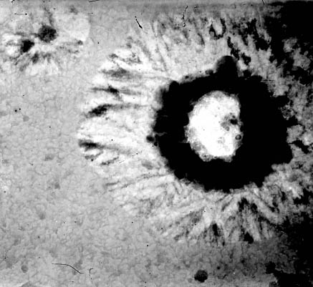
0,15μm
а

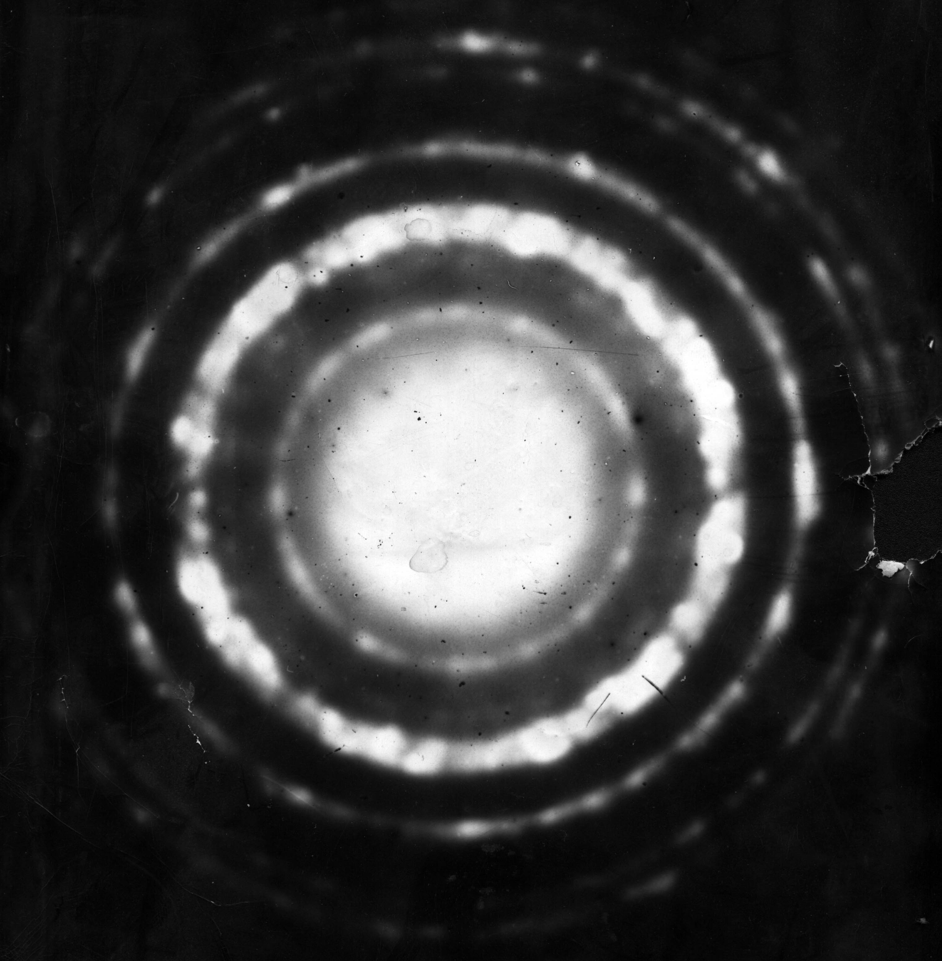
b

Figure 2 to the paper
Microstructure and Magnetic Properties of Сo-С and Сo-Pd Films Crystallized with Internal Bend of a Lattice
L.I. Kveglis, V.S. Zhigalov, V.A. Musikhin, V.G. Arkhipkin

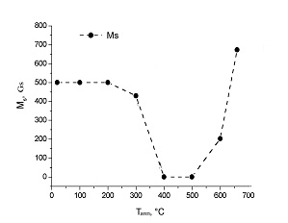
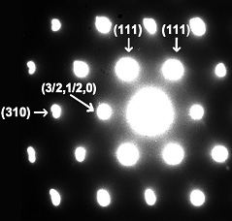
а

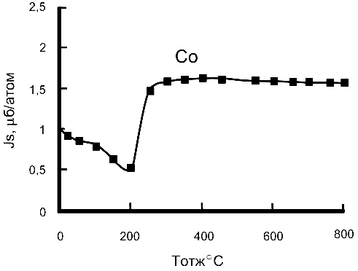
b

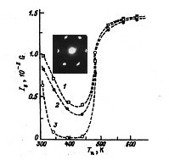
c
Figure 3 to the paper

Microstructure and Magnetic Properties of Сo-С and Сo-Pd Films Crystallized with Internal Bend of a Lattice
L.I. Kveglis, V.S. Zhigalov, V.A. Musikhin, V.G. Arkhipkin

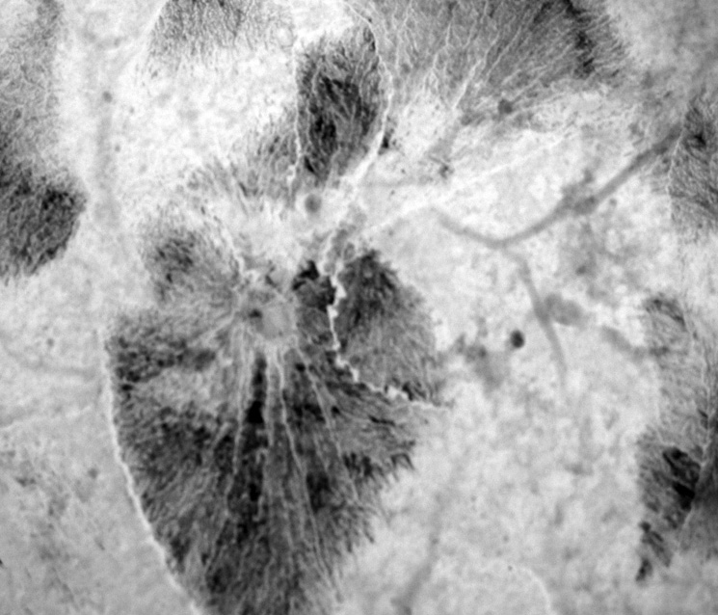
2,7μm
а

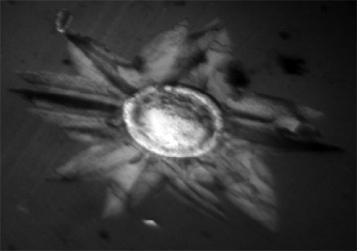
2,7μm
b

Figure 3 c to the paper

Microstructure and Magnetic Properties of Сo-С and Сo-Pd Films Crystallized with Internal Bend of a Lattice
L.I. Kveglis, V.S. Zhigalov, V.A. Musikhin, V.G. Arkhipkin

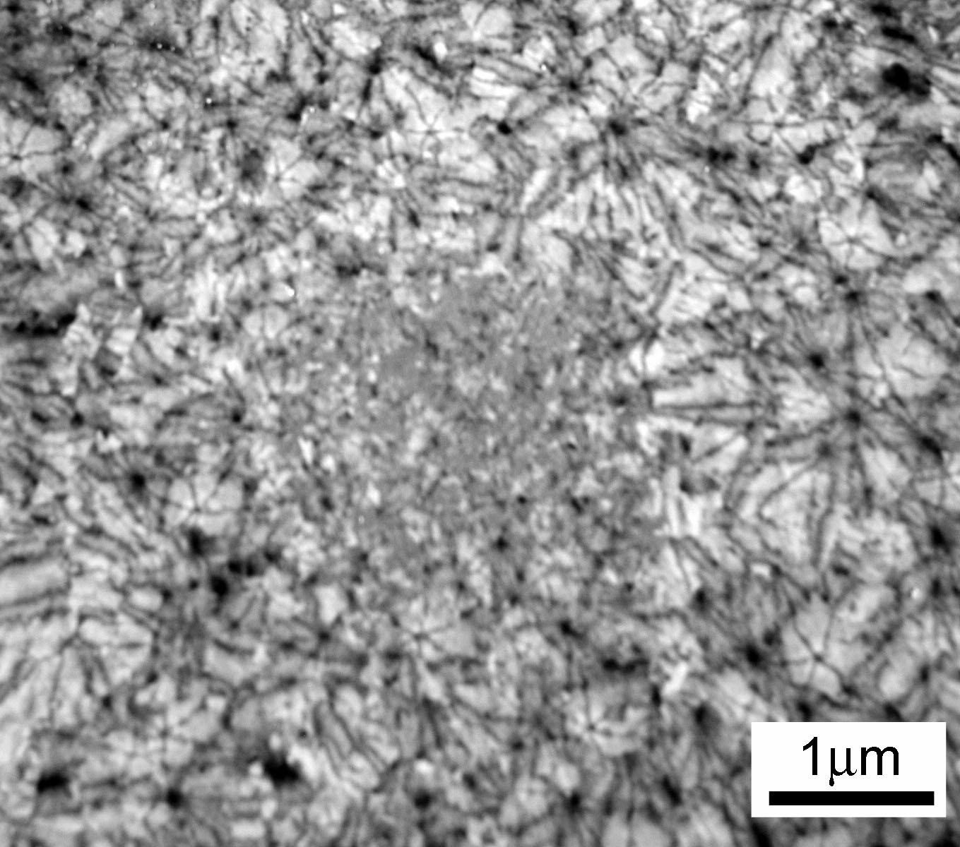
c

