Synchronization of 4 identical chaotic systems
A.I.Lerescu1, Anca Lazar2, Servilia Oancea3, Ioan Grosu2
1HolstCentre,Stichtung IMEC Nederland,Hight Tech Campus 48,5656AE Eindhoven,The Netherlands
2Faculty of Bioengineering,Univ. of Medicine and Pharmacy, Iasi,Romania
3 Biophysics Dept.,Univ. of Agriculture and Veterinary Medicine,Iasi,Romania

Introduction
Synchronization is a fascinating phenomenon in nature [1,2]. It is a great challenge to understand how cardiac cells are connected to do their woek. There are known different connectivity structures like small world and scale free. Are they related to their ability to synchronize?
Here we give a general coupling of 4 identical general nonlinear systems to synchronize. There are chosen 3 different connectivities: all-to-all, ring and star.

The proposed coupling
Let’s consider a general system :
dx/dt= F(x), x$∈R$^{n} (1)
we propose ,for the first time , the following coupling :

dx_{i}/dt = F(x_{i}) + (H-dF(s_{i})/ds_{i})(x_{i}-s_{i}) (2)

where s_{i} is the average of all x_{i} of nodes connected with node “I” including it (see below). H is a Hurwitz matrix. The coupling looks an adaptive one with the coefficient depending on the local properties of the network.

The connections
We consider 4 oscillators in 3 different connections: all-to-all, ring and star.
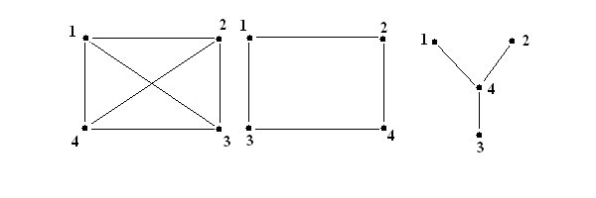
Fig.1 Connections: all-to-all, ring and star

Numerical results
We take one of the systems from the Sprott’s collection [3]:
dx₁/dt=-2x₂
dx₂/dt= x₂+x₃² (3)
dx₃/dt= 1+x₂-2x₃
For this system we can choose the following Hurwitz matrix [4, 5]:

H= $\left(\begin{matrix}0 & −2 & 0 \\ 1 & 0 & p \\ 0 & 1 & −2\end{matrix}\right)$ (4)
with p<0.
In the following we write down the equation (2) for the system (3).
dx₁₁/dt=-2x₁₂
dx₁₂/dt= x₁₂+x₁₃² +(p-2s₁₃)(x₁₃-s₁₃) (5)
dx₃/dt= 1+x₁₂-2x₁₃

dx₂₁/dt=-2x₂₂
dx₂₂/dt= x₂₂+x₂₃² +(p-2s₂₃)(x₂₃-s₂₃) (6)
dx₂₃/dt= 1+x₂₂-2x₂₃

dx₃₁/dt=-2x₃₂
dx₃₂/dt= x₃₂+x₃₃² +(p-2s₃₃)(x₃₃-s₃₃) (7)
dx₃₃/dt= 1+x₃₂-2x₃₃

dx₄₁/dt=-2x₄₂
dx₄₂/dt= x₄₂+x₄₃² +(p-2s₄₃)(x₄₃-s₄₃) (8)
dx₄₃/dt= 1+x₂₂-2x₄₃

where s₁=s₂=s₃=s₄= (x₁+x₂+x₃+x₄)/4 for all-to-all connection,
s₁ =(x₁+x₂+x₄)/3, s₂=(x₁+x₂+x₃)/3, s₃ =(x₂+x₃+x₄)/3, s₄ =(x₁+x₃+x₄)/3 for ring
and s₁ =(x₁+x₄)/2 , s₂=(x₂+x₄)/2, s₃ =(x₃+x₄)/2, s₄ =(x₁+x₂ + x₃+x₄)/4 for star.
Below are shown numerical results for systems (5)-(8) with initial condition
x₁(0)= (-5,-5,-5) ,x₂(0)=(-2,-2,-2), x₃(0)=(1,1,1) ,x₄(0)=(4,4,4) and p=-1.
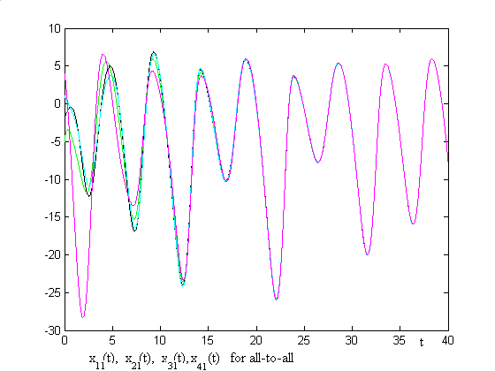
Fig.2 First components for all-to-all
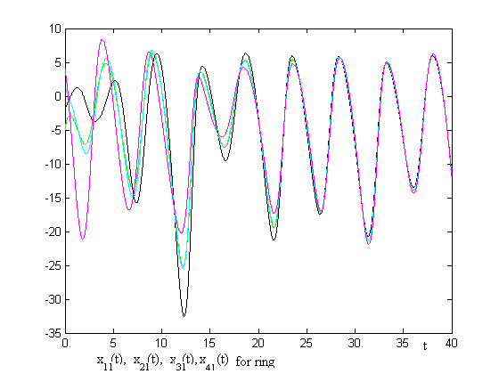
Fig.3 First components for ring
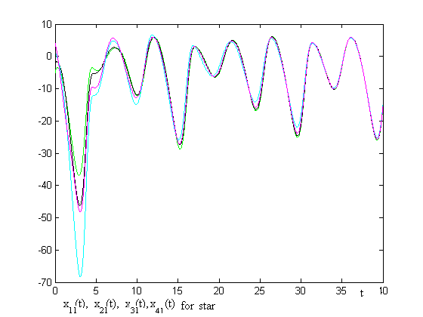
Fig.4 First components for star
It can be observed that the synchronization is achieved faster in all-to-all than in star and in ring connection.

References
- S. Strogatz , Sync :The Emerging Science of Spontaneous Order (Hyperion,New York) 2003
- A.Pikovsky, M.Rosenblum , J. Kurths Synchronization a Universal Concept in Nonlinear Science (CUP, Cambridge ),2001
- J.C. Sprot “ Some Simple Chaotic Flows “,PRE 55,5285 ,1994
- I.Grosu “Robust Synchronization “,PRE 56 3709,1997
- A.I.Lerescu,N.Constandache,S.Oancea “Collection of Master-Slave Synchronized Chaotic Systems “ Chaos,Solitons & Fractals 22,599-604,2004

