ENOC 2008, Saint Petersburg, Russia, June, 30-July, 4 2008

SYSTEMS WITH QUASI-ZERO-STIFFNESS CHARACTERISTIC

Alexey Zotov
Mechanics and Design of Machinery Department
Ufa State Petroleum Tech University
The Russian Federation
a-zot@rambler.ru

Abstract
Vibroprotective and impact-protective systems with elastic elements of passive type moving between two guides were investigated. These systems have force-displacement characteristics with a zone of quasi-zero-stiffness of the necessary length. The linear springs (in accordance with Hook’s law) and the pneumatic springs were used as elastic elements. The force-displacement characteristics with hysteresis loops resulting from the dry friction force were obtained. The amplitude-frequency characteristics for any case of force-displacement characteristic with rectangular loops of hysteresis were determined.

Key words

Quasi-zero-stiffness, vibrodamping, hysteresis.

1 Introduction
The possibility of quasi-zero-stiffness (QZS) elastic systems’ application on the basis of Mesis frame (“systems with jump”) for protection of dynamic objects was firstly revealed by Alabuzhev P.M. in 1967 year [Alabuzhev, Gritchin, Kim, Migirenko, Chon, and Stepanov, 1989].
The dependence of the restoring force from displacement for Mesis frame looks like sine graph. The idea lies in sorting out the third vertical spring having stiffness $с$, so that the inclination angle of $с⋅x$ line matches with the inclination angle of sine-like curve’s linear declining part. Then the superposition of forces will give a region with QZS. If we select corresponding mass, then it will be supported in stationary position by the QZS spring.
One of the main limitation of Alabuzhev’s vibroprotection systems is the small QZS travel range (few cm).
Technology of engineering and production of principally new car suspensions of various types was invented by Ukraine engineering institute NANU and NKAU [http://itm.dp.ua/RUS/Technol/ech1701.html]. Studies were based on the theoretical and experimental investigation of QZS systems’ operation range. The indicated suspensions have QZS operation range of static characteristic and do not require the installation of hydraulic damper for travel softness and firmness of high-class automobiles.
Many quasi-zero-stiffness mechanisms are proposed by well-known scientists Mansuruv I.I. and Mansurov O.I. on the basis of wire rope bumpers [Mansurov, 2006].
The magnetic springs can also be used for development of systems with QZS [Robertson, Wood, and Cazzolato, 2006].
Some systems with QZS consisting of two pairs of elastic elements were proposed by author [Zotov, 2005]. Their force-displacement characteristics have bigger range of QZS than existent systems. The springs obeying Hook’s law, the pneumatic springs and the rubber elements of round section were used as basis for elastic elements.

2 Main Part
A system consisting of elastic element which moves between two guides is studied in this paper (Figure 1, [Chelomey, 1979]). The springs obeying Hook’s law and the pneumatic springs are used as a elastic elements for this system.
The force with which the system counteracts to displacement of spring (in accordance with Hook’s law) along system’s axis at right angle to the axis of spring can be calculated by partial derivative with opposite sign, consequently (1):

$F(x)=−(−\frac{∂П(х)}{∂х})=−2cf^{'}(x)(L−2f(x))$ | (1)
where
$$П(х)=\frac{1}{2}с(L−2f(x))^{2}$$ | (2)
is the potential energy of the system;
L – is the length of unstrained spring;
c – is the stiffness coefficient.

Now, for given function F(x) (with zones of QZS) we may define the necessary function$f(x)$.

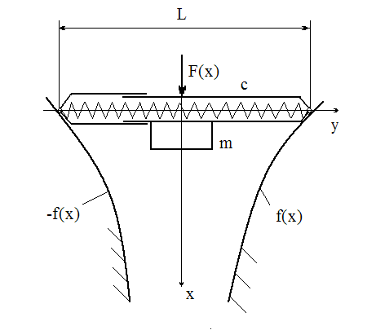

Figure 1 – The system scheme that allows
the obtaining of force-displacement
characteristic with QZS

For the case of the pneumatic spring the function $f(x)$ is determined similarly. The function (3) is written for the case when F(x) = F1/2 – const (Figure 2).

$$f(x)=\frac{L−H}{2}+0,5{\left\{H^{(−n+1)}+\frac{(n−1)⋅(F1/2)⋅x}{p_{0}⋅S⋅H^{n}}\right\}}^{\frac{1}{−n+1}}$$ | (3)
where L – is the length of unstrained pneumatic
spring;
H – is the distance from the bottom of
cylinder to the piston in initial position;
$p_{0}$ - is the initial pressure of the pneumatic
spring;
S – is the square of the pneumatic spring;
n – is the value of the polytropic coefficient
(n = 1,15 - 1,35).

Devices which have force-displacement characteristics with loops of hysteresis are well known [Averianov, Hamitov, and Nagornich, 2007; Boldirev, Keglin, and Ivanov, 2002, Bat, Ganelidze, and Kelson, 1973]. Force-displacement characteristics with loops of hysteresis in Figure 2 can be obtained in the system shown in Figure 1 by using dry friction R. In variants c) and d) (Figure 2) the force of dry friction is variable.
Investigation of the system with force–displacement characteristic shown in Figure 2 (а) was carried out in [Zotov, 2007]. Amplitude-frequency characteristics were received in this article.
The motion of any solid mater connected to the elastic element (Figure 1) under the action of harmonic driving force for force-displacement characteristic shown in Figure 2 (в) (this characteristic was received by scheme on the Figure 1) is described by three differential equations.
At the first phase, during the displacement from the initial position to the position with coordinate $х_{}$ (0А - Figure 2, b; time - $τ_{1}$) the motion is described by the next differential equation:

$$m⋅x_{I}^{''}=F_{0}\text{cos}(\text{pt}+ϕ)$$ | (4)
where m – is the mass of the body connected with
the spring (Figure 1);
$ϕ$ - is the constant angle.

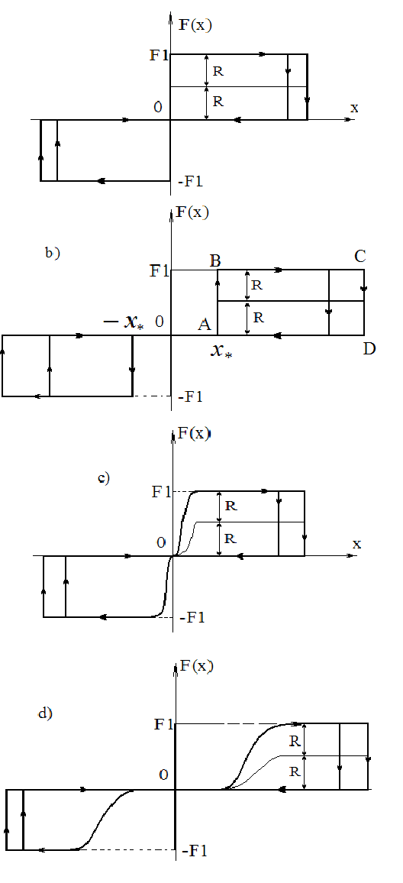
Figure 2 – Force-displacement characteristics with hysteresis loops

At the second phase (ВС – Figure2, b) during the displacement from the coordinate $х_{}$ to the next stop (time - $τ_{2}$) the motion is described by the next differential equation:

$$m⋅x_{\text{II}}^{''}=F_{0}\text{cos}(\text{pt}+ϕ)−F1$$ | (5)

At the third phase (D0 – Figure 2, b) the motion is described by the next differential equation:

$$m⋅x_{\text{III}}^{''}=F_{0}\text{cos}(\text{pt}+ϕ)$$ | (6)

Power characteristic in Figure 2 b) is symmetric relative to the half-cycle, so only three phases of oscillation are examined [Bat, Ganelidze, and Kelson, 1973].
Boundary conditions for the three foregoing differential equations are the following:

$$\begin{aligned}1)\begin{matrix}x_{I}(t=0)=0;\end{matrix}2)\begin{matrix}\end{matrix}x_{\text{III}}(t=\frac{π}{p})=0; \\ 3)\begin{matrix}\end{matrix}x_{I}^{'}(t=0)=−x_{\text{III}}^{'}(t=\frac{π}{p}) \\ 4)\begin{matrix}\end{matrix}x_{I}(t=τ_{I})=x_{} \\ 5)\begin{matrix}\end{matrix}x_{\text{II}}(t=τ_{1})=x_{} \\ 6)\begin{matrix}\end{matrix}x_{I}^{'}(t=τ_{1})=x_{\text{II}}^{'}(t=τ_{1}) \\ 7)\begin{matrix}\end{matrix}x_{\text{II}}(t=τ_{2})=x_{\text{III}}(t=τ_{2}) \\ 8)\begin{matrix}\end{matrix}x_{\text{II}}^{'}(t=τ_{2})=0 \\ 9)\begin{matrix}\end{matrix}x_{\text{III}}^{'}(t=τ_{2})=0\end{aligned}$$ |  | (7)

Substituting the solutions of differential equations (4-6) in conditions (7) we get the next system of transcendent equations.

$$\begin{aligned}\left.−\frac{F_{0}}{{\text{mp}}^{2}}\text{cos}ϕ+C2=0; | \right\}\left.−\frac{F_{0}}{{\text{mp}}^{2}}\text{cos}(p⋅\frac{π}{p}+ϕ)+C5⋅\frac{π}{p}+C6=0; | \right\}\left.\frac{F_{0}}{\text{mp}}\text{sin}ϕ+C1=−\left\{\frac{F_{0}}{\text{mp}}\text{sin}(p⋅\frac{π}{p}+ϕ)+C5\right\}; | \right\}\left.−\frac{F_{0}}{{\text{mp}}^{2}}\text{cos}({pτ}_{1}+ϕ)+C1⋅τ_{1}+C2=x_{}; | \right\}\left.−\frac{F_{0}}{{\text{mp}}^{2}}\text{cos}({pτ}_{1}+ϕ)−\frac{F1⋅τ_{1}^{2}}{2m}+C3⋅τ_{1}+C4=x_{} | \right\}\left.\frac{F_{0}}{\text{mp}}\text{sin}(p⋅τ_{1}+ϕ)+C1= | \right\}\left.\frac{F_{0}}{\text{mp}}\text{sin}(p⋅τ_{1}+ϕ)−\frac{F1}{m}⋅τ_{1}+C3 | \right\}\left.−\frac{F_{0}}{{\text{mp}}^{2}}\text{cos}({pτ}_{2}+ϕ)−\frac{F1⋅τ_{2}^{2}}{2m}+C3⋅τ_{2}+C4= | \right\}\left.−\frac{F_{0}}{m⋅p^{2}}\text{cos}(p⋅τ_{2}+ϕ)+C5⋅τ_{2}+C6 | \right\}\end{aligned}$$ | (8)
$$\left.\frac{F_{0}}{\text{mp}}\text{sin}(p⋅τ_{1}+ϕ)+C5=0\right\}$$ | (8)

System of these equations transforms into two equations:

$$\begin{aligned}\left.\frac{F_{0}}{\text{mp}}\text{sin}({pτ}_{2}+ϕ)\left[2τ_{2}−τ_{1}−\frac{π}{p}\right]− | \right\}\left.\frac{F1}{2m}(τ_{2}−τ_{1})^{2}+x_{}+ | \right\}\left.+\frac{F_{0}}{{\text{mp}}^{2}}\text{cos}({pτ}_{1}+ϕ)+\frac{F_{0}}{{\text{mp}}^{2}}\text{cos}(ϕ)=0 | \right\}\left.−\frac{F_{0}}{{\text{mp}}^{2}}\text{cos}({pτ}_{1}+ϕ)+ | \right\}\left.+\frac{F_{0}τ_{1}}{\text{mp}}\text{sin}({pτ}_{2}+ϕ)+\frac{F_{0}}{{\text{mp}}^{2}}\text{cos}(ϕ)=x_{}, | \right\}\end{aligned}$$ | (9)

These two equations were solved in package “Mathematica 5.0”. Firstly $τ_{2}\left(τ_{1}\right),\begin{matrix}ϕ\end{matrix}$ were expressed. Then C1-C6 integration constants were determined.

$$\begin{aligned}\left.С1=F_{0}⋅\text{sin}({pτ}_{2}+ϕ)/(\text{mp}); | \right\}\left.C2=F_{0}\text{cos}(ϕ)/({\text{mp}}^{2}); | \right\}\left.C3=F_{0}\text{sin}({pτ}_{2}+ϕ)/(\text{mp})+F1{τ_{1}}/m; | \right\}\left.C4=x_{}+F_{0}\text{cos}({pτ}_{1}+ϕ)/({\text{mp}}^{2})− | \right\}\left.−F{1⋅τ_{1}^{2}}/(2m)−F0τ_{1}\text{sin}({pτ}_{2}+ϕ)/(\text{mp}); | \right\}\left.C5=−C1; | \right\}\left.C6=F_{0}π\text{sin}({pτ}_{2}+ϕ)/({\text{mp}}^{2})− | \right\}\end{aligned}$$ | (10)

Dependence of amplitude from frequency was determined by the next formula:

$$\begin{aligned}A=x_{\text{II}}(τ_{2})=x_{\text{III}}(τ_{2})= \\ −\frac{F_{0}}{{\text{mp}}^{2}}\text{cos}(\text{pt}+ϕ)−\frac{F1⋅t^{2}}{2m}+C3⋅t+C4\end{aligned}$$ | (11)

This amplitude was compared with the solution’s results of differential equations (4-6) by numerical method with boundary condition (7). The strong correlation was observed between solutions.
The value $x_{}$ (Figure 2, b) is variable, and it is depends on the necessary function $F(x)$.
The oscillation amplitude derived from formula (11), as seen from Figure 3, has low dependence from$x_{}$. These curves are plot for the following values of parameters:
$m=\text{10}\begin{matrix}\end{matrix}$.

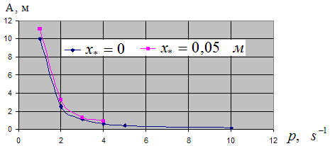
Figure 3 – Amplitude-frequency characteristic for force-displacement characteristics depicted
in Figure 2, b

It’s worth mentioning an interesting feature of systems with force-displacement characteristic depicted on Figure 2, b. For the given frequency of harmonic disturbing force the amplitude at F1=0 is equal to the amplitude at$F1=\frac{π}{2}F_{0}$.
A large preference of the pneumatic spring for the vibroprotective system in the Figure 1 is due to the possibility of creating QZS for the variable mass $m$. That is very difficult problem for the linear spring (Hook’s law) [Alabuzhev, Gritchin, Kim, Migirenko, Chon, and Stepanov, 1989].

3 Results
Systems depicted on the Figure 1, allow getting force-displacement characteristic with QZS region of the required length. As elastic elements linear springs obeying Hook’s law and pneumatic springs may be used. In case of pneumatic spring application an opportunity to vary restoring force (F1/2 – Figure 2) is appeared.
The usage of Coulomb friction for the considered system (Figure 1) allows obtaining force-displacement characteristic with hysteresis loops (Figure 2). Amplitude-frequency characteristics were obtained for force-displacement characteristic with hysteresis loops of rectangular shape, depicted on Figure 2, a, b. Analytical solutions of differential equations (4-6) were verified by numerical solution of the same differential equations in “Mathematica 5.0” software package.
Advantage of the proposed system with QZS is protection against vibration and impacts at the same time. Coefficient of impact absorption is more than for conventional systems and approaches to unit. Here the transmitted force is no more than established (by engineers) (Figure 2).

4 Conclusions
Applications of QZS mechanisms range from space research (to simulate zero gravity) to isolation of high-precision machinery. Systems with quasi-zero-stiffness characteristic are of interest also in other fields, for example in geodynamics, seismic protection, vibroprotection seats, train protection from vibration on railway, vibration-measuring apparatus, drilling equipment and so on.
Now for examination of theoretical results the special test bench is created.

References
Alabuzhev P., Gritchin A.,. Kim L, Migirenko G., Chon V., Stepanov P. (1989). Vibration Protecting and Measuring Systems with Quasi-Zero Stiffness. In: Hemisphere Publishing, New York.
Averianov G.S., Hamitov R.N., Nagornich A.V. (2007). Patent number 2304523.
Bat M.J., Ganelidze G.U., Kelson A.S. (1973). Theoretical Mechanics in Examples and Problems. Volume III. Moscow “Nauka”.
Boldirev A.P., Keglin B.G., Ivanov A.V. (2002). “Working and research of frictional-polymeric absorbent apparatus PMKP-110, class T1”. In: “ Вестник ВНИИЖТ.
Chelomey V.N. (1979). “Vibration in technics”: reference book. In 6 v.– M.; Mechanical engineering. 351 p. (table 1, p.12 (5))
Mansurov I., Mansurov O. (2006). Road antistrike damping system. In: Safety of vital activity №3.
Robertson W., Wood R., Cazzolato B., and Zander A. (2006). “Zero-stiffness magnetic springs for active vibration isolation”. In: Proceedings of the Sixth International Symposium on Active Noise and Vibration Control.
Zotov A. (2007). «Vibroprotective and impactprotective passive systems on base of elastic elements with zone of quasi-zero stiffness”. In: Materials of scientific and technical conference “Mathematical modeling of mechanical phenomena”. Ekaterinburg: UGGTU.
Zotov A. (2005). Vibration isolators with quazi-zero stiffness. In: Scientific and technical production collected articles of III International scientific and technical conference “Vibration machines, lowering, protection”, Donetsk.
Technology of protection any objects and systems from vibration. (2001). Institute of technical mechanics NANU and NKAU (http://itm.dp.ua/RUS/Technol/Tech1701.html).

