IDENTIFICATION OF OPERATING PERIODIC PROCESS BRAKING-UP REGARDING THE NONSTATIONARY PULSE SYSTEMS

Kolokolov¹ Yu.V., Monovskaya¹ A.V., Adjallah² K.H., Kozel¹ A.O.
¹Dep. of Design and Technology of Electronic Systems, Orel State Technical University, Orel, Russia
²Charles Delaunay Institut - FRE CNRS 2848, Technological University of Troyes, France

Abstract.
The disturbance model uncertainty of pulse energy conversion systems (PECS) stipulates the information uncertainty about the working bifurcation boundaries of stationary process existence domains. In this case a non-deterministic dynamics domain is formed within the objectively possible parameter variation ranges and the risk of bifurcation phenomena increases. These phenomena are connected with both the operating periodic process stability loss and abnormal periodic process setting-in. An approach to this problem solution is presented in the paper.

1. Introduction.
Pulse energy conversion systems (PECS) realize one of the promising energy-saving technologies of energy conversion and have got at present the widespread application in practical activities (for example, electric transport, public utilities, metallurgy, chemical production and so on). The operating periodic process of PECS functioning represents the stable energy conversion process at the pulse-width modulation (PWM) frequency with preset output signal characteristics.
However the stationary process existence domain bifurcation boundaries can be moved owing to the actions on PECS dynamics the wide spectrum of internal and external probable disturbances (for example, by variation of an environmental temperature, variation of the load and power-line supply, variation of regulator parameters, the initial technologic parameter spread relatively nameplate values, system degradation over time and so on). As some working parameter values can be unknown [1,2] so the working bifurcation boundaries are allocated in the parameter variation ranges. Moreover system behavior within these ranges can not be treated one-to-one (section 2).
Thus, the unique possibility of both operating process breaking-up forecasting and control algorithm correcting exists during only a transient. The duration of transients can be about fractions of seconds (10⁻²-10⁻³s) owing to the high PWM frequency (10³-10⁵ Hz). This target setting for operating process breaking-up prevention is not practically considered in the present-day approaches to nonstationary nonlinear system dynamics identification and forecasting [3,4]. One of the approaches to this problem solution is presented in the paper by the example of dynamics evolution through the transition-to-chaos scenario by 1-2-4-… period doubling (section 3). This scenario is one of the most widespread in PECS dynamics.
The usage of the geometrical and symbolical interpretations of phase trajectory qualitative features is a peculiarity of the developed approach [5]. These features are stipulated by the physical essence of both pulse-width modulation and transient convergence processes. The approach advantage consists in the possibility of PECS state uninterrupted (including transients) identification. At that an attention focuses on dynamics evolution results instead of cause revealing that lead to it (that is, the working PECS parameters are not identified).

2. Problem
The mathematical model [6] of the synchronous DC-DC buck converter with the second kind pulse-width modulation (PWM-2) and the proportional regularity loaw is used in the paper. This converter represents an example of one of the elementary PECSs, in the dynamics of which the problem considered hereafter exists. It allows explaining clear and obviously both the problem essence and proposed approach to its solution. This model general form is presented as a differential equation system with the following variable structure:
$$\frac{\text{dX}}{\text{dt}}=\text{AX}+B(K_{F}(ξ)),$$
where A is a constant coefficient matrix; B is a variable coefficient matrix; X is a phase variable vector; K_{F} is a pulse function, which is formed according to the PWM-2 and has the values “1” or “0”.
The model structure can be changed either at the beginning of the PWM period (when K_{F}-function is changed from “0” to “1”) or during the PWM period (when K_{F} -function is changed from “1” to “0”). If within k-th PWM period the model structure is changed, then this period is an “unsaturated impulse” one. The period doubling 1-2-4… scenario will be considered in the paper. All periodic processes of this scenario are characterized by existing of only the unsaturated impulse periods. Such a periodic process type is described by means of only the ratio (m) of its frequency (f_{m}=1/mT) to the PWM one (f₁=1/T). This property will be denoted hereafter as a “m-type process”. The mathematical model solution in the Poincare mapping form [7] is used to m value determination. In this case the fixed points of mapping are determined in accordance with the following expression:
X₁ ^{fp}=G⁽¹⁾( X_{m} ^{fp}) = G^{(m)}( X₁ ^{fp}), (1)
where j=1,2…m, G^{(j)} is a j- iteration of mapping.

Fig. 1 – Illustration to PECS dynamics identification problem under the condition of disturbances model uncertainty.
(a)
R₃

R₃
OP _{2D}
NP_{2D}
α

OP _{4D}
NP_{4D}
NP _{3D}
OP_{3D}
R₃

α

α

C
L
(b)
(c)
2D stereo-projection

Δu

4-type processdomain
Δi

2-type
process domain
1-type process domain

is a stationary process image;
is a transient image.
Parametrical space

(d)
5
10
20
10
R₃
1-type process

2-type
process

P
15
4-type
process
α
11
8
(e)
is a direction of a transient convergence
OP is a operating process existence domain
NP is a nonoperating process existence domain
NP_{2D}
OP _{2D}

Let us illustrate the principle of non-deterministic dynamics domain forming under the PECS working parameter value uncertainty (Fig.1). First, let us suppose that only fore variable parameters are taken into account in the paper: the regulator amplification factor (α); the active load (R₃); the capacity (С) and inductance (L), variation of which are conditioned on the maximum initial technologic spread of nameplate data [8] for electrolytic polar capacitors (±50%) and throttles (±20%). Second, let us suppose that the dynamics is characterized by only two stationary process types (operating and non-operating ones), and its existence domains (OP- and NP-domains, Fig.1.a-c) are not overlapped on the αR₃-bifurcation diagram (Fig.1d). The bifurcation boundary between these domains by the nameplate
CL–parameters will be denoted as a “reference” one (thick line in Fig.1a-d).
A working bifurcation boundary is regular shifted practically in parallel to the α-axis to the left relatively to the reference bifurcation boundary, when the C–value (Fig. 1b) and then L–value (Fig. 1c) are decreased consecutively. Maximum shifting to the left will correspond to the combination of the L- and C- minimum values. By analogy, it can be shown, that working bifurcation boundary maximum shifting to the right will correspond to the combination of the L- and C- maximum values. So far as the working L- and C-values are unknown, then the working bifurcation boundary can take any place within the sufficiently wide α–value range (Fig.1a, the shaded part of OP_{2D}-domain). Thus the corresponding part of the parametrical space is a non- deterministic

dynamics domain, in which either operating mode breaking up or normal PECS functioning is possible. For example, one of the 1, 2, 4-type processes can be observed in the point P (Fig. 1) under the C-parameter variation up to -45% (section 3).
The non-deterministic dynamics domain can overlap a sizeable part of the operating process existence domain owing to the working parameter uncertainty. In this case the setting-in periodic process identification during the running transient is one of the ways of the operating process breaking-up prevention. The problem of this identification realization consist in the restrictions on the usage of the preliminary information about the PECS nonlinear dynamics picture in the parametrical space in case of absence of both this information one-to-one interpretation regarding the stationary processes and any information about transients [6]. One of the ways out of this problem is “designing” of some special spaces for dynamics mapping that are free from the shortcomings mentioned.
Fig. 2 – Formation of the m-type constituents for stationary (a-f) and transient (g,h) processes.

w^{<m>}
0
w^{<2>}
w^{<4>}
w^{<1>}
w^{<m>}
0
w^{<2>}
w^{<4>}
w^{<1>}
w^{<4>}
0
w^{<1>}
w^{<2>}
(d)
(e)
(f)
«0» «0» «0»

«w^{<1>}»«0»«0»

«w^{<1>}» «w^{<2>}»«0»
time
t₁
t₂
t₃
t₄
current
w^{<m>}
transient
transient
1-type process
(g)
(h)
0
time
current
1-type process
0
2-type process
0
4-type process
0
(a)
(b)
(c)
K_{F} is equal to «1»
K_{F} is equal to «0»

current
time
current
time
w^{<m>}
time
time
time
time
3. Approach developed
The idea of real-time PECS dynamics forecasting [5] with use of both stationary and transient process image mapping in the special 2D space (hereafter “2D stereo-projection”) is developed in the paper. In this case m-type process existence domains are projected from the parametrical space (in which these domains are overlapped) into the 2D stereo-projection (in which these domains are not overlapped). Dynamics evolution is mapped by the point (stationary process images, Fig.1e, the black point) and trajectory (transient images, Fig.1, the broken line) alternations. At that the running transient trajectory deviates from the existence domain of the m-type process stability lost and directs to the existence domain of the m-type process setting-in.
However this approach practical realization is connected with some obstacles. First, the visual estimation of the trajectory convergence direction in 2D stereo-projection is hard formalizable. Second, as the stationary process images are determined on the

basis of the coordinates of the fixed points of mapping, so the problem of closeness of agreement between the experimental and numerical time series appears. Third, phase trajectory size (pulsation) characteristics are sensitive to the variation of some parameters [9]. Thus the stationary process existence domain boundaries can depend on variable parameter number and parameter variation ranges. For the shortcoming mentioned elimination one of the variants of this approach development is presented hereafter on the basis of the use of only synchronous time series quality features while process image forming. These features are stipulated by the physical essence of both PWM-2 and transient convergence towards a limit cycle processes [7].
With this purpose the geometrical and symbolical interpretations of the fractal regularities revealed in the PECS dynamics [9] are used. These regularities are expressed in the single-type stationary process phase trajectory set, generated under consecutive parameter variation, represents the geometrical structures similar in shape with the regular dimensional (size and rotation) modifications. At that a phase trajectory shape (and its sharp bends) maps the unique consecution and duration of the time lags of the key element open and close states when the K_{F} –function takes on “1” or “0” values accordingly. The phase trajectory shape can be modified (shifted, shrunk, stretched, and turned) in the phase space under parameter variation but its sharp bend unique drawing will be kept. So, the m-type processes of the 1-2-4-… period doubling scenario have «typical points» on their phase trajectory sharp bends at the moments of K_{F}-function changes from «0» to «1», which will be always repeated with the periodicity, equal or divisible to the PWM-period.

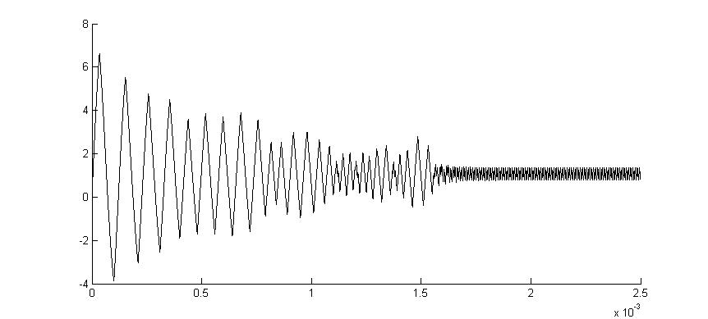
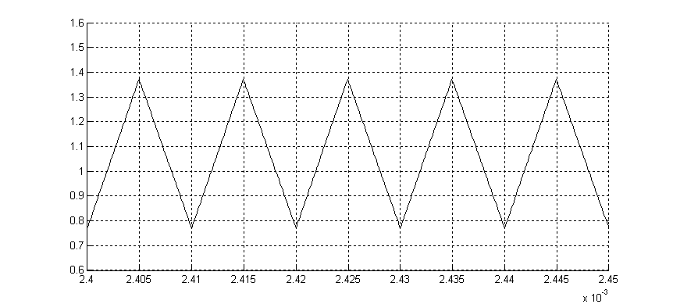
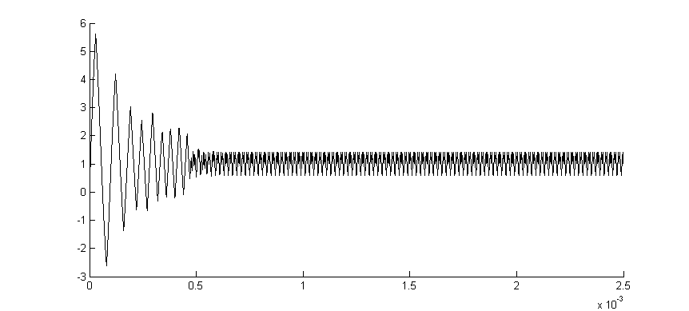
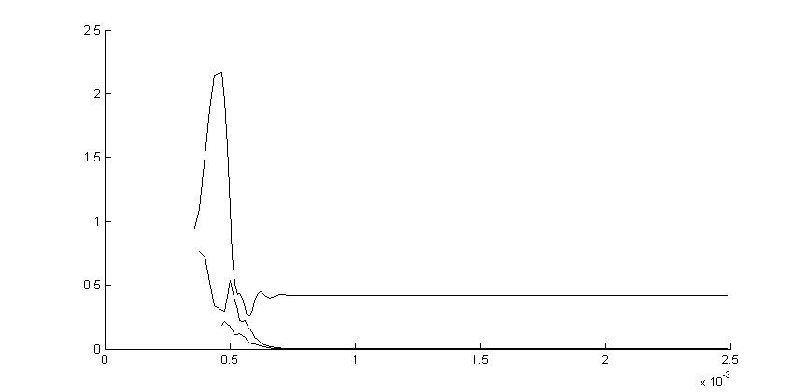
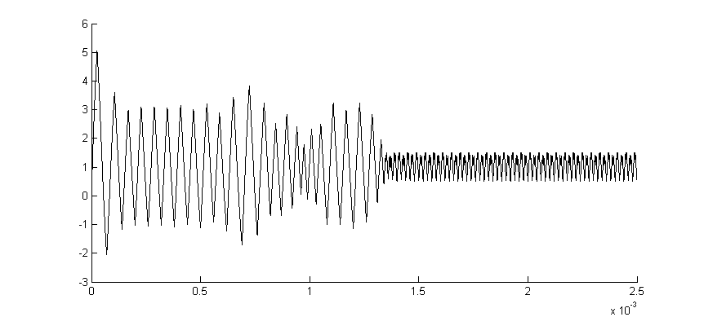
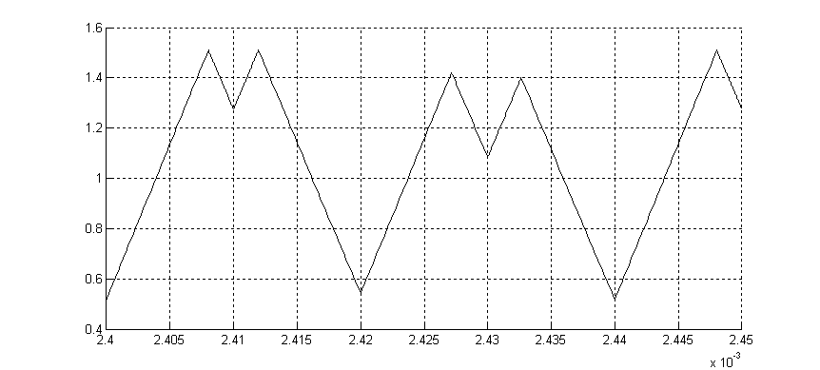
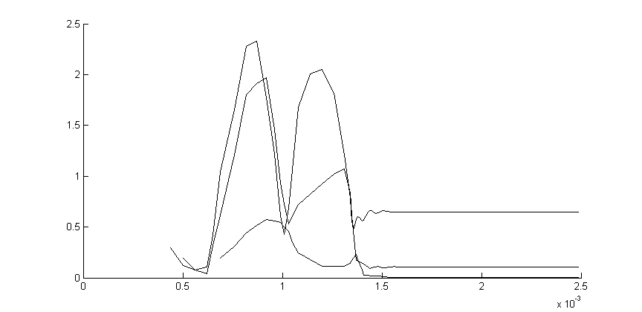
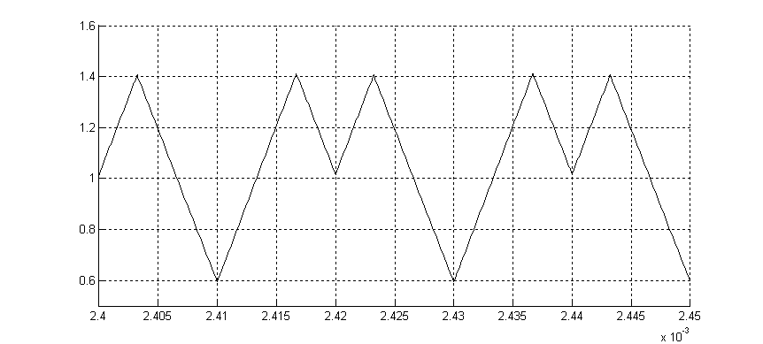
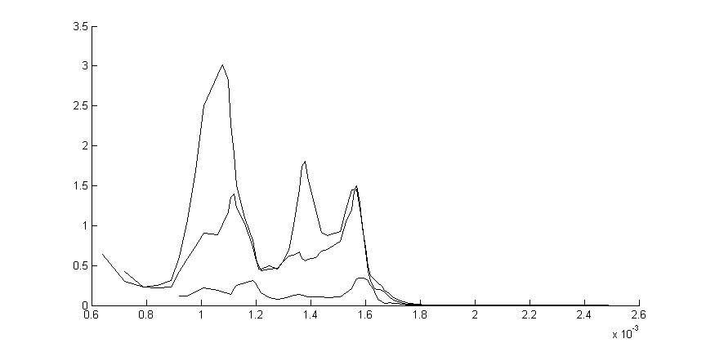
Fig. 3 – Numerical examples of the 1-2-4-type processes at the zero-value initial conditions in the time sires form ( a, d, g) and the m-type constituent aggregate (c,f,i), regarding the R3=11, α=8 (point P, Fig.2)
Convergence to the 1-type process, at the C=1e-5 F
Convergence to the 2-type process, at the C=0.7e-5 F
Convergence to the 4-type process, at the C=0.55e-5 F
zoom in
zoom in
zoom in
a)
b)
c)
d)
e)
f)
g)
h)
i)
time
time
time
time
time
w^{<m>}
w^{<m>}
current
current
current
time
w^{<m>}
w^{<1>}
w^{<2>}
w^{<4>}
w^{<1>}
w^{<2>}
w^{<4>}
w^{<1>}
w^{<4>}
w^{<2>}

For example, the time series of the current phase variable for the 1,2,4-type processes are shown in Fig.2a-c. For component frequency revealing the running process is presented as the aggregate of N time series, each of them represents a m-subharmonic image. Such an image is denoted hereafter as a «m-type constituent», each element (w^{<m>}_{k}) of which is formed in the following way:

w^{<m>}_{k} = ¼ w*, (2)
w*=(Δi ^{<m>}_{k-3} + Δi ^{<m>}_{k-2} + Δi ^{<m>}_{k-1} + Δi ^{<m>}_{k})

where Δi^{<m>}_{k} = ⎜i_{k} – i_{k-m} ⎜,
where k is a number of the PWM period, which has the running typical point; m is a ratio of the subharmonic period to the PWM one. The purpose of these transformations consists in continuous testing of the expression (1) and trend revealing [10] of the obtained time series. In this case, if the running elements of one of the m-type constituents have constant zero-values, then the running stationary process has the corresponding m- subharmonic. This process type is determined by m=2^{r}, where r is a number of the m-type constituents which have constant non-zero-value elements. For example, if m can be equal to 1,2 or 4 (Fig.2a-c), then N=3 and the elements of the1,2,4-type constituents will be calculated while the running process image formation. At that the following element value combinations are possible (Fig.2d-f): «0» «0» «0» (for 1-type process), «w^{<1>}» «0» «0» (for 2-type process) и «w^{<1>}» «w^{<2>}» «0» (for 4-type process), where «w^{<m>}» designates the running constant non-zero-value of the m-type constituent.
While the running process is stationary, the element values of each m-type constituent in the aggregate remain constant. For example, while the 1-type process keeps in stability (time interval [t₂ … t₃] in Fig.2g,h), the element values of all m-type constituents are equal to zero. As far as during a transient the K_{F}-function changes from “0” to “1” take place also (designated by the circles in Fig.2 g), then there is a possibility to continue formally the fulfillment of the transformations (2). While transient convergence to the m-type (stationary) process the affix of the running transient trajectory will be strived to the corresponding stability limit cycle structure [7], so the elements of each m-type constituent will be strived to a constant values, which will coincide with the element values of the m-type constituents of the stationary process set-in. For example, in the course of the transient trajectory convergence towards the 1-type process the element values of all m-type constituents will be equal to zero (circles with black points, Fig.2g, time interval [t₂ … t₃]). The fact of the m-type constituent element value divergence from their constant ones is a sign of m-type process stability loss (time interval [t₃… t₄], Fig.2g,h).
The examples of numerical realization of the proposed approach to identification of the setting-in stationary process type within the transition-to-chaos scenario through 1-2-4-… period doubling is presented in Fig.3. In these examples the model solutions at the zero-value initial conditions are used at the parameter values mentioned in section 2 (point P, Fig.1d).

Conclusion
The approach to the setting-in periodic process identification is presented in the paper.
In this approach frequency constituent revealing looks lie the Fourier analysis, but as opposite to it, the physical essence of both pulse-width modulation and transient convergence processes is taken into account.
It allows distinguishing some advantages, which lead to the following possibilities:
1. Real-time mode realization owing to the elementary mathematical operation use through time-sires analysis.
2. Identification of the setting-in periodic process type during a transient.

References
1. Amaral A.M.R., Cardoso A.J.M. The Consequences of aging of electrolytic capacitors, used in DC-DC converters, under steady-state operating conditions. // Proc. 11th Int. Conf. on Power Electronics and Motion Control, Riga, 2004. CD-ROM (A27187).
2.Kolokolov Yu.V., Koschinsky S.L., Bagrov V.V. Experimental Dynamics of Electromechanical Pulse Energy Conversion System. // IEEE Trans. on Instrumentation and Measurement. 2006. V.55. No.1, pp. 35-43.
3. Kleiman E., Mochalov I. Identification of non-stationary systems. // Automation and Remote Control. 1994. V. 55. No.2, Part 1, pp. 149-163.
4. De Gooijer J.G., Hyndman R.J. 25 years of time series forecasting. // Int. J. of Forecasting. 2006. V.22, pp.443-473.
5. Kolokolov Yu., Monovskaya A. Fractal principles of multidimensional data structurization for real-time pulse system dynamics forecasting and identification. // Chaos, Solitons & Fractals. 2005. V.25. Iss. 5, pp. 991-1006.
6. Kolokolov Yu., Monovskaya A., Hamzaoui A. On-line fault prediction algorithm for the pulse system. Proc. of the 16th IFAC World Congress, 4-8 July, 2005, Prague, Czech Republic, CD-ROM (#02317)
7. Anishchenko V.S. Dynamical Chaos – Models and Experiments. World Scientific, Singapore, 1995, 420 p.
8. http://www.power-one.com; http://www.peak-electronics.de; http:// www.chinfa.com; http://www.fabrimex.ch; http:// www.mmp-irbis.ru; http: // www.epcos.com
9. Kolokolov Yu.V., Monovskaya A.V. An influence of parameter variation on model-based emergency forecasting in the pulse system. // Proc. of the IEEE 2nd Workshop “On Intelligent Data Acquisition and Advanced Computer Systems: Technology and Applications (IDAACS’2003)”, 2003, Sept., 8-10, Lviv, Ukraine, PP. 349-354.
10. Box G.E., Jenkins G.M. Time series analysis, forecasting and control. Rev. Ed. San Francisko: Holden Day, 1976.

